Vocabulary | Symbol | Definition
nutrition | 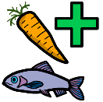 | A study of food
bacteria | 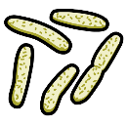 | Tiny organisms that can give good nutrients to our bodies,
germs | 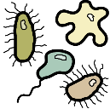 | Tiny organisms that live in our body.
pasteurisation | 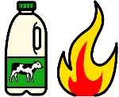 | Involves heating a liquid or food to remove germs or bacteria.
diet | 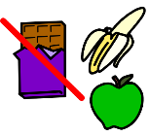 | The type and range of food that you regularly eat.
carbohydrate | 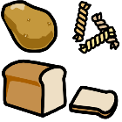 | Certain foods that provide you with energy, such as pasta, potatoes and bread
protein | 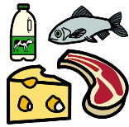 | Certain foods that help you to grow and be healthy, such as meat, eggs, milk and fish.
fat | 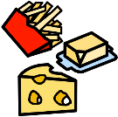 | Certain foods that give you energy but should only be eaten in a small amount.
vitamins and minerals | 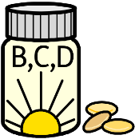 | Substances that you need to remain healthy which are found in certain foods.
fibre | 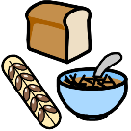 | Fibre helps good to pass through your body. Most vegetables contain fibre
balanced diet | 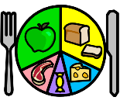 | A diet consisting of the correct amount and variety of food groups.
unbalanced diet | 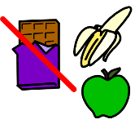 | A diet consisting of too much in one type of food group.
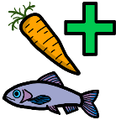
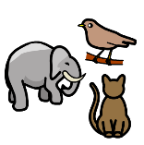
Animals including humans, and their Nutrition
Vocabulary Organiser
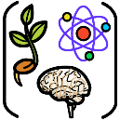
Biology is the scientific study of living things.
Vocabulary | Symbol | Definition
bones | 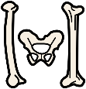 | The human skeleton or body
skeleton | 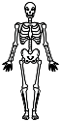 | The bones of the body.
endoskeleton | 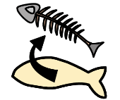 | An skeleton inside a body.
exoskeleton | 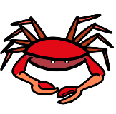 | A skeleton covering the outside of the body.
hydrostatic skeleton |  | An animal that has no skeleton.
vertebrate | 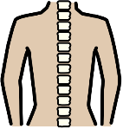 | A creature that has a spine, such as a human, bird or dog.
invertebrate | 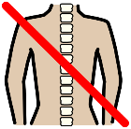 | A creature that does not have a spine, such as an octopus or worm.
muscles | 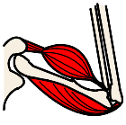 | A piece of tissue inside your body that connect two bones and you use when you move.
tendon | 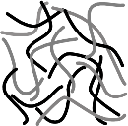 | A strong cord in the body that connects a muscle to a bone.

