Parents will,
- Let school know if your child is too unwell to complete any work via a Dojo message.
- Supervise children when using the resources specifically for home learning.
- When your child is writing their name, ensure they are holding the pencil correctly.
- Upload a photo of your child’s work onto Dojo.

Parents will ensure children
- Write their name using the name card/ handwriting pattern in the pack.
- Count from 0-20 then from 20-0.
- 10 minutes of reading.
- Listen to a story at least once a day. .
- Log onto Education City and complete your allocated activities over the 2 weeks.
- Practise writing the numbers 0-9.
- Sing the days of the week song https://www.youtube.com/watch?v=3tx0rvuXIRg

Home Learning Expectations for Reception
We expect your child to complete a little work every day whilst they are off school to isolate unless they are showing symptoms of Covid-19 and are too unwell to do so.
School will,
- Send a home learning grid and a grab bag of resources for the child’s home learning needs
- Organise weekly activities on Education City for the 2 weeks of absence
- Send topic and English related tasks on class dojo portfolio

Keeping Fit - Cosmic Yoga
https://www.youtube.com/watch?v=xhWDiQRrC1Y

Sing the rhymes:
Old Macdonald https://www.youtube.com/watch?v=_6HzoUcx3eo
5 Little Ducks https://www.youtube.com/watch?v=pZw9veQ76fo
1, 2, 3, 4, 5 https://www.youtube.com/watch?v=9ir_l7qTiZ4

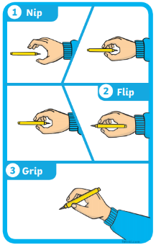

Discuss the Weather and Season
Discuss the weather. What do you observe happening outside? Do we have to take any measures against the weather? (Wellies and umbrella).
What changes can you see happening outside?


Creative Activity
Using your paints or colouring pencils can you draw your favourite fruit or vegetable?
Play- dough challenge
Can you use your playdough to make a model of something you would find on a farm?

