Harrow Gate Primary Academy
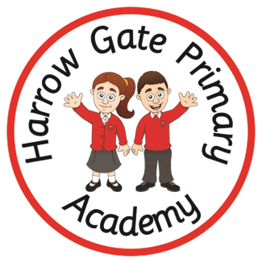

Personnel Development Curriculum

Personal Development at Harrow Gate Primary:

Our curriculum extends far beyond the academic, to allow pupils to develop in many diverse aspects of life. This is encapsulated in our Personal Development Curriculum.

We aim to ensure that, over their time at Harrow Gate Primary, learners receive a Personal Development programme that gives them the knowledge that they need to make decisions, to strengthen them personally and to allow them to develop their character and personality. We provide these rich experiences in a coherently planned way, in the curriculum and through extra-curricular activities.

At Harrow Gate Primary, there are four key drivers that underpin our Personal Development approach:
- Healthy & safe behaviours
- Awareness of the world
- Character development
- British Values

Healthy & safe behaviours include our PSHE curriculum, Relationship Education, Sex Education, Physical Health, Mental Wellbeing and Wider Aspects of Safety.

Awareness of the world includes Economic Understanding, Understanding Media and Technology and Spiritual, Moral, Social and Cultural development.

Character development includes development of children’s own character and personality, our RESPECT values framework, children’s behaviour and wider opportunities for children to engage with.

British Values includes Democracy, Rule of Law, Respect & Tolerance and Individual Liberty.

Personal Development Curriculum Overview:

Some areas of our personal development approach are taught through subjects with their own curriculum, e.g. our PSHE curriculum, or the online safety strand of our Computing curriculum. Other aspects are taught discretely. The following table illustrates which aspects are taught through which approach.

Aspect of Personal Development | Integrated area of wider school curriculum | Discrete personal development curriculum
Safe Behaviours  Including; Relationship Education, Sex Education, Physical Health, Mental Wellbeing, Wider Safety | - Jigsaw PSHE curriculum – Healthy Me, Relationships, Changing Me  - Complete PE  - Specialist PE delivery- gymnastic and dance  - Computing Curriculum – online safety strand  - Thrive Approach sessions  - OPAL (Outdoor Play And Learning)  - Forest School  - Commando Joe  - Balance Bikes – reception | - Anti-bullying week – November  - E-safety day – February  - NSPCC Pants  - NSPCC Speak Out Stay Safe – Workshops Y2, 5 and 6  - Sun Safety (Extra Jigsaw session)  - St John’s Ambulance First Aid (KS2)  - Bikability Training (Y5 and Y6)  - Dental visits about teeth care (EYFS)  - Road Safety - Jigsaw KS2 and Cleveland Fire Service  - Knife Crime Extra sessions – Jigsaw (Yr4-6)  - Water safety (yr 4 linked to Rivers topic)  - Middlesbrough FC Move and Learn (Y5)
Awareness of the world  Including; Economic Understanding, Understanding Media and Technology, Spiritual, Social, Moral, Cultural | - Jigsaw PSHE curriculum – Dreams & Goals  - RE/ Music/ Art/ Geography Curriculum  - Individual, ongoing subject contribution to SMSC (see statements)  - School visits programme  - Cultural Curriculum  - Harrow Gate Reading Cannon (Appendix 1)  - Global Curriculum  - Text Based Curriculum linked to CLPE  - Forest School  - Purpose build teaching environments – STEM lab, Bio-dome.  - Eco Club | - Exposure to BBC Newsround when relevant  - Economic development including NatWest MoneySense (Year 6)  - Enterprise Project with Virgin Bank’s “Grow the £5”  - Children Challenging Industry (Year 5)  - Whole School Assembly schedule (Appendix 2)
Character  Including; development of character, confidence and resilience, citizenship, wider opportunities | - Jigsaw PSHE curriculum – Being Me In My World, Celebrating Difference,  - Commando Joes curriculum (RESPECT framework)  - Relational Policy linked to Restorative Approach and Principals  - Extra-curricular clubs programme  - Instrument tuition programme  - Christmas performances & other performances (e.g. music)  - Thrive Approach  - Global Curriculum  - Cultural Curriculum  - Emotional Literacy development  - Texted Based Curriculum linked to CLPE  - OPAL (Outdoor Play and Learn)  - Forest School  - CALM approach (Future Steps Programme) | - 100 things you’ll do across the curriculum (Appendix 3)  - Residential Trip (Y6)  - Charity opportunities e.g. Comic Relief, Children In Need  - Targeted Thrive sessions – 1-1  - Targeted Theraplay  - Whole School Assembly Schedule (Appendix 1)  - Alliance Whole class offer – Emotions Express, We Eat Elephants.  - Alliance low level CBT – targeted  - Wheelchair basketball – half a term each year group KS2  - School Dog  - Transgender programme (Y6)  - Careers Week (Y6)
British Values  Including; Democracy, Rule of Law, Respect & Tolerance, Individual Liberty. This also includes elements of citizenship. | - Jigsaw PSHE curriculum – Being Me In My World, Celebrating Difference  - Individual, ongoing subject contribution to British Values (see statements)  - RE/ History Curriculum  - Smart School Council  - Texted Based Curriculum linked to CLPE  - Global Curriculum  - Relational Policy linked to Restorative Approach and Principals | - Whole School Assembly Schedule (Appendix 2)  - British Values discrete curriculum  - Black History Month study  - Pride & Diversity week study  - Remembrance Day study - November  - UK Parliament Week Study – November  - Anti-bullying week  - Autism Awareness month  - Royal National celebrations – Jubilee, Coronation

Discrete Personal Development Long Term Plan:
 | Autumn 1 | Autumn 2 | Spring 1 | Spring 2 | Summer 1 | Summer 2
Discrete personal development curriculum (lesson time) | Safe behaviours: NSPCC PANTS (EYFS)  Bikeability (year 5/6)  British Values (in Jigsaw time) Discrimination (KS2) | Safe behaviours: Anti-Bullying Week  British Values (in Jigsaw time) Democracy (KS2) | Safe behaviours:  Road Safety – Jigsaw extra unit and Cleveland Fire Service  British Values (in Jigsaw time)  Rule of law – the big legal lesson  Awareness of the world:  Children Challenging Industry (Year 5) | Safe behaviours:  SJA: First Aid (KS2) | Safe behaviours:  Sun Safety – Extra Jigsaw session  NSPCC PANTS (KS1 and 2)  MFC Move and Learn (Y5)  Awareness of the world:  Children Challenging Industry (Year 5) | Safe behaviours:  NSPCC Speak Out Stay Safe  Knife Crime Awareness – Jigsaw  Yr4-6  Awareness of the world:  Enterprise Project with Virgin Bank’s “Grow the £5”  Careers Week (Y6)  Character:  Year 6 Outdoor Learning Residential
Special Events / Days | National Poetry Day (6/10/22)  Black History Month – each year group to have a famous person to study | Christmas Performances  Children In Need  Anti-Bullying Week  Remembrance Day Study  UK Parliament Week  Primary Mathematics Challenge Competition  LBGTQ+ History Month | Safer Internet Day (7/2/23)  Comic Relief  (17/3/23) | World Book Day (2/3/23)  British Science Week (w/c 14/3/23) | Earth Day  (22/4/23)  Autism Awareness Month | Pride & Diversity Week - each year group to have a famous person to study  (w/c 26/6/23)

Personal Development Curriculum – Objectives / Progression of Learning:
Some aspects of personal development – such as the PSHE curriculum – are already mapped out in their own documentation.
Events – such as anti-bullying week – are thematic each year and do not have year group specific progression.
Other aspects – such as first aid – are more progressive each year and have specific objectives and are therefore mapped out here.
 | EYFS | KS1 | Lower KS2 |  | Upper KS2
NSPCC PANTS | Understand and learn the PANTS rules • Name body parts and know which parts should be private • Know the difference between appropriate and inappropriate touch • Understand that they have the right to say “no” to unwanted touch start thinking about who they trust and who they can ask for help.
NSPCC Speak Out Stay Safe |  | Understand abuse in all its forms and recognise the signs of abuse • Understand that abuse is never their fault, and they have the right to be safe • Know how to get help, and the sources of help available to them, including the Childline service. • (Lesson plans are differentiated for KS1 and ks2)  Workshops from NSPCC in Year 2, 5 and 6
Sun Safety |  | UV rays cannot be seen, but they can damage the skin and lead to sunburn, wrinkles, rashes and more serious conditions in later life, including skin cancer. UVA and UVB are the two types of UV rays that affect humans the most. • SPF stands for Sun Protection Factor: the higher the SPF number, the more protection the sun cream gives you. Children should use sun cream with an SPF of 30 or higher. • The Star Rating refers to the product’s protection from UVA. The Star Rating goes from 1 to 5 and it is recommended that children use sun cream with five stars, as this gives the best protection.
Knife Crime Awareness |  |  |  | Children will know why some people might carry knives. They will develop knowledge so they can make an informed decision about how to keep myself and other people safe when I am out by myself and with friend
Road Safety |  | ● The importance of knowing and understanding the Green Cross Code. ●How safer crossing places can help in crossing roads more safely. ●The importance of being seen by drivers.● What they can do to make themselves safer when on or near roads.
First Aid |  |  | Emergencies & calling for help:  • Understand it’s most important to ensure the safety of myself and others in the event of an emergency  • Assist in an emergency by correctly calling for help  • Know the information I need to give to emergency services if they are called to an incident Head injuries  • Identify a minor or major head injury  • Give first aid to a casualty who has a head injury  • Call for help for a casualty who has a head injury Bites & stings  • Identify when a casualty is having an allergic reaction to a bite or sting  • Provide first aid treatment for a casualty who has been bitten or stung  • Comfort and reassure a casualty who has been bitten or stung  • Seek medical help if required | Asthma:  • identify a casualty who is having an asthma attack  • assess and give first aid to a casualty who is having difficulty breathing due to an asthma attack  • understand when to seek medical help for a casualty w | Bleeding:  • Ensure the safety of themselves and others.  • Assess a casualty’s condition calmly and give first aid to a casualty who is bleeding  • I can give first aid to a casualty who is in shock. I can seek medical help if required for a casualty who is bleeding | Choking  • Identify a casualty who is choking  • Assess and give first aid to a casualty who is choking  • Seek medical help if required  Basic Life Support  • Conduct a primary survey  • Place an unresponsive casualty, who is breathing normally, into the recovery position  • Know when and how to deliver CPR to an unresponsive casualty who is not breathing normally Seek medical help

APPENDIX 1:
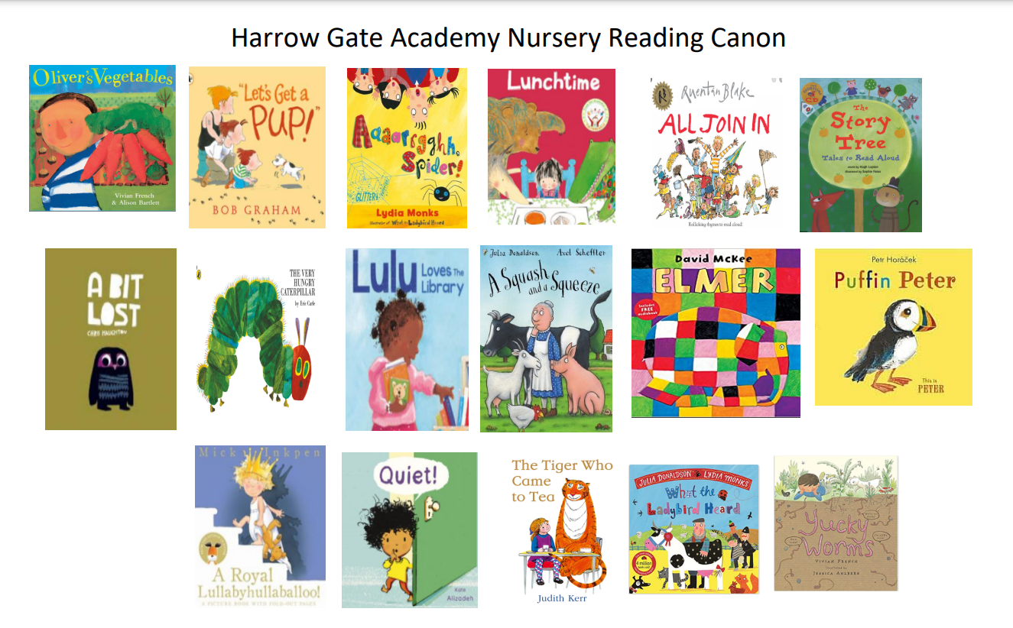
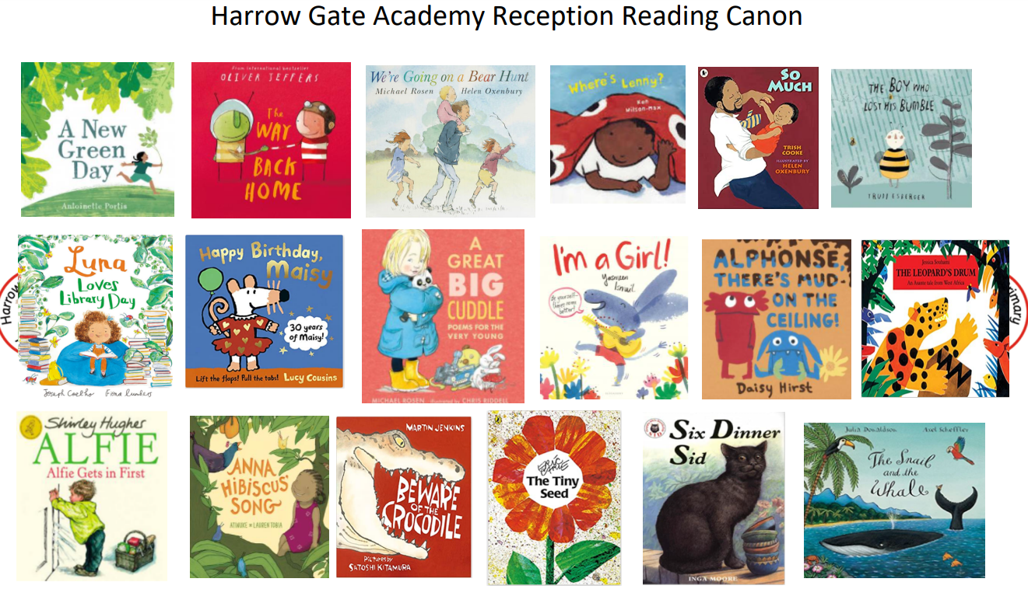

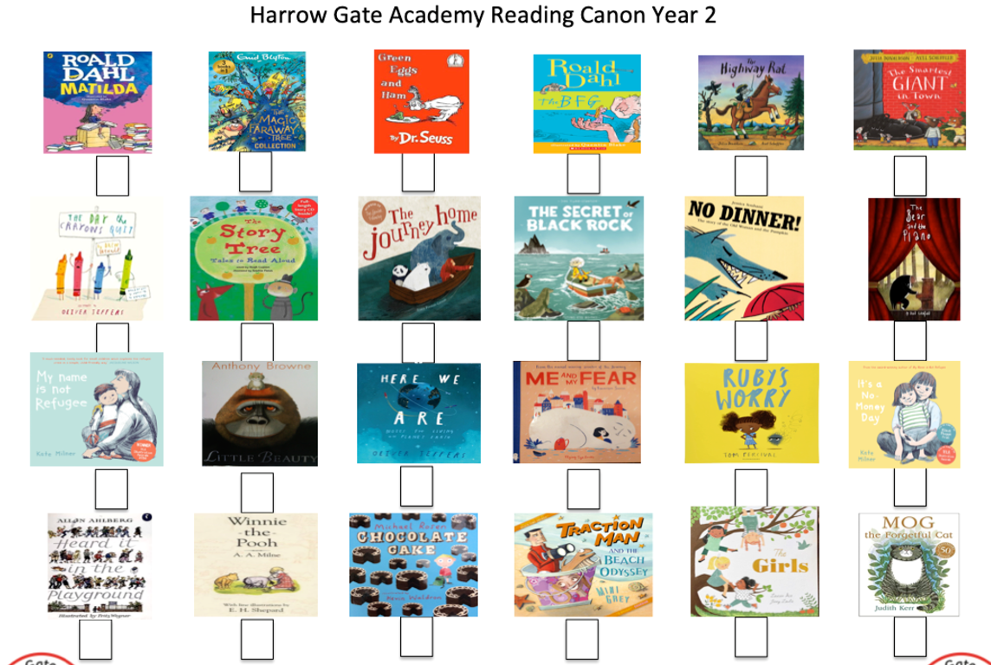
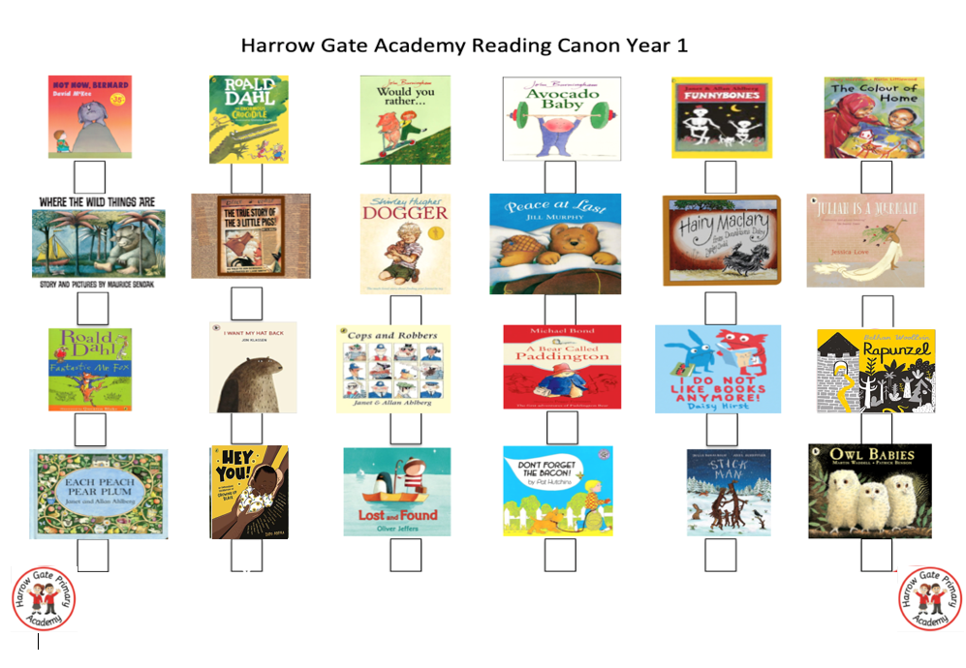
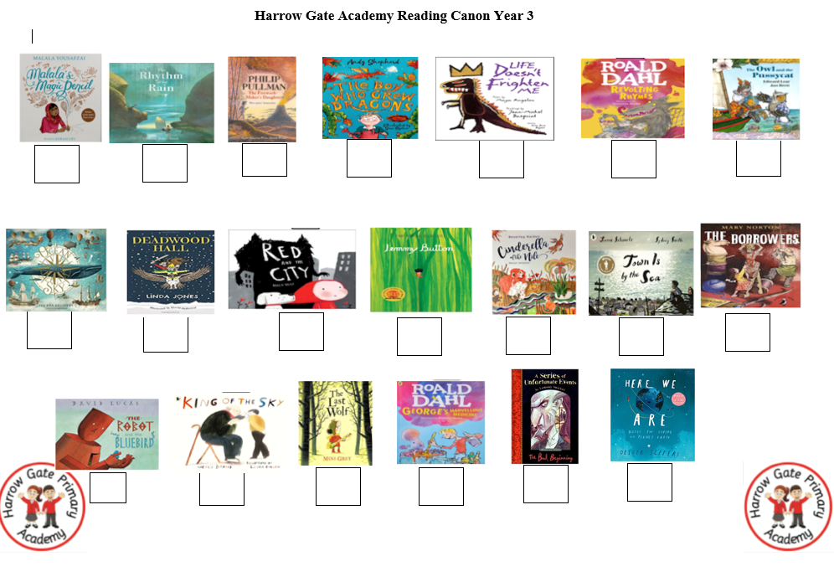
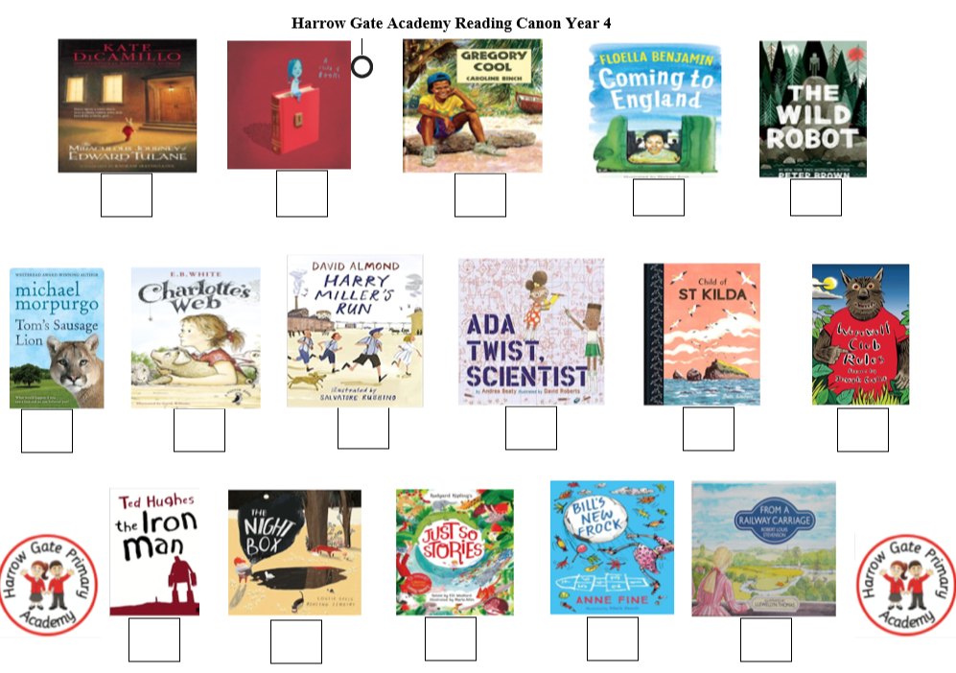
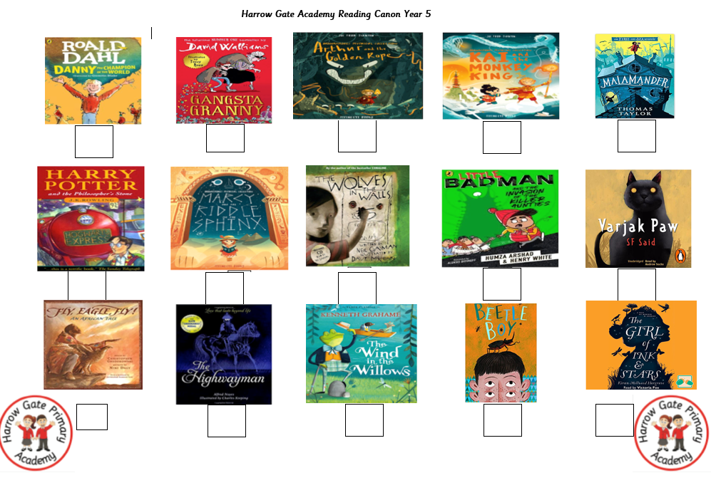
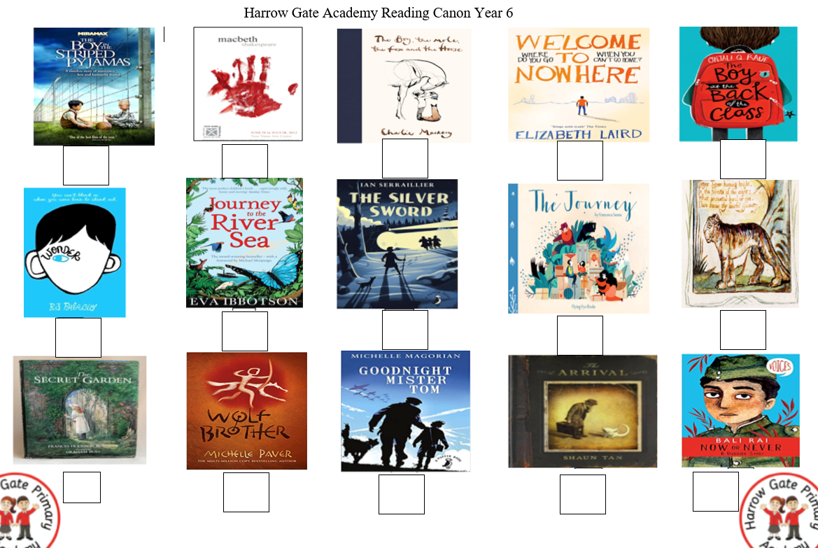
Appendix 2

Autumn 1 Wk1
Sep 4th Welcome Back: Being me in my world |  | VG
Wk2
Mon 11th | Helping others feel welcome: Anxious | VG
Wed 13th | KS2 OPAL Assembly – see OPAL assembly plan
Friday 15th | KS1 OPAL Assembly
Wk 3
Mon 18th | Making our school community even better  Emotion of the week: Proud  Harrow Gate Heros | GH
Wed 20th | 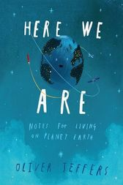  2:50  KS2 assembly  Here we Are  Author/Illustrator: Oliver Jeffers  A short essay on what makes our global community work. | RT
Friday 22nd | KS1 assembly  Same as KS2 | VW
Wk 4
Mon 25th | Thinking about everyone’s right to learn  Emotion of the week: Frustrated  Harrow Gate Heros: | AA
Wed 27th | KS2 OPAL Assembly – see OPAL assembly plan | VG
Friday 29th | KS1 OPAL Assembly | SW
Wk 5
Mon 2th Oct | Care about other people’s feelings  Emotion of the week: Lonely  Harrow Gate Heros | GH
Wed 4th | 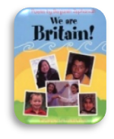  KS2  Black History month  We are Britain  Author: Benjamin Zephaniah  Poems to celebrate the diversity of British society. | AV
Friday 6th | 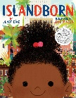  KS1  Black History Month  IslandBorn  Author: Junot Diaz  Illustrator: Leo Espinosa  Every kid in Lola’s school was from somewhere else. She can’t remember where she comes from so draws on the memories of others. | LC
Wk 6
Mon 9th | Work well with others  Emotion of the week: Surprise  Harrow Gate Heros | VG
Wed 11th | KS2 OPAL Assembly – see OPAL assembly plan | VG
Friday 13th | KS1 OPAL Assembly | SW
Wk 7
Mon 16th | Being a Harrow Gate role model (revisit everything so far)  Emotion of the week: Determined  Harrow Gate Heros | GH
Wed 18th | 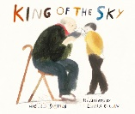  KS2  King of the Sky  Author: Nicola Davies  Illustrator: Laura Carlin  A poignant story of a young boy who misses his homeland - befriended by an old man and becomes enthralled by racing pigeons. | VD
Friday 20th | 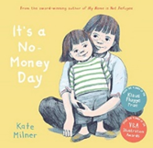  KS1 World Food Day  A moving insight into the sad rise and necessity of foodbanks from the perspective of society's most vulnerable, and an essential book to help develop empathy in younger readers. | JD
Wk 8
Mon 23th | Halloween and All Saints  Emotion of the week- scared | VG
Wed 25th | KS2 OPAL Assembly | VG
Friday 27th | KS1 OPAL Assembly | SW
Autumn 2 Wk1
Tues 7th Nov | KS1  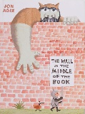  The Wall in the Middle of the Book  Author/Illustrator: Jon Agee  A gentle reminder that preconceived notions about things and people, over a boundary or otherwise, are often distinctly wrong. | SW
Wed 8th | 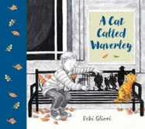  KS2  A cat called Waverly  Born in a city park, Waverley is looked after by his best friend, Donald. Until, one fateful day, Donald signs up to fight in a war-zone far away. Loyal and patient, the homeless little ginger cat waits for his friend at Edinburgh's Waverley Station. He waits... and waits. Years go by but Waverley never gives up. He knows that home is where Donald is. Will Donald ever return and will he and Waverley find a home at last? | NP
Fri 10th | Whole school Remembrance  Sing we will remember | VG
Wk 2 Celebrating Difference
Mon 13th | 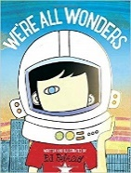  Accept that everyone is different (links to bullying)  Emotion of the week: Jealous  Harrow Gate Heros | GH
Wed 15th | KS2  Say no to bullying / friendship and tolerance.  We’re All Wonders  Author: R.J. Palacio  We’re All Wonders focuses on belonging and to be seen for what we truly are. A perfect way in to talking about empathy, difference and kindness. | SB
Friday 17th | 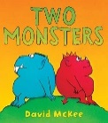  KS1  Say no to bullying / friendship and tolerance.  Two Monsters  Author: David McKee  Two monsters argue over many things but they eventually learn to respect each other’s point of view. | VW
Wk3
Mon 20th | Road safety week  Emotion of the Week: Hopeful | VG
Wed 22nd | KS2 OPAL Assembly | VG
Friday 24th | KS1 OPAL Assembly | SW
Pause in assemblies for Christmas concert practise and performances
Wk 6
Fri 15th December | Whole school Christmas Assembly | VG
Spring 2024
Wed 3rd January | Dreams and Goals  Emotion of the week: Excited | VG
Wk 2
Mon 8th Jan | Stay motivated when it is challenging / resilience.  Emotion of the week resilient | GH
Wed | 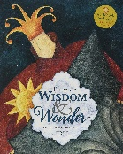  KS2  Tales of Wisdom and Wonder  Retold by: Hugh Lupton  Illustrator: Niamh Sharkey  A selection of traditional tales from around the world which show us that not everything is as it seems. | AJ
Friday | 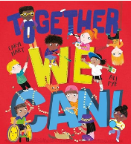  KS1  Together we can  Author: Caryl Hart  The perfect rhyming read-aloud with joyous illustrations, this book celebrates diversity and inclusivity throughout and highlights how important togetherness is in our world. | LC
 | Wk 3
Mon 15^{h} Jan | Work well with a partner or in a group  Emotion of the week: Fighting  Harrow Gate Heros | VG
Wed | KS2 OPAL Assembly | VG
Friday | KS1 OPAL Assembly | SW
 | Wk 4
Mon 22^{h} Jan | Tolerance and acceptance  Emotion of the week: Apologetic/ sorry  Harrow Gate Heros | GH
Wed | KS2  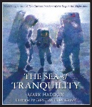  The Sea of Tranquillity  Author: Mark Haddon  Illustrator: Christian Birmingham  A boy dreams of rocketing to the moon. Every night he hoped that astronauts would find a way to land there. | VD
Friday | 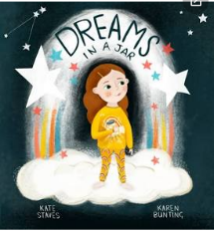  KS1  Dreams In A Jar  Author: Kate Staves  Illustrator: Karen Bunting  A little girl who takes something from each of her dreams whether it be a coin from a pirate ship or a pebble from the time ancient beasts roamed and puts them in a jar in order to remember them. | JD
 | Wk 5
Mon 29 Jan | 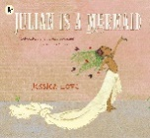  LGBTQ+ month: acceptance and inclusion  (Scan pics on Ipad and show on board as read to the school)  Julian is a Mermaid  Author/Illustrator: Jessica Love  A wonderful story about being who you want to be.  Emotion of the week: loved  Harrow Gate Heros | VG
Wed | KS2 OPAL Assembly | VG
Friday | KS1 OPAL Assembly | SW
 | Wk 6
Mon 5th Feb | Chinese new year  Emoji – Joyful | GH
Wed | KS2 | RT
Friday | KS1 | LC
 | Wk 7
Mon 12th | Self belief  Emotion of the week: Optimistic  Harrow Gate Heros | VG
Wed 14th | 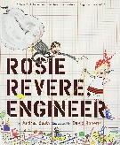  Women and girls in science  KS2  Rosie Revere Engineer  Author: Andrea Beatty  Illustrator: David Roberts  A book about pursuing your passion. Rosie is a brilliant inventor who dreams of becoming a great engineer. | AV
Friday | KS1  As above | SW
 | Spring 2 Healthy Me
Mon 26th Feb | Jigsaw introduction to healthy me – Lent and thinking of others  Emotion of the week: Thoughtful  Harrow Gate Heros | GH
Wed 28 | 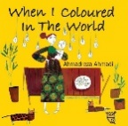  KS2  When I Coloured the World  Author: Ahmeadreza Ahmadi  Uplifting book of hope and joy. | AA
Friday1st March | 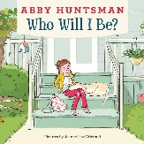  KS1  Who Will I Be  Author: Abby Huntman  Illustrator: Joanne Lew- Vriethoff  A book which explores the power of service and of giving back. Isabel learns about the different jobs people do to help people every day. | VW
 | Wk2
Mon 4th | International Women’s day (8th)  Emotion of the week: Confused  Harrow Gate Heros | VG
Wed 6th | KS2 OPAL Assembly | VG
Friday 8th | KS1 OPAL Assembly | SW
 | Wk 3
Mon 11th | Ramadan – 10th March – 8th April  Emotion of the week: Peaceful  Harrow Gate Heros | VG
Wed 13th | 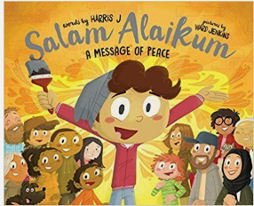  KS2:  KS1: | VD
Friday 15th |  | LC
 | Wk 4
Mon 18th | Science week: Science show?  Harrow Gate Heros Protection of our world  Emotion of the week: Guilty  Harrow Gate Heros | VG
Wed 20th | 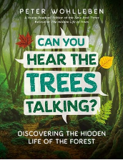  KS2: Can you hear the trees  Discover the secret life of trees with this nature and science book for kids: Can You Hear the Trees Talking? shares the mysteries and magic of the forest with young readers, revealing what trees feel, how they communicate, and the ways trees take care of their families.  The author of The Hidden Life of Trees, Peter Wohlleben, tells kids about the forest internet, aphids who keep ants as pets, nature’s water filters, and more fascinating things that happen under the canopy. | NP
Friday 22nd | 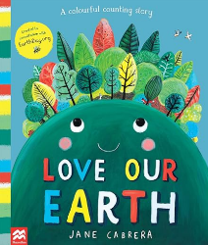  KS1:  Love our Earth  Jane Cabrera  With warm, playful illustrations from Jane Cabrera and a gentle read-aloud text, this is the perfect introduction to the wonders of life on Earth. Created in collaboration with EarthDay.org. | JD
 | Wk 5
Mon 25th | 26th Earth Hour is the world’s largest grassroots movement for the environment, inspiring millions of people to take action for the planet and nature. It is organised by World Wide Fund for Nature (formerly known as the World Wildlife Fund) and encourages people to turn off their lights for a set hour and to advocate for measures to fight climate change.  Emotion of the week: peaceful  Harrow Gate Heros | GH
Wed 27th | Easter: Whole school assembly – Mr Oliver | VG
 | Summer 1 Relationships
Mon 15th April | Jigsaw introduction - relationships  Emotion of the week: Mad  Harrow Gate Heros | VG
Wed 17 | 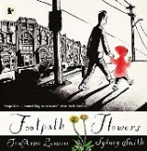  KS2  Footpath Flowers  Author: Jon Arno Lawson  Illustrator: Sydney Smith  Emphasis on the importance of small acts of kindness. The little girl suggests how we can change the world through paying closer attention to the environment and community. | RT
Friday 19th | 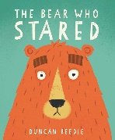  KS1  The Bear Who Stared  Author/Illustrator: Duncan Beedie  A charming book about a curious bear who discovers that a smile is all you need to turn a stare into a friendly hello. | SW
 | Wk2
Mon 22nd | Earth Day (22nd)  Emotion of the week: exasperated  Harrow Gate Heros | GH
Wed 24th | KS2 OPAL Assembly | VG
Friday26Th | KS1 OPAL Assembly | SW
 | Wk 3
Mon 29th | Autism Awareness Month  Emotion of the week: confused  Harrow Gate Heros | VG
Wed 1st May | 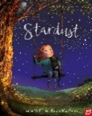  KS2:  Stardust  Author: Jeanne Willis  Illustrator: Briony May Smith  A reminder that we are all important and it is what we do each and every moment that counts. | AV
Friday 3rd | 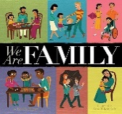  KS1:  We Are Family  Author: Patricia Hegarty  Illustrator: Ryan Wheatcroft  All families are different – and yet in many ways the same. A gentle rhyming text. | VW
 | Wk4
Mon 6th | Sir David Attenborough B’day  Emotion of the week: Happy  Harrow Gate Heros | GH
Wed 8th | 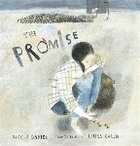  KS2:  The Promise  Author: Nicola Davies  Illustrator: Laura Carlin  A girl spreads hope among the grey, unforgiving city. | AA
Friday 10th | 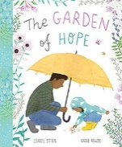  KS1:  The Garden of Hope  Author: Isabel Otter  Illustrator: Katie Rewse  A little girl finds courage and purpose as she transforms an overgrown and neglected garden into a place of beauty, love and ultimately hope. | LC
 | Wk 5
Mon 13th | SATs week no assembly
 | Wk 6
Mon 20th | Respect – how we treat others.  Emotion of the week: hurt  Harrow Gate Heros | VG
Wed 22nd | KS2 OPAL Assembly | VG
Friday 24th | KS1 OPAL Assembly | SW
 | Summer 2 Changing Me
Mon 3 June | Jigsaw introduction assembly  Emotion of the week: Yelling  Harrow Gate Heros | GH
Wed 5th | 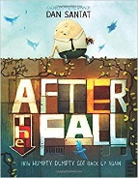  KS2:  AfterFall  Author: Dan Santat  A retelling of Humpty Dumpty from the egg’s perspective. Promotes perspectives, a growth mindset, perseverance, and courage as Humpty Dumpty conquers his fear of heights. | AA
Friday 7th | KS1:  AfterFall  Author: Dan Santat  A retelling of Humpty Dumpty from the egg’s perspective. Promotes perspectives, a growth mindset, perseverance, and courage as Humpty Dumpty conquers his fear of heights. | JD
 | Wk 2
Mon 10th | Understanding that everyone is unique and special.  Emotion of the week: bored  Harrow Gate Heros | VG
Wed 12th | KS2 OPAL Assembly | VG
Friday 14th | KS1 OPAL Assembly | SW
 | WK3
Mon 17th | Refugee Week was established in 1998 to promote understanding and awareness of refugees, the challenges they face, and the contribution that refugees have made to society in the UK.  Emotion of the week:  Harrow Gate Heros | GH
Wed 19th | 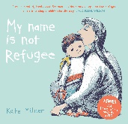  KS2:  My Name is Not Refugee  Author: Kate Milner  A powerful and moving journey of a young boy and his mother who have to say goodbye to loved ones. | RT
Friday 21st | 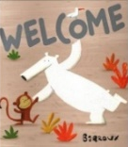  KS1:  Welcome  Author: Barroux  Links to the current refugee crisis and climate change in this story about a bear’s vulnerability when finding a new home. | SW
 | Wk 4
Mon 24th | Can express how they feel when change happens.  Emotion of the week: Disappointed  Harrow Gate Heros | VG
Wed 26th | 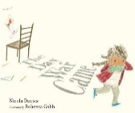  KS2:  The Day War Came  Author: Nicola Davies  Illustrator: Rebecca Cobb  Follow the heartbreaking yet hopeful journey of a little girl forced to become a refugee. | AV
Friday 28th | 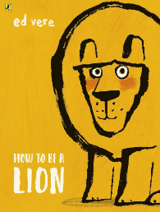  KS1:  How to Be a Lion by Ed Vere  Leonard's love of words and poetry help him stand up for himself when he is mocked for his quiet and gentle ways. Promotes self-awareness, acceptance, thinking and courage. | VW
 | Wk5
Mon 1st July | Understand and respect the change that they see in themselves and other people.  Emotion of the week: overwhelmed  Harrow Gate Heros | GH
Wed 3rd | KS2 OPAL Assembly | VG
Friday 5th | KS1 OPAL Assembly | SW
 | Wk 6
Mon 8th | Know how to ask for help if they are worried about change.  Emotion of the week: nervous  Harrow Gate Heros | VG
Wed 10th | 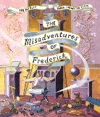  KS2:  The Misadventures of Frederick  Author: Ben Manley  Illustrator: Emma Chichester Clark  A celebration of overcoming fears and enjoying life to the full. | VD
Friday12th | 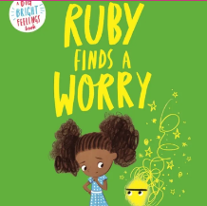  KS1  Ruby Finds a Worry by Tom Percival  This is the first of two picture books about adapting to change by Tom Percival. Ruby has a Worry. It wasn’t very big, but it stayed with her all day, so she stopped doing the things she loved. She finds discussing her worry makes it gets smaller until it is almost gone. Though the Worry appears every now and again, Ruby knows how to get rid of them.  Read to discuss adaptability, self-awareness, self-management and self-esteem. | LC
Mon 15th | Emotion of the week: confident  Harrow Gate Heros
Wed 17th | KS2
Friday 19th | KS1

Appendix 3
100 Thing you will do at Harrow Gate Primary
Each year | Watch a live theatre performance | Receive your very own book to keep as part of World Book Day. | Sing together as a school in a candle celebration at Christmas | Help raise money for charity | Take part in a democratic process: Have a say in the development of Harrow Gate through school council
Each year | Take part in a sports competition | Visit the church at Christmas | Display artwork for an audience | Be part of a Poetry Slam. | Read 8 books from the year group Reading Cannon
Each year | Learn how to stay safe online | OPAL play time – make mud pies, role play on a boat etc | Take part in charity events: Children in Need, Red Nose Day. | Take part in Remembrance Celebrations | Take part in a school concert
Nursery | Build a den | Grow a plant | Sing Nursery Rhymes | Make mud pies | Bake cakes
Nursery | Watch the life cycle of a frog | Harvesting fruit from the garden for snack time | Make a diwa | Toasting marshmallows in Forest School | Sit in a fire engine
Reception | Go to the aquarium | Post a letter at a post box | Bake biscuits | Collect some minibeasts | Play Hide and Seek
Reception | Watch the life cycle of a Butterfly | Learn to ride a balance bike | Learn some Fairy tales | Learn a Diwali dance | Create a wormery
Year 1 | Visit the Centre for Life in Newcastle | Have a Beast Party | Visit Stewart’s Park | Build and race a car | Enjoy visits with the Librarian
Year 1 | Make bird feeders | Visit Seven Stories in Newcastle | Learn to tie our shoe laces | Plant and harvest vegetables from the bio-dome | Dress up for Halloween and have a party
Year 2 | Visit Captain Cook’s Museum in Stewarts Park | Prepare fruit and vegetables from the bio-dome | Develop basic chopping skills | Visit Saltburn and walk along the pier and play on the beach | Visit Guisbrough Woods
Year 2 | Visit the Yorkshire Sculpture Park | Neolithic hunters – Stone Age day | Visit Danby Forest | Have a Hanukkah party | Visit Tees Barage
Year 3 | Start to learn to speak French | Learn sawing skills | Learn to play the ukulele | Visit to Segedunum | Visit to Jarrow Hall
Year 3 | Visit Hardwick Park to create a field sketch | Make a fossil | Learn how to be safe in the sun | Begin First Aid learning | Design and make a nutritious meal
Year 4 | Use fieldwork skills at Danby Forest | Learn new First Aid skills | Trip to Life Centre Newcastle exploring the body | Learn to play the ukulele | Learn to make a friendship bracelet
Year 4 | Visit the immersive classroom | Visit to Murton Park Danelaw Village | Make a cross stitch bookmark | Learn how to line dance | Raise money to help those in need linked to Sikhism RE focus
Year 5 | Use orienteering and grid reference skill at Danby Centre | Visit Kielder Dam | Take part in Children Challenging Industry project | Develop regulation strategies through Strive activities | Visit to RSPB Saltholme
Year 5 | Use green screening to recreate the Victorian times | Learn new First Aid skills | Learn to play a range of games | Visit Darlington Buddhist temple of meditation | Visit Ripon Museum to learn about Victorian Life
Year 6 | Be part of an enterprise project | Take part in an outdoor learning residential | Visit Heugh Battery | Have a visit from the Imam | Take part in a Macbeth drama project
Year 6 | Take part in a Graduation Ceremony | Learn to swim 25m | Take part in Crucial Crew Project | Visit Eden Camp | Daily Newround and reflections on global issues

