Ways of working scientifically  Identified across each scientific area in the progression document |   Observing changes over time | 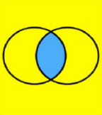  Grouping and classifying |   Carrying out comparative fair tests |   Noticing patterns |   Researching using secondary sources |   Asking questions
Design and Technology  The design and technology process is at the heart of activities / learning cycles | 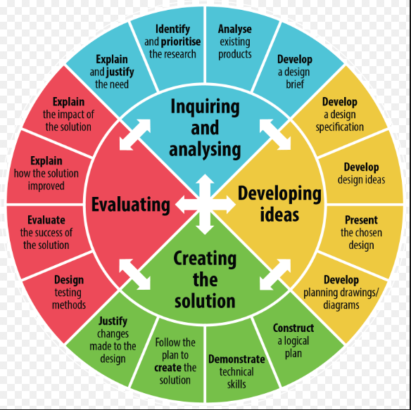
Year group | Autumn 1 | Autumn 2 | Spring 1 | Spring 2 | Summer 1 | Summer 2
Year 1 | Chemistry  What is a scientist?  Learning Intention:  - Know that a Scientist can be anyone  - Understand the scientific lines of enquiry  - Be able to Select appropriate scientific line of enquiry  Mini experiments weekly that introduce the 3 main ‘working scientifically’ skills |  | Chemistry  Everyday materials  Learning Intention:  - Understand properties of materials  - Understand the mechanism of an axle and wheel  - Be able to combine knowledge properties of materials to suit a specific design criteria  Mechanisms / Axels and wheels  Wacky Races  Learning Intention:  Pose the children a variety of design criteria which enables them to use and apply their understanding of properties of materials and mechanisms.  Content: DT specific processes  - Wheel  - Axle  - Balance |  | Biology  Plants  Learning Intention:  - To identify the basic parts of a flowering plant and a tree  - To understand the basic functions of the flower, stem, leaves and roots  - To understand the basic functions of a tree.  Parts and functions of a plant. | Biology  Animals including humans  Learning Intention:  - To name common animals.  - To know how animals are grouped (5 categories).  - To understand how you can identify animals.  - To name and label the parts of the human body.  - Be able to place animals into groups dependent on their characteristics.
Year 2 | Biology  Learning intention:  - Understand basic needs for survival  - To use understanding of healthy food and cutting skills to design and make a healthy snack.  Animals including Humans  (Offspring, needs for survival)  Chemistry  Uses of every day materials  Learning Intention:  - Understand why materials are selected for certain uses  - Test materials to identify their suitability  - Use this knowledge to create products which are absorbent or waterproof  Charles Mackintosh  LINKS: Art sculpture Spring 2 &  Puppy challenge |  | Biology  Learning Intention:  - Understand the difference between a seed and a bulb  - Understand what a plant needs to germinate  - Understand how certain conditions can affect germination.  Plants  (seed and bulb, what plants need to grow) | Food and Nutrition  Prior Learning: EYFS Healthy eating and food names.  Content: Food hygiene  Food processes and equipment  Cutting terminology / skills | Biology  Learning Intention:  - Use their understanding of living things and their habitats to apply to a real life context  - Why do we need to know more about certain animals (endangered animals, human impact)?  - How can we use our knowledge to observe animals in their natural habitats  Living things and their habitats  (Habitats, dead or alive  Food chains)  LINKS: Geog Spring 1  Famous Scientist  Jane Goodall Biologist Study of gorillas in natural habitat. Effects of humans on this family group
Year 3 | Chemistry  Rocks and Soils  Learning Intentions:  - To identify the physical properties of rocks  - To use this knowledge to group and compare.  - To understand how fossils are formed.  - To know how soil is created and the properties of different types.  (How they are formed)  LINKS: Geography Spring 1  Mary Anning  John McAdam | Physics  Light  Learning intention:  - To understand what light is and its importance.  - To identify sources of light (man-made and natural).  - To know how light moves and how it can be reflected.  - To understand how the eye detects light.  - Use their knowledge of light to create suitable eye wear. | Biology  Plants  Learning Intentions:  - To understand the functions of a flowering plant (plant, tree)  - Understand how water is transported through a plant (transpiration)  - Understand how the processes of pollination, seed formation and seed dispersal in flowering plants.  - Understand the needs of particular plants (e.g. a cactus, volcanic plants etc.) | Biology  Animals including humans (Nutrition)  Learning Intentions:  - To understand that animals and humans need the right types and amounts of nutrition.  - To be able to identify human and animal skeletal systems and muscular systems  - To know these provide support, protection and movement.  DT – Food and Nutrition  Learning Intention:  - To use their knowledge of nutrition and seasonality to create a nutritious savoury meal.  Famous Scientist  Louis Pasteur  Learning Intention:  - To use their knowledge of pasteurisation and how foods are processed and manufactured to ensure they are safe for human consumption |  | Physics  Forces and Magnets  Learning Intentions:  - Understand how things move on different surfaces and the forces acting on them.  - Understand the properties of magnets  - Use the knowledge of magnets and materials to identify magnetic materials.  Pneumatics  Learning Intentions:  - To use their knowledge of forces and pneumatics to create a moving figure.  Content:  History of Pneumatics  German physicist Otto  James Watt  Uses of Pneumatics  DT vocabulary  Tools required for a simple pneumatic
Year 4 | Physics  Electricity  Learning Intention:  - To understand that electricity is an energy and identify everyday appliances that use it  - To be able to construct simple circuits and know the electrical components but not their symbols  - To use their knowledge of circuits and electricity to create a circuit with a switch and a light which serves a purpose  Famous Scientist  Alessandro Volta  Physicist  Discovered the battery!  Electrical systems – simple circuits and switches  Learning Intention:  Pose the children a variety of design criteria which enables them to use and apply their understanding of circuits to design and make a Christmas decoration.  Content:  Design criteria  Toggle switch  Reed switch  Secure connections  Handmade switches  Commercial switches  Circuit symbols |  | Chemistry  States of matter  Learning Intention:  - To know there are three states of matter.  - Use this knowledge to group materials according to their properties.  - To know that water exists naturally in all 3 states.  - To know how the different states play a part in the Water Cycle | Biology  Living things and their habitats  Learning Intention:  - Understand that vertebrates can be grouped due to their characteristics.  - Use this understanding to use and create classification keys  - To know that environments are changing and how this affects the wildlife.  (Basic classification, environment)  David Attenborough | Physics  Sound  Learning Intentions:  - To understand how sounds are made  - Know that vibrations from sounds travel through a medium to our ear.  - To understand pitch and volume how this affects sound  - To understand how the volume of a sound is affected by distance.  Marin Mersenne  Robert Boyle | Biology  Animals Including Humans  Learning Intentions:  - To know the basic parts and functions of the digestive system in humans.  - To indentify the different types of teeth and functions in humans.  - To be able to construct food chains  LINK: Yr5 Hist Autumn 1
Year 5 | Chemistry  Properties and Changes of Materials  Learning Intention:  - To be able to group everyday materials on the basis of their properties  - To know that some materials dissolve in liquids to form a solution.  - To identify the correct process for separating mixtures  - Understand everyday uses of particular materials  - Understand that some changes are reversible and some irreversible.  John Dunlop | Physics  Earth and Space  Learning Intentions:  - Understand the movement of the Earth in relation to the sun and the other planets.  - Explain the movement of the Moon relative to the Earth  - Know why the Earth’s rotation causes night and day  - Explain that the Sun, Moon and Earth are spherical bodies  - To recognise the theories of black holes and relativity  Famous Scientist  Stephen Hawking  Brian Cox  Guion ‘Guy’ Bluford (first African American in Space) | Biology  Living Things and their Habitats  Learning Intentions:  - To know the differences in the life cycles of a mammals, amphibian , insect and a bird  - Describe the life process of reproduction in plants and animals | Biology  Animals including humans  Learning Intentions:  - Understand and describe the changes in humans as they age. | Physics  Forces  Learning Intentions:  - Know why unsupported objects fall towards earth because of the force of Gravity  - Identify the effects of air resistance, water resistance and friction  - Recognise that some mechanisms can allow a smaller force to have a greater effect.  Mechanical systems – Pulleys and gears  Learning Intentions:  Pose the children a variety of design criteria which enables them to use and apply their understanding of forces and mechanical systems to design and make a moving object.  Content: 6 simple machines identified by science and DT  Pulley rotations  Gear ratios  Reversing switches  Annotated diagram  Exploded diagram
Year 6 | Biology  Evolution and Inheritance  Learning Intentions:  - Understand that living things have changed over time (evolved).  - Recognise that living things produce offspring which are similar but not identical  - Identify how plants and animals are adapted to their environment.  Charles Darwin  Mary Anning  Alfred Wallace | Biology  Animals Including Humans  Learning Intentions:  - Identify and name the main parts of the human circulatory system  - Describe how water and nutrients are transported through the body.  - Explain the impact of diet, exercise, drugs and lifestyle on the way the body functions.  DT – Food and Nutrition | Biology  Living Things and Their Habitats  Learning Intentions:  - Describe how living things can be classified into broad groups according to common observable characteristics  - Understand the characteristics particular of plants, animals and micro-organisms  - Justify reasons for classifying living things.  Carl Linnaeus | Physics  Electricity  Learning Outcomes:  - To understand how the voltage of cells affects the brightness of a lamp and the volume of a buzzer.  - To be able to compare and give reasons for how different electrical components function  - Use recognised symbols to represent electrical circuits in a diagram. | STEM Critical Thinking Tomato Challenge  Learning Intention:  Provide the children with a real life challenge for them to demonstrate and consolidate their STEM skills. | Physics  Light  Learning Intentions:  - To know how light travels  - To explain how light allows us to see  - To explain how shadows are formed  Thomas Edison  STEM Critical Thinking

