A warm welcome to Harrow Gate Primary Academy!
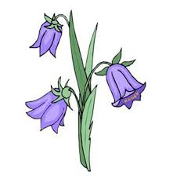
We are delighted to offer you a place at Harrow Gate Primary Academy Nursery.
Your child will be in the ‘Bluebells Class.’ We are really looking forward to meeting you and your child and beginning our learning adventure together.
Nursery Staff

Mrs Pybus  Nursery Teacher 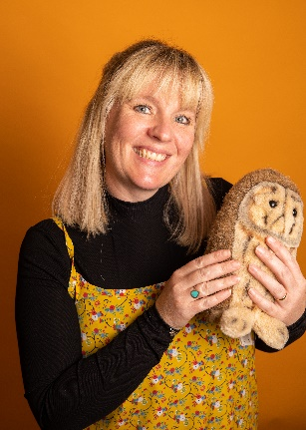 | Miss Ruston  Nursery Manager | Mrs Wilson  Teaching Assistant  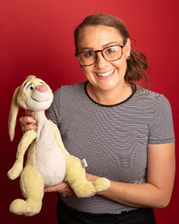
- Children have access to the outdoor environment every day, in all weathers; so wellies and a change of clothes are essential, please bring a set in to leave in school.
- Please also label everything! Jumpers, wellies, cardigans and coats.
- Each child will receive a book bag with a reading and storybook. Please bring their book bag to nursery each day, along with their reading record and book. We ask you to try to read three times a week with your child. We encourage you to re-read books together, as this will help your child to remember repeated phrases and events in the stories.
- Each half term, we will have a topic and book focus we are learning. All information on how you can support your child’s learning throughout the topic will be available at the beginning of each half term.
- Nursery P.E is every Wednesday. The children are to come to nursery in their P.E kits.
At Harrow Gate Primary Academy, we use ‘Class Dojo’ to communicate with our families. We will post photos, videos and information you need to follow your child’s learning journey in nursery. Please log in as soon as possible, using the code in the welcome pack.
Mrs Galt
Principal

We look forward to welcoming you to nursery very soon!
Mrs Pybus and Mrs Galt

