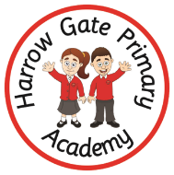
Welcome to Year 1
Your child is going to be 1SB. We cannot wait to get to meet you!
My new teacher is Mrs Best.  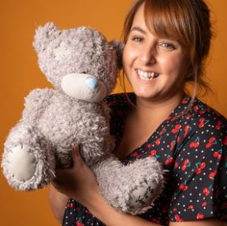 | The teaching assistant in year 1 is Miss Shaw.  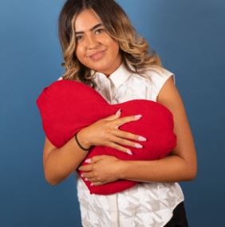
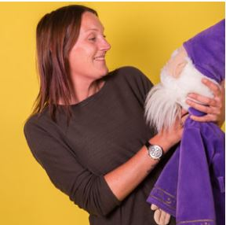
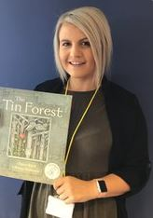
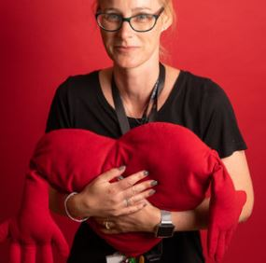
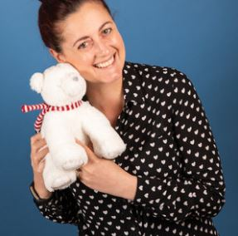

Other adults that work in year 1 are…
Miss Ward (Yr 1 teacher) Mrs Williams (Student Teacher),
Miss O’Hara and Mrs Green (TA)
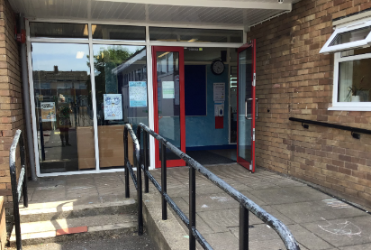  The door into school. | 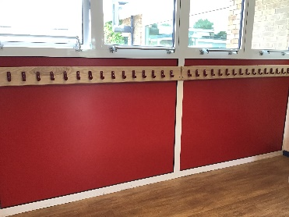  I will hang my coat here.
This is my new classroom.  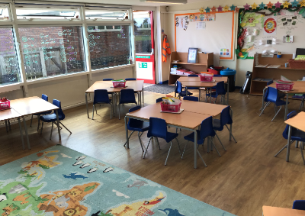 | 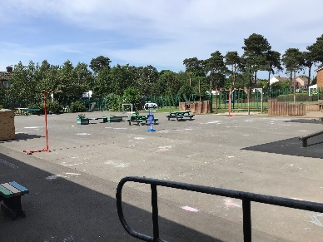  This is my playground.
The school door opens at 8.45am The end of the school day is 3pm
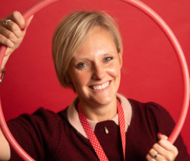

Mrs Galt- Principal Mrs Holloway – Vice Principal

