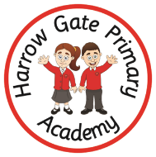
Welcome to Year 1
Your child is going to be 1SW. We cannot wait to get to meet you!
My new teacher is Miss Ward.  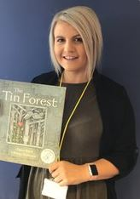 | 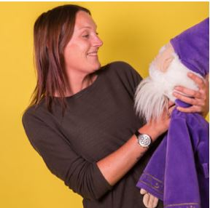  The teaching assistant in year 1 is Miss O’Hara.
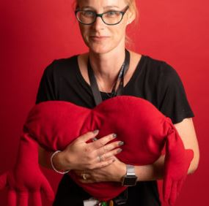

Other adults that work in year 1 are…
Mrs Best (Yr 1 teacher) Mrs Williams ( Y1 student teacher), Miss Shaw and Mrs Green (TA)
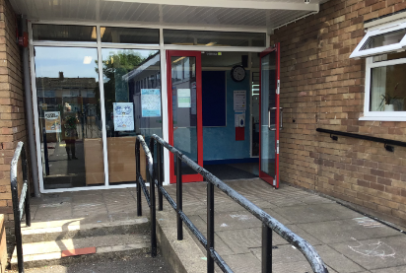  The door into school. | 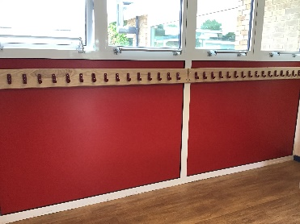  I will hang my coat here.
This is my new classroom.  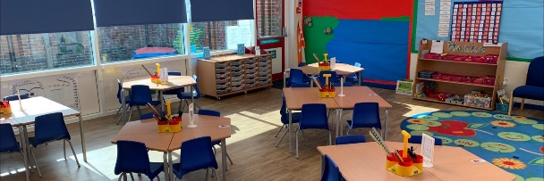 | 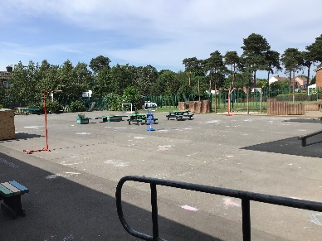  This is my playground.
The school door opens at 8.45am The end of the school day is 3pm
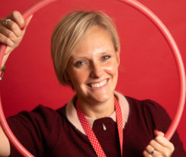

Mrs Galt- Principal Mrs Holloway – Vice Principal

