20.7.2020
*Once you have completed your work do not forget to show it on your profile.
 | Morning exercise | Session 1 | BREAK | Session 2 |  | Lunch | Session 3
Mon |  | Maths  Every day we will post some challenges on dojo for you to complete |  | English  Click on the link to reveal the questions:  https://www.onceuponapicture.co.uk/portfolio_page/above-the-sky/ | Phonics  Watch the phase 3 flashcards video: https://www.youtube.com/watch?v=aNcBWSBxSp0  This is important and must be done before any new learning.  Phonics Play – Picnic on Pluto |  | Science  Properties of materials  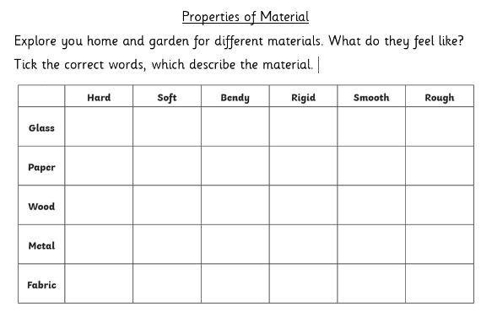  Explore you home and garden for different materials. What do they feel like?
Tue |  | Every day we will post some challenges on dojo for you to complete |  | Click on the link to reveal the questions:  https://www.onceuponapicture.co.uk/portfolio_page/said-the-stars/ | Watch the phase 3 flashcards video: https://www.youtube.com/watch?v=aNcBWSBxSp0  This is important and must be done before any new learning.  Phonics Play – Dragons Den |  | Make a postcard for a relative or friend and post it to them.
Wed |  | Every day we will post some challenges on dojo for you to complete |  | Click on the link to reveal the questions:  https://www.onceuponapicture.co.uk/portfolio_page/bear-and-cub/ | Watch the phase 3 flashcards video: https://www.youtube.com/watch?v=aNcBWSBxSp0  This is important and must be done before any new learning.  Phonics Play – Buried Treasure |  | PE  Cosmic Yoga  Or  Joe Wickes  Step master  How many steps can you achieve going on a walk with your family?  Don’t forget to send us your steps on portfolio.
Thu |  | Every day we will post some challenges on dojo for you to complete |  | Click on the link to reveal the questions:  https://www.onceuponapicture.co.uk/portfolio_page/night-and-day/ | Watch the phase 3 flashcards video: https://www.youtube.com/watch?v=aNcBWSBxSp0  This is important and must be done before any new learning.  Phonics Play – Choose a game |  | Mathletics  Complete any assigned tasks for the week.  Virtual tours  Have a look at the virtual tours on the school website. Where will you go?
Fri

