Your child will be in 2ED and the classroom teacher will be Miss Duncan

We are really looking forward to meeting you and your child and beginning our learning adventure together.

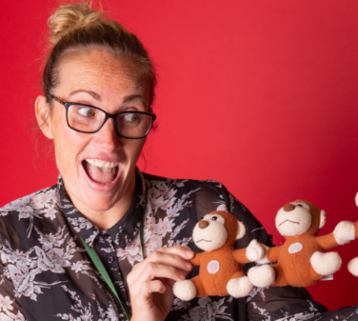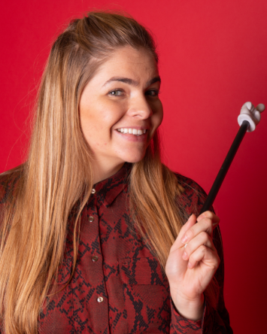

Mrs Bailey

Teaching Assistant

Mrs Shotton

Teaching Assistant

Miss Duncan

Year 2 Teacher

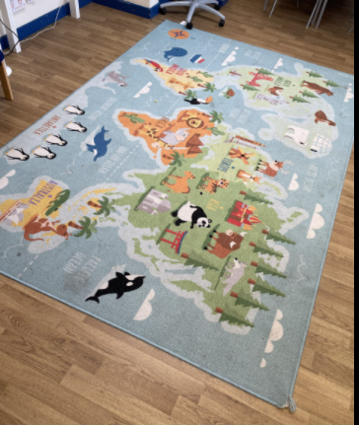

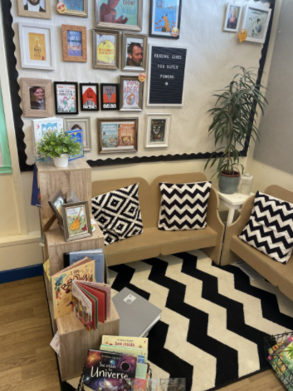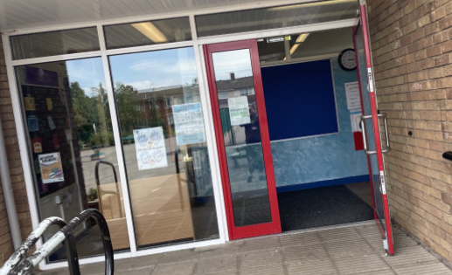

This is your carpet.

This is the door you will go into on a morning and leave at home time.

You will hang your coat here.

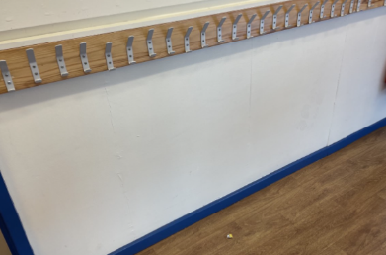

**School starts 8:45**

**School finished 3:05**

**We understand you may have other children to collect from other year groups.**

This is your reading area.

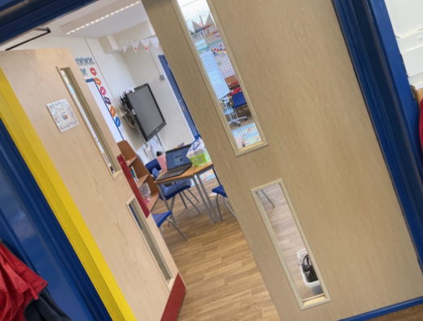

We look forward to seeing you all very soon!

This is your classroom.