Your child will be in 2RT and the classroom teacher will be Mrs Tash.

We are really looking forward to meeting you and your child and beginning our learning adventure together.

**Meet the team!**

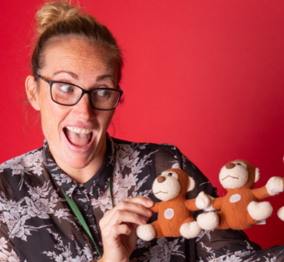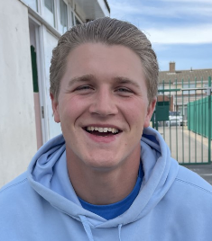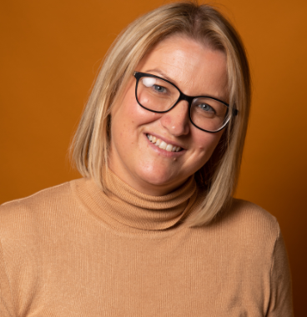

Mrs Shotton

Teaching Assistant

Mrs Bailey

Teaching Assistant

Mrs Tash

Year 2 Teacher

Mr Dalton

Student Teacher

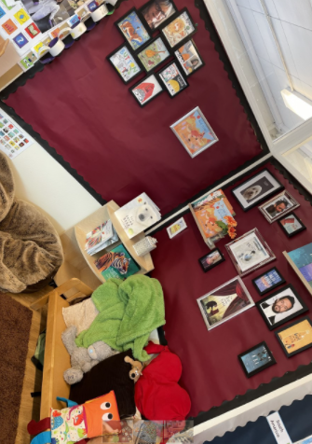

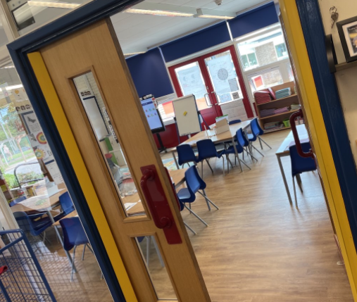

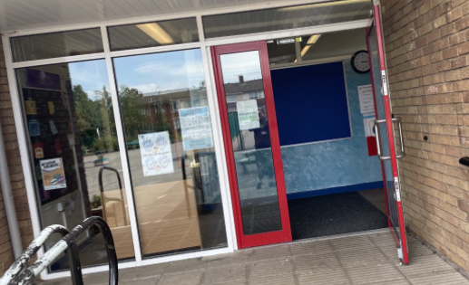

This is the door you will go into on a morning and leave at home time.

This is your classroom.

This is your reading area.

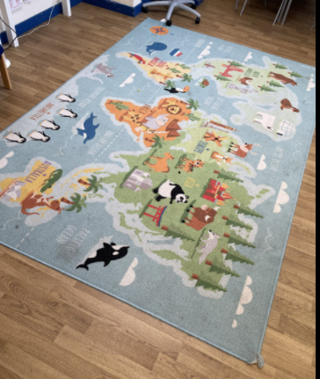

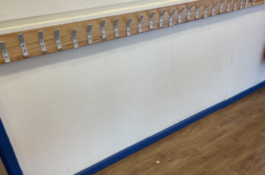

**School starts 8:45**

**School finished 3:05**

**We understand you may have other children to collect from other year groups.**

You will hang your coat here.

This is your carpet.

We look forward to seeing you all very soon!