Parents will,

* Let school know if your child is too unwell to complete any work via a Dojo message.
* Supervise children when using the resources specifically for home learning.
* When your child is writing their name, ensure they are holding the pencil correctly.
* Upload a photo of your child’s work onto Dojo.

Parents will ensure children

* Write their name using the name card/ handwriting pattern in the pack.
* Count from 0-20 then from 20-0.
* 10 minutes of reading.
* Listen to a story at least once a day. .
* Log onto Education City and complete your allocated activities over the 2 weeks.
* Practise writing the numbers 0-9.
* Sing the days of the week song <https://www.youtube.com/watch?v=3tx0rvuXIRg>

**Home Learning Expectations for Reception**

We expect your child to complete a little work every day whilst they are off school to isolate unless they are showing symptoms of Covid-19 and are too unwell to do so.

**School will,**

* Send a home learning grid and a grab bag of resources for the child’s home learning needs
* Organise weekly activities on Education City for the 2 weeks of absence
* Send topic and English related tasks on class dojo portfolio

**Keeping Fit - Cosmic Yoga**

<https://www.youtube.com/watch?v=xhWDiQRrC1Y>

**Sing the rhymes:**

Old Macdonald <https://www.youtube.com/watch?v=_6HzoUcx3eo>

5 Little Ducks <https://www.youtube.com/watch?v=pZw9veQ76fo>

1, 2, 3, 4, 5 <https://www.youtube.com/watch?v=9ir_l7qTiZ4>

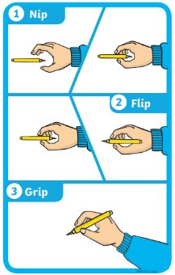

**Discuss the Weather and Season**

Discuss the weather. What do you observe happening outside? Do we have to take any measures against the weather? (Wellies and umbrella).

What changes can you see happening outside?



**Creative Activity**

Using your paints or colouring pencils can you draw your favourite fruit or vegetable?

**Play- dough challenge**

Can you use your playdough to make a model of something you would find on a farm?