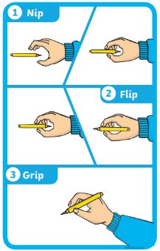

**Daily Practise!**

* Write my name.
* Count from 0-20 then from 20-0.
* 10 minutes of reading.
* Listen to a story.
* Log onto Education City and complete you allocated activities.
* Practise writing the numbers 0-9.
* Sing the days of the week song <https://www.youtube.com/watch?v=3tx0rvuXIRg>

**Reception**

**Home learning activities**

**Keeping Fit - Cosmic Yoga**

<https://www.youtube.com/watch?v=xhWDiQRrC1Y>

**Sing the rhyme:**

Old Macdonald <https://www.youtube.com/watch?v=_6HzoUcx3eo>

5 little ducks <https://www.youtube.com/watch?v=pZw9veQ76fo>

1, 2, 3, 4, 5 <https://www.youtube.com/watch?v=9ir_l7qTiZ4>

**Instructions**

* When your child is writing their

name ensure they are holding

their pencil correctly.

* Put a photo of your child’s

work onto their portfolio.

* All other activities will be put

onto Class Dojo.

**Discuss the Weather**

Discuss the weather and record on a daily weather chart- what is the temperature? Do we have to take any measures against the weather? (Sun lotion and a hat). 

**Creative Activity**

Using your paints or colouring pencils can you draw your favourite fruit or vegetable?

**Play- dough challenge**

Can you use your playdough to make a model of something you would find on a farm?