This is your weekly plan if you have a phonics book number 2
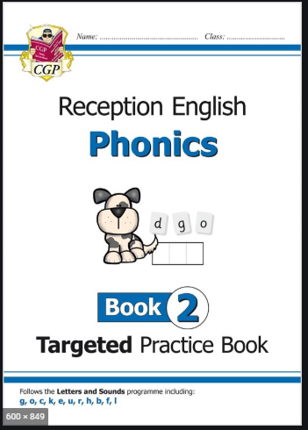
Everyday your child must;
Daily work out  https://youtu.be/JoF_d5sgGgc  Relaxation exercise  https://youtu.be/uyj5LooYWyg |  | Practice their;  - Handwriting card (name or patterns)  - Letter formation card (alphabet sheet)  - Number formation card | Sing the rhyme:  There are 2 rhymes this week  I’m a little bean and  beanstalk  Lyrics will be uploaded to class story on Monday  These are action thymes. You have to think of or follow actions for the words. |  | Discuss the Weather  Discuss the weather and record on a daily weather chart- what is the temperature? Do we have to take any measures against the weather?
 | Phonics/ Math |  |  | Power of Reading and Topic
Monday 13ht July | It is a phonics day  We are looking at the sound f we will revisit this as an initial sounds, the beginning.  - Recapping the sounds so far; try watching the video then turn the sound off and watch is again, asking your child to say the sounds as the lady points. https://youtu.be/cinTOCJZOtI Then try to learn your non decodable words. https://youtu.be/FMnqRAKz1q8  - Learning the f sound here is an alphablocks on the initial sound https://www.bbc.co.uk/iplayer/episode/b01dlvg5/alphablocks-series-2-12-fred |  |  | Use your creative accessories either paint, pencils, or pens to make a character.  This could be an animal, person, objects or even something make believe like a monster.
Follow up activity
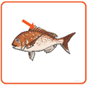
Please complete pages 36 and 37 of your phonics workbook at home. There is a game set for letter f on your child’s education city. Try to write these two words on your own, Answers; fan and fin.
Tuesday 14th July | It’s a maths day  - Mental and oral starter; counting from 0-20 then backwards from 10-0. Point to any number and have your child shout the answer.  - Main teaching; recognising all numbers to 10. Draw a hopscotch on the ground outside and then play with your child. If its bad weather draw a mini hopscotch on paper then roll a dice onto a number and move a counter that many spaces. |  |  | Topic time  I want you to think about if your character is;  A boy or girl  Name  Age  If they have friends or brothers and sisters  Who they live with  Ask your adults to write all the answers down.
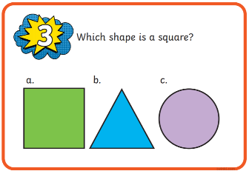
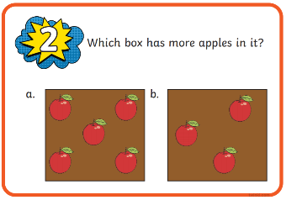
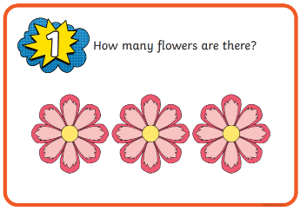
- Follow up activity; ask your child these questions using the cards below. If they struggle think of how to explain the concept to them.

Wednesday 15th July | It is a phonics day  We are looking at the sound l we will revisit this as an initial sounds, the beginning.  - Recapping the sounds so far; try watching the video then turn the sound off and watch is again, asking your child to say the sounds as the lady points. https://youtu.be/cinTOCJZOtI Then try to learn your non decodable words. https://youtu.be/FMnqRAKz1q8  - Learning the l sound here is an alphablocks on the initial sound  https://www.bbc.co.uk/iplayer/episode/b01dwf94/alphablocks-series-2-17-lips |  |  | Topic time  Make a model of your character using playdough, try to make it 3D rather then 2D and flat, do you need to begin with a ball, cube etc. can you talk to your adult about what you had to do first, then, next and last?
Follow up activity
Please complete pages 38 and 39 of your phonics workbook at home. There is a game set for letter l on your child’s education city. Try to write these two words on your own, Answers; laptop and leg.
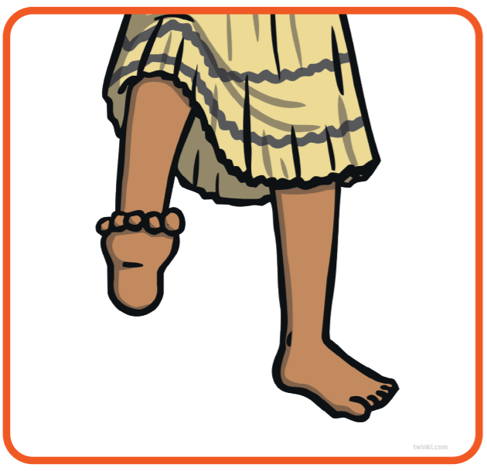
Thursday 16th July | It’s a maths day  - Mental and oral starter;  Using the number line on the number mat- have your child point to each number and count forwards then backwards again. Jump about on the spot and count verbally from 0-20 then back again 10-0.  - Main teaching;  Recap all the shapes you have learned so far/ use I spy game with the shalpes on the the maths learning mat, following the example of eye spy with my little eye something that has 4 sides all the same length and 4 corners.
 | 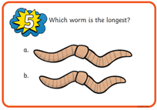  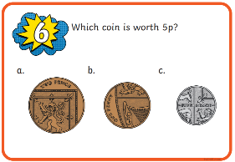  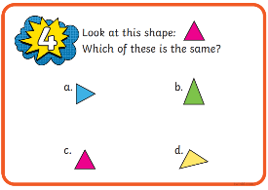  Follow up activity If they struggle think of how to explain the concept to them. |  |  | Topic time  Watch how the creator of this animation made his characters from playdough, all of them are little monsters which we have learned aren’t real. https://youtu.be/TonbD0TWGzU  Can you tell your adult how the characters are the same and different, can you think of names for any of them?
Friday 17th Juky | It’s a topic day  I want you to use junk model materials and made a setting for your character to live in. Remember a setting can be any place from a single room like the living room to an area like the woods. Which setting will you make? Can’t wait to see.  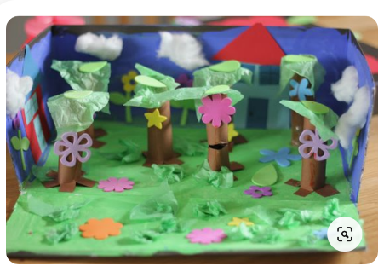  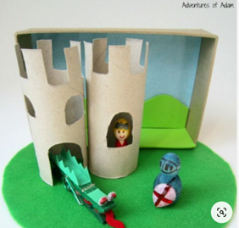  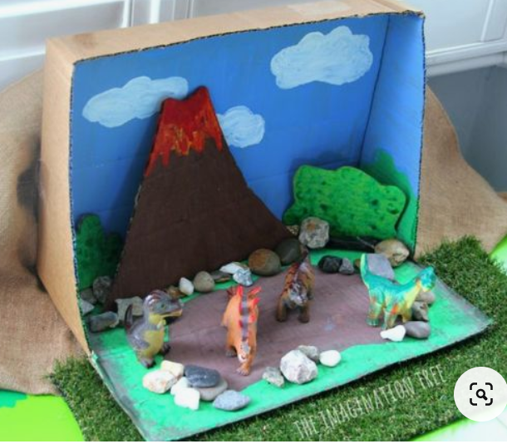
 | Phonics/ Math |  |  | Power of Reading and Topic
Monday 20th July | It is a phonics day  We are looking at the digraph ll, this happens either in a word or at the end. It is one sound made by two letters.  - Recapping the sounds so far; try watching the video then turn the sound off and watch is again, asking your child to say the sounds as the lady points. https://youtu.be/cinTOCJZOtI Then try to learn your non decodable words. https://youtu.be/FMnqRAKz1q8  - Learning the ll digraph here is an alphablocks on the initial sound  https://www.bbc.co.uk/iplayer/episode/b01dlx1t/alphablocks-series-2-13-hill |  |  | Now you have a character and a setting I want you to tell your adult the start of your very own story making up the key events yourself. You could even draw each development on your own story map, or even be an author and write a book.  One upon a time there was a … called… He/she/ it was out/in the (setting). When all of a sudden??? What will happen, this is just the beginning. Think of a problem that will happen to the character?
Follow up activity
Please complete pages 40 and 41 of your phonics workbook at home. There is a game set for letter ll on your child’s education city. Try to write these two words on your own, Answers; bell and doll.
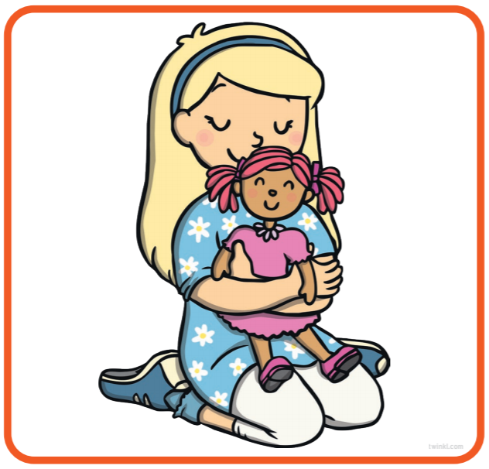
Tuesday 21st July | It’s a maths day  We are not going to continue with the maths books at home as they move onto numbers up to 20, some children aren’t ready for that until reception.  - Mental and oral starter;  Using the number line on the number mat- have your child point to each number and count forwards then backwards again. Jump about on the spot and count verbally from 0-20 then back again 10-0.  I point, you shout, you point to random numbers on the number line and then ask children to tell you what they are.  - Main teaching;  Thinking about amount, ask children to show you less than a number then more than that number then the same as that number, you can do this using showing fingers, counting objects like buttons and pasta. Tell them the number or show them the numeral written down. |  |  | Topic time  We are going to talk about the next part of the story, telling your adult and they can write it down, continue with the story map or book,  All of a sudden a … appeared! And helped the … by ….
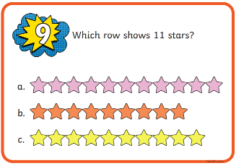
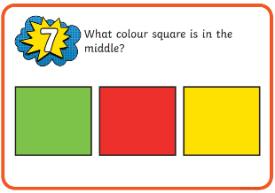
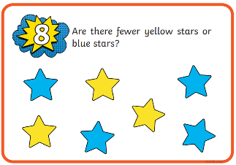
- Follow up activity If they struggle think of how to explain the concept to them.

Wednesday 22nd July | It is a phonics day  We are looking at the digraph ss, this happens either in a word or at the end. It is one sound made by two letters.  - Recapping the sounds so far; try watching the video then turn the sound off and watch is again, asking your child to say the sounds as the lady points. https://youtu.be/cinTOCJZOtI Then try to learn your non decodable words. https://youtu.be/FMnqRAKz1q8  - Learning all the diagraphs https://youtu.be/hPcl5i30IGI |  |  | Topic time  Continue with your story, all good stories have a twist! continue with the story map or book,  (the character) grabbed a … from (setting) and used it to…  They thought it was all over but then… happened.
- Follow up activity
Please complete pages 34 and 35 of your phonics workbook at home. There is a game set for letter ss on your child’s education city. Try to write these two words on your own, Answers; hiss and kiss.
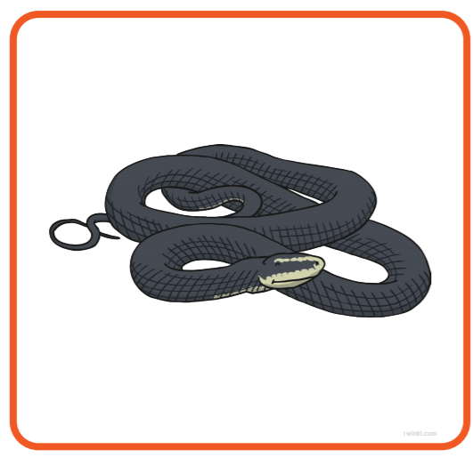
Thursday 23rd July | It’s a maths day  - Mental and oral starter;  Using the number line on the number mat- have your child point to each number and count forwards then backwards again. Jump about on the spot and count verbally from 0-20 then back again 10-0.  - Main teaching;  Following directions, using a room or an outside space as an obstacle course. Directing children around the space, move forward 3 jumps, walk between the pillows etc. Children love an obstacle course. If completing outside try using some string or wool to make it more interesting. Use the words, in, out, in between, side, below, above, next to, beside and under.  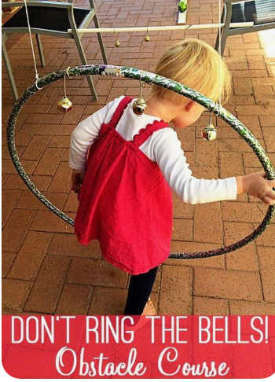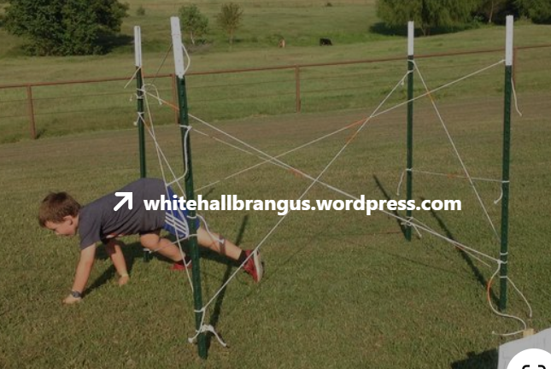 |  |  | Topic time  Continue with the story writing, continue with the story map or book,  by the end … (character) felt … and … but was pleased that… had happened  (the character) learned to… again.
Follow up activity; If they struggle think of how to explain the concept to them.
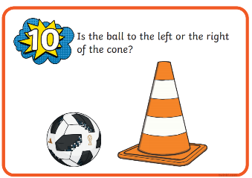
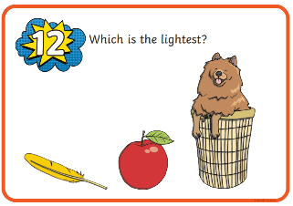
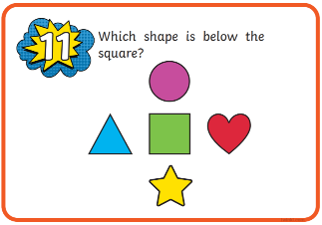

Friday 24th July | It’s a topic day  Use all the books you have in the house, or all the stories you know (this can include video and cartoons) make a list of all the different types of characters and all the different settings.

