Curriculum Protocol for Parallel Learning
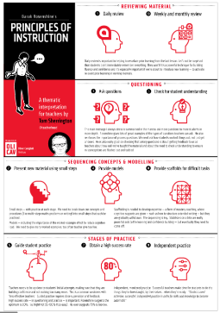
Teaching some children in school and some remotely presents us with a wide range of difficulties - but what we know about delivering a high-quality curriculum still applies.
Our ‘remote’ offer needs to be aligned with our ‘classroom’ offer. Sessions must be well sequenced and follow the pedagogies and practices children are familiar with in school.

English
Power of Reading
English sessions will follow CLPE Power of Reading as per ‘normal practice’. Texts and images can be shared on Class Dojo alongside instructions, tasks and questions. English ‘S planning’ will be adapted to suit remote learning as appropriate. This will ensure that we can continue to teach a high quality, broad and balanced English Curriculum. We can also ensure that teaching and learning mirrors, as much as possible, what children would benefit from if they were in the school building. The level of ‘blended learning’ for each POR session should be discussed in year groups to ensure maximum impact whilst managing workload. English lessons, for example, can be recorded using ‘Teams’ and then accessed by home learners as a teaching input. Children at home will continue to benefit from HGPA pedagogies as well as being able to hear class discussion and questions. Children will also be able to revisit the session as many times as is necessary to support their learning. Questions about viewed session can then be asked/answered using the class dojo platform.

Writing/Extended Writing
Opportunities for writing as identified in POR sessions will continue for all learners. Our writing tasks must continue to be authentic to ensure that children are engaged in their writing and can continue to develop and perfect their writing skills. Writing tasks will still vary, from short tasks (Role on the Wall) to extended writing tasks (diary entry). All children are au fait with the POR approaches and writing genres – they know exactly what is expected from them.

The use of drama and art should continue to be a hook into writing and the recorded Teams sessions will help children at home to be immersed in these sessions. Worked examples and scaffolds will still be provided to support writing and small group discussion/feedback could be offered using Teams where necessary.

Our aim is that outcomes in writing maintain the same high standards during this period of lockdown as they would in normal circumstances.

Punctuation and Grammar
Punctuation and grammar will continue to be taught, where possible, with in the context of chosen POR text. New learning can be taught using Teams and recorded for children accessing learning at home. Education City could be used to consolidate skills before/alongside writing tasks and there is often a brief teaching point before each activity – they are usually high quality explanations with a visual stimulus.

Handwriting
Handwriting should still be taught using Pen Pals and children should be given time to practise especially in EYFS and KS1. When children submit written work remotely we must ensure that we have high expectation and comment on this in our feedback.
We must strive for high standards for all children whether in school or learning at home.

Phonics and Early Reading
Phonic sessions should continue to follow the DFE Letters and Sounds Programme. In EYFS and KS1 phonics will continue to be taught daily and the DFE Letters and Sounds YouTube channel can be used to teach and reinforce all new and learnt GPCs. An activity to support application through decoding and encoding must also be set to allow children to experience success – this could be to read a closely matched Big Cat Letters and Sounds book or to complete an Education City/Phonics Play game.

We will continue to support emerging readers by reading 1:1 with the children using Teams. This is also a great opportunity to model reading support to parents and carers.

Reading
Reading will continue to be supported as outlined in our year group reading agreements. Collins EBook library will be used to hear 1:1 reading both in school and remotely. 1:1 reading should be carried out using Teams for those children who are not in school. In years five and six, reading can be supported in small groups using Teams and those children who access Reading Plus can continue to do this both in school and remotely. Year group reading commitments will remain unchanged in terms of how we support reading and feedback to parents and we should, where possible, strive to meet the agreed 1:1 ‘reading timeframes’. A timetable for 1:1/small group reading should be agreed by year group staff and support will be given by SLT should any issues arise – please just ask! Reading will continue to be underpinned the key pedagogies outlined in HGPA Reading on a Page.

Reading for Pleasure
Reading for pleasure is more important than ever through lockdown and offering children some comfort and escape through story continues to be high on our agenda. Every year group MUST offer a shared story, every day, where the whole class come together via Teams. This is to be recorded so that children can watch again or access later if unable to join. We can also signpost children to websites offering story telling such as CBBC and Oak National Academy. Offering advice on book choice becomes quite limited in lockdown but there are some high quality text and ‘classics’ included in the Collins Ebook library that children can be assigned.

Vocabulary Teaching
We will continue to ensure that teaching is language and vocabulary rich. The identification of words and phrases that require direct instruction should continue as outlined in HGPA Vocabulary on a Page document as should the use of vocabulary organisers.
Marzano’s ‘Six Steps to Effective Vocabulary Instruction’ can still be followed when teaching vocabulary remotely.
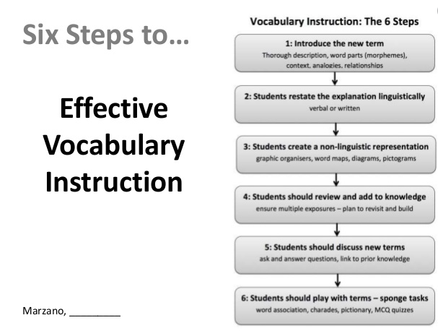

Spelling
Spelling instruction will continue as outlined in ‘Spelling at Harrow Gate’ document. Explicit teaching including detailed study of letters in each word/ spelling pattern/rules will be shared on a Monday. This can be recorded so that children can re-watch and daily practise must be encouraged if children are not in school. There are some activities on Education City/Spelling Frame that teach spelling patterns well and are followed by an application activity - so take a look in your year group. Children in school will be given their usual practise session. There will continue to be a spelling quiz on a Friday for all children. When marking written work please remember to ask children to correct all taught high and medial frequency words and spelling patterns taught so far – this might look different for you SEND children.

Maths
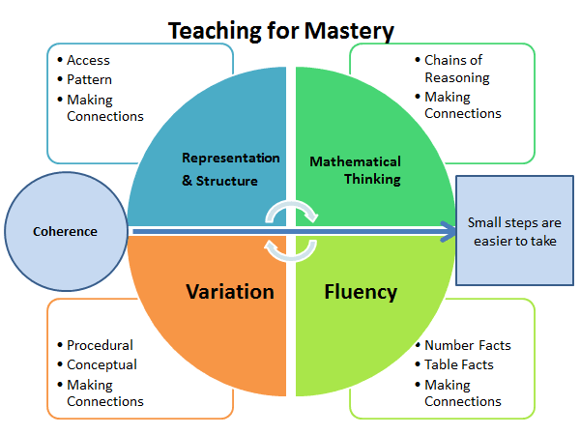
All children will continue to follow the agreed HGPA principals and pedagogy for teaching maths. Our curriculum is based on a ‘mastery’ approach underpinned by the ‘big five ideas’ of mastery, as defined by the NCETM. They are as follows:

The White Rose Maths Scheme of Learning has identified the order and length of time for each curriculum block in KS1 and KS2. An ‘S’ Plan should be constructed at the start of each curriculum block during PPA time. The most important aspect of this stage is the discussion about pedagogy between the professionals and how aspects translate from class to home learning.

Interleaving:
Although we ‘block’ our curriculum, links should always be made with the whole of mathematics and identified gaps from Lockdown 1. Remember, the ‘Flashback 4’ from White Rose is good but they do not know our children or where their gaps are. Use them where appropriate.

Home Learners
All home learners should be accessing the DNA that you have prepared for your class. To make this as straight forward as possible, prepare 5 DNAs that you are using in class and share all 5 for the week on portfolio in one post.
The White Rose workbooks are to be completed by the children and work shared on their portfolio once completed. It is essential that the children’s work is marked and feedback given to support and challenge. Teams is to be used for precision intervention or to provide group support where a need is identified.
Continue to challenge those more able children by sharing additional tasks where appropriate - investigations, missing digits, SSDD.

School learners:
The HGPA agreed maths lesson structure must be followed for the children in school:
Generally, a lesson will take the following structure:
• Rapid Recall Y1 – Y4 / Times Tables Y5 – Y6
• Do Now Activity – recap prior learning
• New Learning – age related expectations
• Fluency
• Reasoning
• Problem solving
• Dong Nao Jin – challenge at Greater Depth FOR ALL

Additional challenges should be available for those children you identified as potential GDS. These challenges are to be recorded in their Maths books. Marking and feedback must be carried out as per the school policy.

The HGPA Curriculum
Our curriculum is created around ‘schema-building’: that every student is piecing together ideas, information, experiences and concepts to form a coherent web that constitutes their understanding and fluency with the material in hand. A key element in the learning process as viewed through this model, is that students need to build on prior knowledge.

All subjects must continue to follow the HGPA long term plan and detailed ‘S’ planning will ensure that all children’s learning / outcomes is considered and appropriate. Teachers must ensure that they are:
- Making learning sufficiently broad and generative to allow secure schema-building at a conceptual level to take place, building on prior knowledge, linking elements of knowledge into a coherent whole, before engaging in too much retrieval practice for individual elements.

- Constructing activities so that all students can do this at the same time, including opportunities for all students to run through what they know and understand.

SEND
Schools have a responsibility to make best endeavours to continue to support children with SEND in meeting their desirable outcomes even in these current circumstances. Our ‘remote’ SEND offer is required to meet the needs that are highlighted and supported through each child’s individual Graduated Approach by adopting small, manageable adaptions to delivering the necessary support and provision in the home.

Putting things in context
Some of the challenges that SEN learners face may be made worse at this time. So for example, dealing with numerous tasks demanding attention, a lack of structure or routine, or feeling isolated from peers and teachers, could exacerbate a child’s SEN diagnosis.
However, some of the barriers to learning which exist for SEN learners may have been reduced or removed entirely. Now that learners are working remotely, they may not have to deal with social pressures, busy and potentially overwhelming learning environments, meeting deadlines or dealing with inaccessible classrooms or corridors.
SEND learners have an opportunity to reflect on what works for them as learners, to focus on their strengths and their metacognition. They can have more control over where or when they work, the pace they choose to work at and how they adapt their environment to support work (with teacher/TA and parent support).

Graduated Approach Plans cycles will continue, with plans taking the current context into account.

Non-Negotiables for all SEND learners
Be specific
The potential for information overload can be really overwhelming and make it hard to know where to start or how to identify the most useful information.
- Make sure information is clear and specific with clear examples of expectations.
- Break information and tasks into smaller and more manageable chunks and steps. This approach can be very motivating as children can easily see the progress they are making. It can reduce the feelings of being overwhelmed.
- Consider using bullet points, space on the page and bold text to make information accessible and easier to navigate.
- Highlight critical information or instruction so they don’t get missed or overlooked.
- Consider carefully what you want the outcome to be for the child in order for them to demonstrate learning. If a short paragraph would allow them to demonstrate learning then do they need to write a page of writing? Be clear with the child about what outcome you are expecting.
- Where possible use routine activities but change the learning focus – support the feeling of predictability and familiarity.

Provide learning resources
Many children with SEND in school rely on the tools, resources and models that we make available. We need to transfer this into the home
- Make an online resource pack – sound mats, word mats, number lines etc.
- Provide scaffolds for writing- sentence openers, a modelled good example, topic word mats etc

Recorded or live session
Try to limit the length of each session delivered to children with SEND. An hour lesson for example is much harder to concentrate on when viewing online. Therefore, identifying the key concepts and points that you would like learners to retain is important and sometimes a ‘less is more’ approach and a shorter session can be more powerful. Shorter videos, which emphasise the key concepts or ideas, can be useful and this can really allow student to focus on the key points in a shorter time.

Flexibility
- Where possible incorporate activities, which are flexible and offer choice in terms of how a child can demonstrate their learning i.e. a poster, a short paragraph, a presentation, labelled illustration. All of those will give the child greater variety.
- Allow/ encourage children to work on tasks in an order that they can face or that feels natural to them and working flexibly in this way can increase productivity and output.
- Support/ encourage children/parents to set a workable, flexible timetable that allows for the fact that motivation can fluctuate i.e. it can be better to set a goal of doing four half hour sessions across the day.
- Encourage children to reflect on how the environment is when they do their best work; when they have increased concentration, motivation and focus. They can then be mindful of the small changes they can make to support their learning.

Stay in touch
- Reassure them that you are happy to help and answer any questions they may have about their work.
- Reach out to parents/ carers too. This is likely to be a stressful time for all presents, but for those with a child or children with special needs, it could be even more so. Be on hand to offer advice, or just a listening ear.
- Some children with autism find homework difficult at the best of times. They can be fixed in their thinking: school is for work and home is for relaxation. This could be very challenging for parents. If you feel the parents needs more support than you have been able to offer then direct them to the Inclusion Team.

Recap, revision and recall
Children with SEND often require opportunities for over learning and revisiting to ensure that learning is embedded. Provide opportunity for children to recap, revisit and recall previous learning.
- Simple multiple choice quizzes – Kahoot could be used
- Matching vocabulary to pictures
- Specific DNA task Etc.

Interventions
Staff need to make every effort to find ways and means to continue the interventions that are part of the usual provision planned in order to meet the needs of children with SEND.

Early Reading interventions such as Word Wasp, Toe by Toe, Alpha Omega, ATTACK Read and Spell, bespoke Letters and Sounds teaching are to be delivered through the use of Teams with the support of the Inclusion Team where necessary.

Children with identified reading difficulties need the opportunity to read 1-1 with a skilled adult through Teams. The number of times that the child needs to be heard to read needs to be agreed with the SENCO for each individual case. The children need to access the same book at home through the Collins Ebook library for a week (as per the school reading policy).

For children with identified motor development difficulties, staff are responsible for sharing appropriate activities through dojo for the child to do in the home i.e. sharing a list of gross or fine motor exercises appropriate to the needs of the child with the child choosing one to practise each day for 10 minutes, directing the child to Go Noodle activities or approrpiate You Tube exercise links etc.

Specific individual speech and language interventions delivered through Teams in the Early Years following the programmes in place in school: specific speech sound work, Colourful Semantic intervention.

Feedback and assessment
Harrow Gate will continue to follow the curriculum as it is set for the academic year. The Harrow Gate curriculum is a progressive model that builds scheme year on year. Children will be given these building blocks both at home and at school.
The use of the Harrow Gate Marking and Feedback policy applies to all children who continue to attend school. Teachers and teaching assistants respond to children’s posts on profile with feedback that supports and extends for their next steps in learning.
It is very important that the progress of pupils is monitored and recorded. This will enable gaps in learning to be clearly identified and support the process of baselining and a ‘catch up’ curriculum when the children return to school.
Assessment will be completed for all children, at school and at home. An acknowledgment of ‘1’ will be used against objectives that children have accessed – at home or school. Teachers must be mindful that scores of 2 /3 you must be secure that the child has accessed this objective independently and is confident.

