Key Diagram
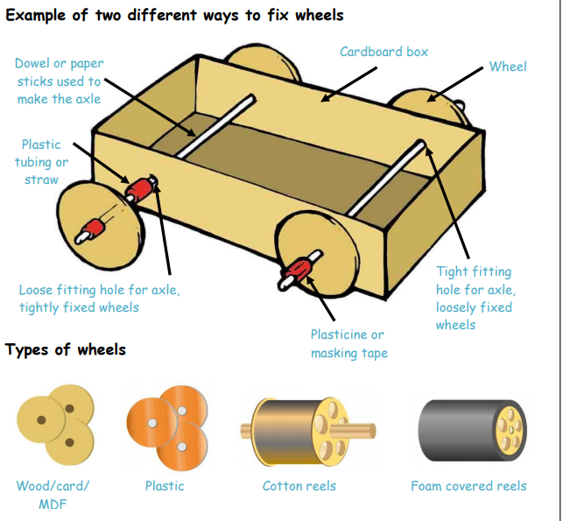
Vocabulary
axle | A rod that enables a wheel to rotate. The wheel can rotate freely on the axle or be fixed to, and turn with the axle.
axle holder | the component through which an axle fits and rotates.
chassis | the frame or base on which a vehicle is built.
friction | resistance which is encountered when two things rub together.
dowel | wooden rods used for making axles to hold wheels - circular object which forms a part of a machine. Usually a moving part.
vehicle | a thing used for transporting people or goods, such as a car or bus.
cab | the area of a vehicle where the driver sits.
assemble | to fit together separate component parts of a machine.
component | a small part of a larger whole (machine).
mechanism | part of a machine that performs a certain job (function).
design | a plan or a drawing showing an object that will be made
evaluate | to form an opinion of something
purpose | the reason for which something is made.
user | a person who uses something
functional | being useful or practical

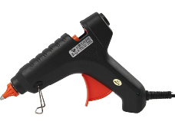
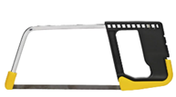
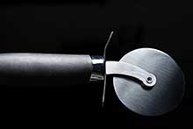
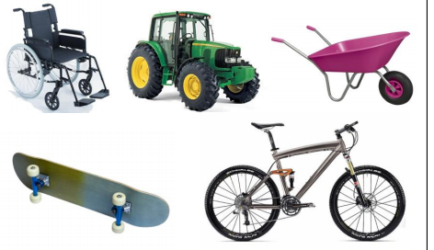

Key Information
1. | Definition of a wheel – a circular object which forms part of a machine. Usually a moving part.
2. | Definition of an axle – a rod or bar that runs through a hole in a wheel.
2. | When you use an axle the wheel then spins in a balanced circle. (Wheels generally spin in a balanced circle around an axle like a bike)
4. | The first wheels were likely made from wood or stone, depending on the materials available.
5. | Doorknobs, pizza cutters, pencil sharpeners and even electric fans all use wheels and axles.

