Exclusion Policy

The Enquire Learning Trust
Believe, Persevere, Achieve

Contents

1. | Legislation | 3
2. | Definitions used in the Policy | 3
3. | Context | 3
4. | Principles | 4
5. | The Power to Exclude | 4
6. | Informing parties about an exclusion | 5
7. | The Academy Improvement Committee duty to consider an exclusion | 6
8. | The Trust’s duty to arrange an independent review panel | 6
9. | Appeal | 6
10. | Appendix A- Prevention- a thought process | 7
11. | Appendix B- Prevention- Analysing behaviours | 8
12. | Appendix C- Transition- sharing information | 12

Version History

Date | Author | Version | Comment
Sep 18 | JH | 1
July 19 | JH | 2
Sep 20 | JH | 3
July 21 | JH | 4

1. Legislation

This policy is compliant with the following legislation:
- The Education Act 2002, as amended by the Education Act 2011;
- The Academy Discipline (Pupil Exclusions and Reviews) (England) Regulations 2012;
- The Education and Inspections Act 2006; and
- The Education (Provision of Full-Time Education for Excluded Pupils) (England) Regulations 2007

2. Definitions used in the Policy
Use of term ‘parent’ within this policy.
In addition to the pupil's birth parents, references to parents in this policy include any person who has parental responsibility (which includes the local authority where it has a care order in respect of the pupil) and any person (for example, a foster carer) with whom the pupil lives.
Use of the word ‘term’ within this policy
Where the academy year consists of 3 terms or fewer, a reference to a ‘term’ in this policy means one of those terms. Where the Academy’s academic year consists of more than 3 terms, then a reference to ‘term’ means the period falling between: 31 December to Easter Monday; Easter Monday to 31 July; or 31 July to 31 December.

3. Context
The Enquire Learning Trust (hereafter referred to as the Trust) recognises that in order to ensure a positive atmosphere based on a sense of community and shared values it may, on occasions, be necessary to exclude an individual or individuals either for a fixed period, not exceeding forty five academy days in any one academic year, or, in some circumstances, permanently.
Such exclusions will only be resorted to when the academy can demonstrate with adequate evidence that all reasonable steps have been taken (including education off site) and/ or that the presence of the learner is likely to be severely detrimental to his/herself, other learners or employees. There may also be occasions when a short-term exclusion is appropriate because of unacceptable behaviour.
Good discipline in academies is essential to ensure that all pupils can benefit from the opportunities provided by education. The Trust supports its academies in using exclusion as a sanction where it is warranted. However, permanent exclusions should only be used as a last resort, in response to a serious breach, or persistent breaches, of the Academy's Behaviour Policy; and where allowing the pupil to remain in the academy would seriously harm the education or welfare of the pupil or others in the academy.

4. Principles
The academy will not discriminate against pupils on the basis of protected characteristics, such as disability or race and will give particular consideration to the fair treatment of pupils from groups who are vulnerable to exclusion.
Disruptive behaviour can be an indication of unmet needs. Where there are concerns about a pupil’s behaviour the first steps will be to identify whether there are any causal factors and intervene early in order to reduce the need for a subsequent exclusion. The Academy will give consideration to a multi-agency assessment that goes beyond the pupil’s educational needs.
All pupils who return to the academy following a fixed period exclusion will be subject to a re-integration process that will include a meeting with the parent and pupil prior to their return to their class. This meeting will include an agreement with the pupil on managing their future behaviour.
The academy will take reasonable steps to set and mark work for pupils during the first five Academy days of exclusion and will arrange alternative provision from the sixth day.
Where parents dispute the decision of the Academy Improvement Committee / Trust not to reinstate a permanently excluded pupil, they can ask for this decision to be reviewed by an independent review panel to be arranged by Trust. Where there is an allegation of discrimination (under the Equality Act 2010) in relation to a fixed-period or permanent exclusion, parents can also make an appeal through the Trust’s Complaints Policy.
All parents have the right to request the presence of a SEN expert at an independent review panel. The SEN expert’s role is to provide impartial advice to the panel about how SEN could be relevant to the exclusion;

5. The Power to Exclude
Only the Principal of the academy can exclude a pupil and this must be on disciplinary grounds.
A pupil may be excluded for one or more fixed periods (up to a maximum of 45 Academy days in a single academic year), or permanently.
Pupils whose behaviour at lunchtime is disruptive may be excluded from the academy premises for the duration of the lunchtime period. This constitutes a half day exclusion.
The behaviour of pupils outside academy can be considered as grounds for exclusion.
The Principal may withdraw an exclusion that has not been reviewed by the Trust.
The academy will take account of their legal duty of care when sending a pupil home following an exclusion.
The academy will use the civil standard of proof, i.e. ‘on the balance of probabilities’ when making judgments in relation to exclusions.
The academy will not make use of ‘informal’ or ‘unofficial’ exclusions, such as sending pupils home ‘to cool off’. Any exclusion of a pupil, even for short periods of time, will be formally recorded. A decision to exclude a pupil permanently will only be taken:
- In response to a serious breach, or persistent breaches, of the academy's behaviour policy; and where allowing the pupil to remain in academy would seriously harm the education or welfare of the pupil or others in the Academy. The academy will take account of any contributing factors that are identified after an incident of poor behaviour has occurred. For example, where it comes to light that a pupil has suffered bereavement has mental health issues or has been subject to bullying.

All exclusions must be recorded on SIMS and with the Chief Admin Officer.

6. Informing parties about an exclusion
Whenever a pupil is excluded, the academy will notify parents of the period of the exclusion and the reasons for it as soon as is immediately practical. In addition, the academy will provide parents with the following information in writing:
- the reasons for the exclusion
- the period of a fixed period exclusion or, for a permanent exclusion, the fact that it is permanent
- parents’ right to make representations about the exclusion to the Academy Improvement Committee and Trust and how the pupil may be involved in this
- the start date for any provision of full-time education that has been arranged for the pupil during the exclusion
- In addition, the Academy will draw attention to relevant sources of free and impartial information including:
- a link to DfE statutory guidance on exclusions: exclusions guidance (Exclusion from maintained Schools, Academies and pupil referral units in England from September 2012)

- a link to the Coram Children’s Legal Centre: www.pupilrenslegalcentre.com 08088 020 008
- The Principal will, without delay, notify the Academy Improvement Committee, Trust and the Local Authority of
- a permanent exclusion (including where a fixed period exclusion is made permanent);
- exclusions which would result in the pupil being excluded for more than five Academy days (or more than ten lunchtimes) in a term; and
- exclusions which would result in the pupil missing a public examination or national curriculum test. For all other exclusions the Principal will notify the local authority, Academy Improvement Committee and the Trust once a term.
- For a permanent exclusion, if the pupil lives outside the local authority in which the Academy is located, the academy will also advise the pupil’s ‘home authority’ of the exclusion without delay.

7. The Academy Improvement Committee duty to consider an exclusion
The Academy Improvement Committee, under delegated powers from the Trust, will consider parents’ representations about an exclusion. Those invited to this meeting will include:
- parents;
- the Principal
- 3 members of the Academy Improvement Committee
The Academy Improvement Committee will make every effort to arrange this meeting for a date and time convenient to all parties.
Where there is a fixed period exclusion which brings the pupil's total number of days of exclusion to more than five in a term, the Academy Improvement Committee must be informed. The AIC must consider any representations made by parents but cannot direct reinstatement and is not required to arrange a meeting with parents.
In reaching a decision on whether or not to reinstate a pupil, the Academy Improvement Committee will consider whether the decision to exclude the pupil was lawful, reasonable and procedurally fair, taking account of the legal duties of the Academy Leadership.

8. The Trust’s duty to arrange an independent review panel
If applied for by parents within the legal time frame, the Trust will arrange for an independent review panel hearing to review the decision of the Academy Improvement Committee not to reinstate a permanently excluded pupil.
The legal time frame for an application is:
- Within 15 Academy days of notice being given to the parents by the Academy Improvement Committee of their decision to uphold a permanent exclusion or
- Where an application has not been made within this time frame, within 15 Academy days of the final determination of a claim of discrimination under the Equality Act 2010, in relation to the exclusion
- Any application made outside of the legal time frame will be rejected by the Trust

9. Appeal
- Parents should put in writing to the Clerk to the Academy Improvement Committee if they wish to appeal against the Academy Improvement Committees decision. Details can be obtained from the individual academies.

Appendix A - Prevention
Any form of exclusion is a last resort. Principals and Academy Improvement Committees (AICs) must be assured that all reasonable measures have been taken to support every pupil. The following chart sets out a range of points to consider before administering any exclusion:

Preventing Fixed Term Exclusion:
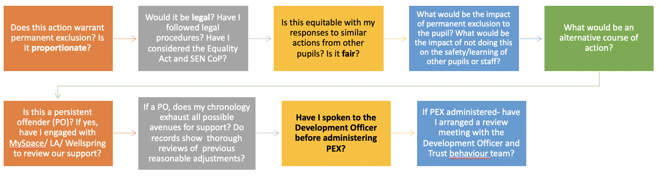

Preventing Permanent Exclusion:

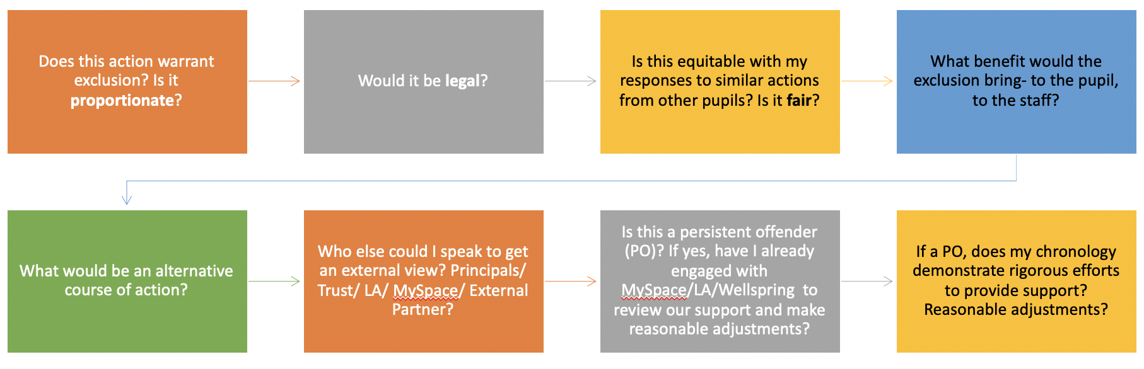

Appendix B- Prevention- Analysing Behaviours
The ABC of Behaviour
This is a useful way of thinking about why a child is behaving in a certain way. It starts with the premise that the majority of behaviour is rational. It is optimistic – if a behaviour has been learned, it can be unlearned. The ABC model suggests that behaviour can be understood in terms of:

Antecedents:
What happened immediately before the misbehaviour, the events that led up to it?
What was the provocation, who did or said, or did not say, what?
What was the setting for the behaviour? Is it always at the same activity, with the same child, or children?
Does it always happen at certain times of the day or on the same day of the week? (Does it happen regularly on a Monday after weekend visits with an estranged parent?)

Behaviour:
What precisely did the child do?

Consequences:
What happened as a result of the behaviour? How was the problem dealt with?
What did the others do?
How did they react?
Remember that the consequences might be reinforcing the undesirable behaviour, for example, gaining adults’ attention, peer approval, avoiding disliked activity.
The main question to ask is ‘what is the child getting out of behaving like this?’
Teaching incompatible skills
This should be the first strategy to consider when attempting to manage challenging behaviour. The most effective, and least restrictive, way of dealing with any kind of disruptive behaviour is attempting to increase the frequency of any kind of activity that is in opposition to the problem behaviour.
REMEMBER – Whatever strategies you use to manage inappropriate behaviour you must be consistent in your approach.

CPOMs should be used to develop a chronology of support. The narrative of this chronology should follow the Plan-Do-Review cycle and demonstrate that reasonable adjustments have been made to support improvements in behaviour. This should include evidence of seeking support beyond the immediate academy where possible.
The following charts may be useful when analysing the behaviour/s of specific pupils.

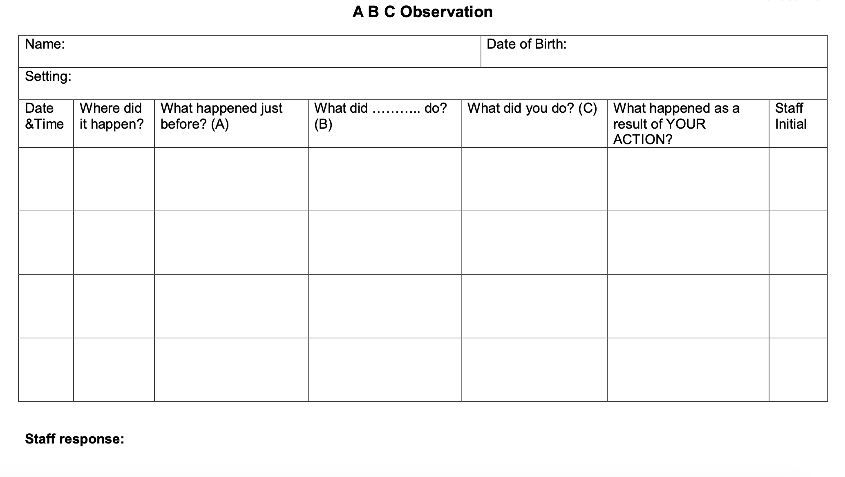
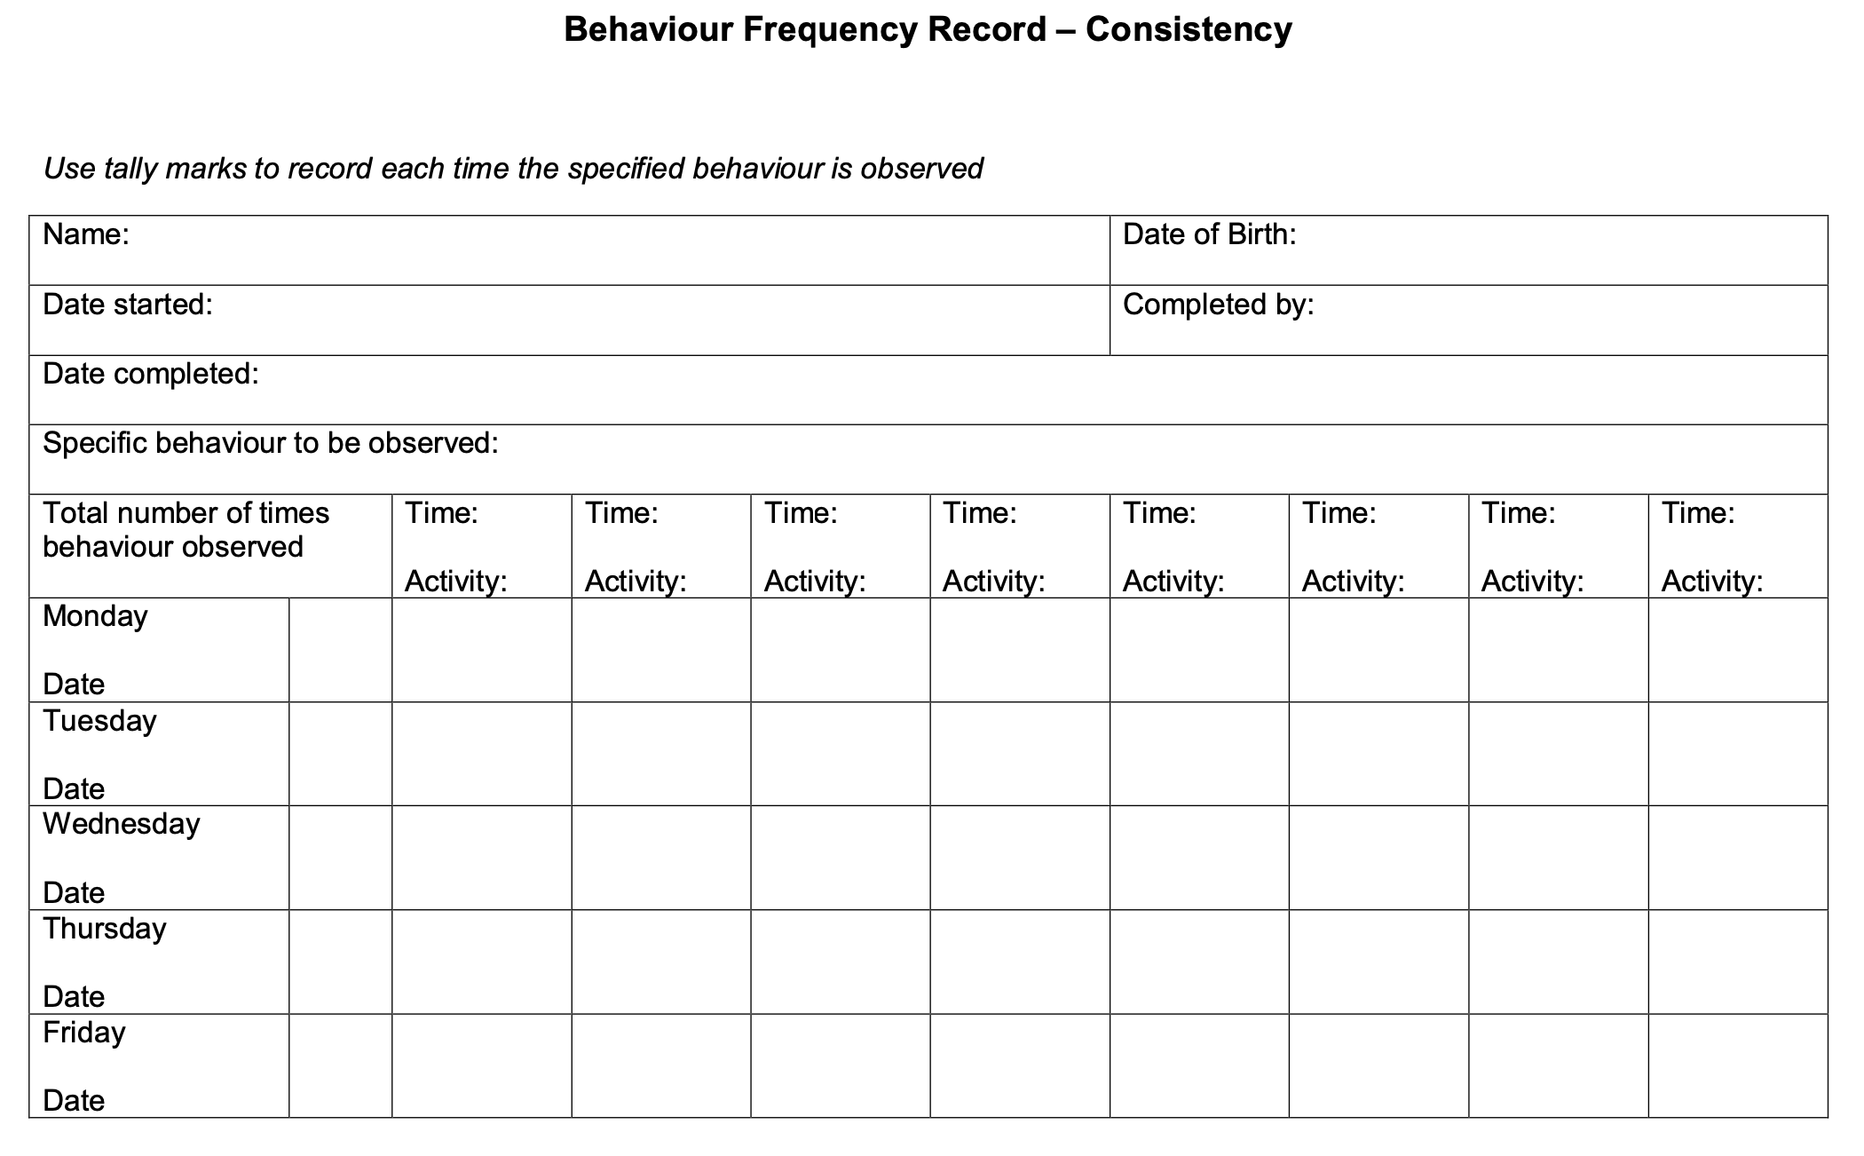
Appendix C- Exclusions - Transition Information

Behavioural Transition Information

Academy
Pupil’s full name
Date of PEX/FTE/s
Date of birth |  |  | Year group
If LAC which Local Authority? |  | Social Worker
Ethnicity
Language(s) spoken
Will the family require an interpreter for induction meeting? | Yes |  | No
FSM eligibility | Yes |  | No
In receipt of Pupil Premium | Yes |  | No
Attendance %
Punctuality
Name of Lead Professional if CAF in place |  |  | Date of CAF review:
CIN  C.P. | Yes  Yes | No  No | Comments:
Reason(s) for exclusion
Details of persistent disruptive behaviour (if applicable)
Identified triggers for behaviours
Details of relationships with peers
Details of relationships with staff
Full details of support strategies used to support the pupil and their effectiveness
What should staff avoid?
Pupils’ strengths and interests
What works?

Details of any SEN/Medical needs and any medication:
Hearing/visual
Speech, language, communication
Specific leaning difficulties
Autistic spectrum disorder
Attention Deficit Hyperactivity Disorder
other
Details of academic attainment:  Subjects | Reading: | Writing: | Mathematics:
Support services involved:
Educational Psychology
Social Care
Healthy Young Minds
Youth Offending Team
BLISS
MST
Other
Any other relevant information

