Key Dates
23rd Sep – 21st Dec | Autumn
21st Dec – 20th March | Winter
20th march – 21st June | Spring
21st June – 23rd Sept | Summer
21st Dec | Winter Solstice
21st June | Summer Solstice

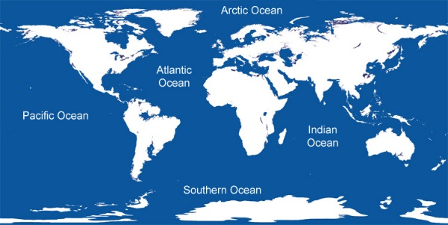
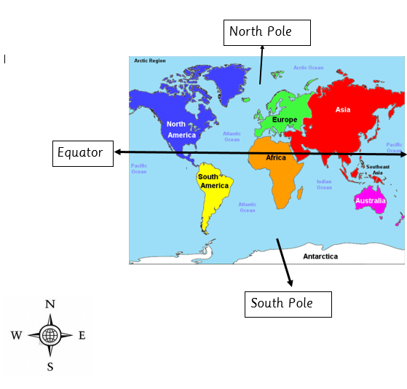

Key Information
1. | Know the location of the seven continents: North American, South America, Africa, Asia, Europe, Australia and Antarctica
2. | Know the location of the five oceans: Pacific, Atlantic, Indian, Southern and Arctic
3. | Know the names and timings of the four seasons:  Autumn, Winter, Spring and Summer
4. | Know the location of the four countries of the United Kingdom:  England, Northern Ireland, Scotland and Wales
5. | Map Knowledge:  Equator, North Pole, South Pole and the four compass points.
6. | Weather types and Vocab e.g. Lightning, blizzard.

Vocabulary
Equator | It divides Earth into two equal parts: the Northern Hemisphere and the Southern Hemisphere.
Seven continents | North America, South America, Europe, Africa, Asia, Australasia and Antarctica.
5 Oceans | Pacific, Atlantic, Indian, Southern, Arctic
UK countries | England  Northern Ireland  Scotland  Wales
North/South poles | The North Pole is the northern end of Earth’s axis.  The South Pole is the southern end of Earth’s axis.
Winter Solstice | Shortest day of the year
Summer Solstice | Longest day of the year
Lightning | A bright flash of electricity produced by a thunderstorm.
Blizzard | A storm with blowing snow with low visibility, lasting at least 3 hours.
Celsius | A scale for measuring temperature
Cloud | A large collection of tiny droplets of water or ice crystals.
Fog | Like a cloud, but it is near the group, not high in the sky.
Forecast | A prediction of the weather
Frost | A light, white covering of dew or water vapour frozen into ice crystals.
Freeze/Frozen | Water harden to ice from cold temp
Hurricane | A large rotating storm, with high wind speeds that form over warm waters and in tropical areas.
Tornado | A rotating column of air extending from a thunderstorm to the ground.

