Harrow Gate Primary Academy
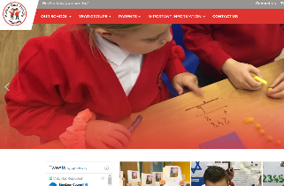
Home Learning Expectations
Harrow Gate Primary Academy are using two ways to communicate home learning to our families:
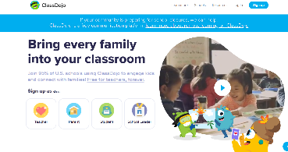
School website: https://www.harrowgateacademy.org/
Class Dojo: https://www.classdojo.com/

School will:
- Provide each child with the equipment needed to record their home learning: IPad / workbooks / stationary
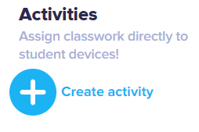
- Ensure that resources are available at the beginning of each week on the school website https://www.harrowgateacademy.org/
- Set activities for children on ‘Class Dojo’, Education City, Mathletics and Timestable Rockstars
- Ensure the children receive a full broad and balanced curriculum that is in line with teaching in school.
- Have daily contact with the children through ‘class dojo’
- Class teachers and teaching assistants will support children in their activities and give feedback on their profile posts.
- Provide updates to parents through ‘Class Dojo’ school story and Twitter
Parents will:
- Ensure school equipment is supervised
- Ensure that they log into ‘Class Dojo’ daily
- Ensure your child has access to their home learning through Dojo and the school website https://www.harrowgateacademy.org/
- Ask for support and advice from Harrow Gate staff in order to help their child.
- Contact school if unable to access learning
- Ensure your child posts their work onto their ‘Dojo’ profile
Children will:
- Look at the school website and class dojo every day to find out their home learning activity.
- Complete the work set and show this to their teacher through their ‘Dojo’ Profile
- Use their IPad, schoolbooks and pencils to show their ‘best’ learning.
- Take pride in their learning.
- Talk to their teacher and other Harrow Gate staff through ‘dojo’.
- Ask for help from the teachers whenever they need it.

