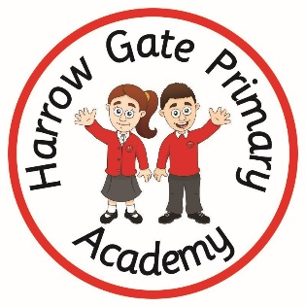
Harrow Gate Primary Academy

Remote education provision: information for parents
This information is intended to provide clarity and transparency to pupils and parents or carers about what to expect from remote education where national or local restrictions require entire cohorts (or bubbles) to remain at home.
For details of what to expect where individual pupils are self-isolating, please see the final section of this page.
The remote curriculum: what is taught to pupils at home
A pupil’s first day or two of being educated remotely might look different from our standard approach, while we take all necessary actions to prepare for a longer period of remote teaching.

What should my child expect from immediate remote education in the first day or two of pupils being sent home?
If your child is sent home for remote learning, they will have immediate access to Microsoft Teams/Class Dojo to access our online learning platforms. Class teachers will inform children/parents of the timetable to be followed and attended remotely (e.g. children will also be expected to join ‘live’ registration sessions). School will contact you to check if you need a device or support with internet access. If there are still technical issues that cannot be resolved, school will provide paper copies of the work to be completed.

Following the first few days of remote education, will my child be taught broadly the same curriculum as they would if they were in school?
Your child will be broadly taught the same curriculum as if they were in school. However, some subjects may need slight adaptations depending on practicality and the resourcing availability of equipment. Teachers may also identify and plan to revisit objectives that they feel will be better taught when back at school. Here a few examples of adaptations we have had to make:
- In PE, children are completing fitness challenges rather than participating in team-based activities.
- In science, children may focus on the theoretical aspects now (e.g. the structure of rocks) but then follow this up in the summer when all children can physically touch and see the different structures of igneous, metamorphic and sedimentary rocks – this will promote long-term learning but also make such a topic more engaging for a child.
- In art, many areas are heavily dependent on specialist equipment/resources (e.g. clay and the modelling tools to carve and sculpt). Therefore, drawing/sketching is a more practical alternative to teach remotely as it requires only pencil and paper

Remote teaching and study time each day

How long can I expect work set by the school to take my child each day?
We expect that remote education (including remote teaching and independent work) will take pupils broadly the following number of hours each day:
Reception | A minimum of 2 hours
Key Stage 1 | A minimum of 3 hours
Key Stage 2 | A minimum of 5 hours

Accessing remote education

How will my child access any online remote education you are providing?
Two main platforms are used to set and submit work. EYFS and KS1 primarily use Class Dojo, due to its more child-friendly interface. However, the majority of children have been encouraged to learn how to log into Microsoft Teams to maintain daily contact – parents are contacted by Miss Dunning who is a teacher that is in in place to support with remote learning across the school. KS2 children use Microsoft Teams to view and submit their work. All children are able to use Teams to access live sessions with the teacher, to maintain daily contact, wherever possible. There are a number of additional apps that the children are familiar with in school and may be used remotely (e.g. Times Table Rockstars, Numbots and Mathletics)

