Key Dates
1837 | William IV dies. His niece Alexandrina Victoria becomes queen age 18yrs
1842 | First Police force introduced
1840 | Queen Victoria married Prince Albert
1825 | Darlington – Stockton Railway
1842 | Mines Act – stopped children under 10yrs working
1843 | Charles Dickens published ‘A Christmas Carol’
1844 | The Factory Act – stopped children between 8 – 13yrs working
1844 | 49 8,000km of railway track built across Britain
1848 | Public Health Act
1850 | Workhouses open
1851 | London now the largest city 2.4million
1852 | First public flushing toilet
1854 | Cholera epidemic from dirty water
1861 | Death of Prince Albert from typhoid
1864 | Law passed to ban boys under 10 working as Chimney sweeps
1868 | First public hanging
1870 | School provided for 5 – 10yr olds:
1878 | First public electric lighting in London replacing gas lamps
1880 | Education Act – compulsory schooling for children between 5yrs and 10yrs
1891 | Free education for every child – 5yrs to 13yrs
1901 | Queen Victoria dies
Key Facts
1 | Children were treated very badly in Victorian period
2 | There was a huge gap between wealthy and poor families (the rich had lots and the poor had nothing)
3 | Living standards for the majority was very poor quality
4 | Medical treatment was of poor standards and cost money leading to many people dying from diseases
5 | People lived as close as they could to where they worked so that they would not waste time walking to work
6 | Poor families lived in slums whereas wealthy business owners lived in large, luxurious housing
7 | The poorest of families lived in small houses often sharing with two, three or even four families in one house
8 | Many children were homeless as a result of them either being kicked out from their homes or they ran away due to ill treatment
9 | Many children then turned to crime (stealing) to survive
10 | There was no such thing as Police until 1842
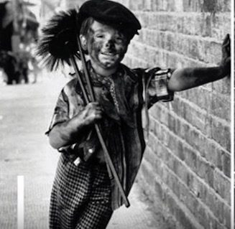
Vocabulary
Slums | An area of a city where living conditions are very poor
Poverty | The state of being very poor
Wealthy | People who have a large amount of money or property
Workhouse | A place where those unable to support themselves were offered accommodation and employment
Society | Consists of all the people in the country or region, considered as a group
Hygiene | Keeping yourself and your surroundings clean, especially to prevent disease
Sewers | Large underground tunnel designed to carry waste matter and rainwater away
Vagrant | A person without a settled home or regular work who wanders from place to place and lives by begging
Infection | A disease caused by germs
Disease | An illness that affects humans, animals or plants
Pauper | A very poor person
Lawless | Break the law often in a violent or wild way
Pickpocket | Steal from someone else’s pocket without them realising
Illiteracy | Not being able to read or write

