Key Dates
1940’s | Rationing was introduced and lasted 14 years.
 | During World War Two toy making came to a standstill. Factories and materials were used to make weapons instead. Cheaper toys were made from card or paper such as cut out paper dolls.
1944 | The Education Act guaranteed free education for every child in England and Wales.
1950’s | Rationing was in force until 1954.
 | T.V became the focus of entertainment.
1953 | Preston Hall museum opened.  Coronation of Queen Elizabeth II.
1963 | Harrow Gate Primary Infant and Junior school opened.
1960’s | Beginning of convenience foods.
1969 | Neil Armstrong landed on the moon.
1980’s | Children started to take packed lunches to school.
1982 | First McDonalds opens in Stockton.
1990-present | In the 1990s the portable video game system Gameboy was produced by Nintendo Co Ltd
1995 | Tees Barrage opened.
Key Facts
Butter, milk, eggs, meat, cheese and sugar were all rationed.

Up until 1944, children left school when they were 10 years old. 28 years later, it was raised till 16.
During World War Two, toy making stopped. Factories and materials were used to make weapons instead. Cheaper toys were made from card or paper such as cut out paper dolls.

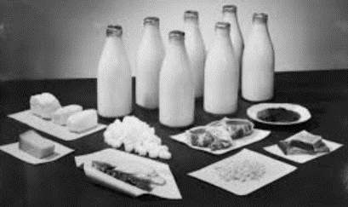

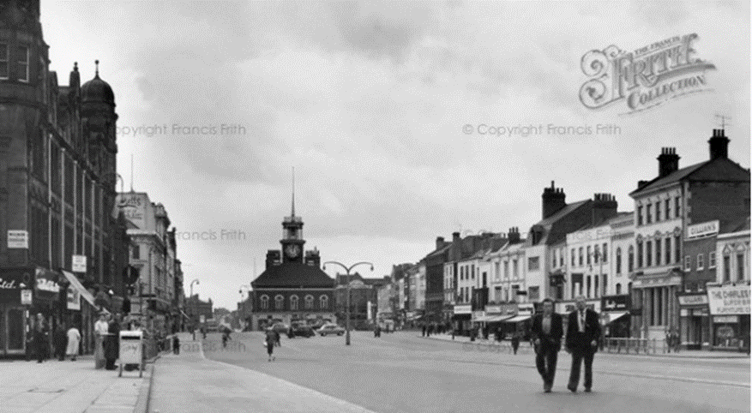

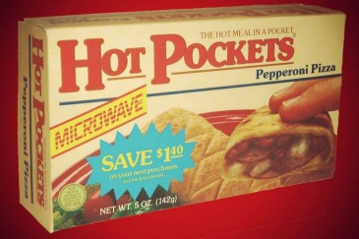
Vocabulary
past | The time before the present and the things that happened then.
present | Existing now.
history | Events that happened in the past.
rationing | A small amount of something.
Living memory | A time that can be remembered by people who are alive.
Corporal Punishment | Punishment that involves hitting someone

