Home Learning Grid Year 2 1/6/20
 | Morning exercise | Session 1 | BREAK | Session 2 |  | Lunch | Session 3
Mon |  | Maths  Shape  Page 84-87  Recognising 2D and 3D shapes  Tasks set on Mathletics |  | Spellings  ‘tion’ words | 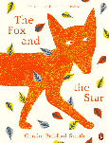  English  The Fox and the Star  Explore it!  ‘tion’ sounds like ‘shon’ |  | Where do you live? Who with? What do you wear?  What do you eat? Do you have any hobbies?  History  Life as me!  Draw yourself and then draw\write your answers.
Tue |  | Maths  Shape  Page 88-91  Counting faces on 3D shapes  Tasks set on Mathletics |  | Spellings  ‘tion’ words | English  The Fox and the Star  Illustrate it! |  | Science  Living or non-living  Watch the video https://www.bbc.co.uk/bitesize/clips/zg7s39q  Complete the activity living and non-living on education city.
Wed |  | Maths  Shape  92-95  Sorting 2D shapes  Tasks set on Education city |  | Spellings  ‘tion’ words | English  The Fox and the Star  Talk about it! |  | Global week  Why is World Environment day so incredibly important? Watch the video - https://www.littletreehouseapps.com/blog/world-environment-day/  Make a poster to inform people about World Environment Day.
Thu |  | Maths  Shape  96-99  Making patterns with 2D shapes  Tasks set on Mathletics |  | Spellings  ‘tion’ words | English  The Fox and the Star  Imagine it! |  | Global week  Create a piece of art work using twigs, leaves or anything in your garden to spell the word ‘hope’  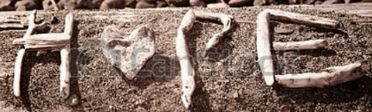
Fri |  | Maths  Symmetry  Tasks set on Education City |  | Spellings  ‘tion’ words | English  The Fox and the Star  Create it! |  | Global week  https://www.youtube.com/watch?v=92uF0nI_E-s  Book Review – Likes and dislikes
*Once you have completed your work do not forget to show it on your profile.

