Home Learning Grid Year 2 20/7/20
*Once you have completed your work do not forget to show it on your profile.
 | Morning exercise | Session 1
Mon |  | English  Click on the link to reveal the questions!  https://www.onceuponapicture.co.uk/portfolio_page/above-the-sky/
Tue |  | 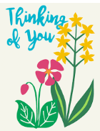  Make a postcard for a relative or friend and post it to them.
Wed |  | Watch your favourite cartoon or movie and create a Role of the Wall of your favourite character.
Thu |  | Picnic Day!!  Can you hold your own sports day in your garden? This could be laps around the garden, egg and spoon race or sack race. Get the family involved and see who can win the most activities.
Fri

