How to be COVID safe!

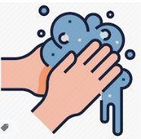
- Wash your hands with soap and water (sing Happy Birthday twice)
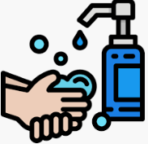
- Use hand sanitiser

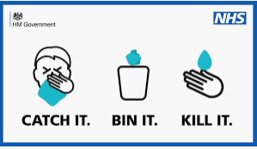
- Catch it Bin it Kill it

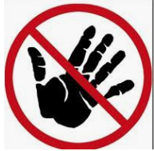
- Only use your own resources

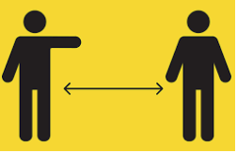
- Try to stay a distance from others

These rules are to be followed along with the school rules

