India Vocabulary Organiser
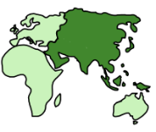  Asia | The continent in which India is a part of.
Saris | A garment consisting of cotton or silk draped around the body.
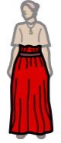  Lehenga | An ankle length skirt.
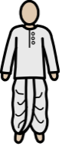  Dhotis | A garment worn by males. It is made from a loin cloth that is wrapped around the legs and hips.
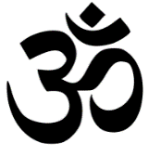  Hinduism | An Indian religion.
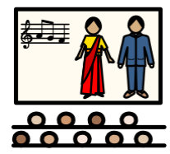  Bollywood | A popular Indian film industry.
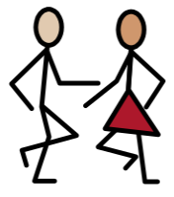  Dance | Move with rhythm.
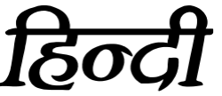  Hindi | India’s official language.
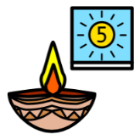  Diwali | Festival of light.
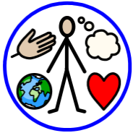  Culture | The way of life that people live.
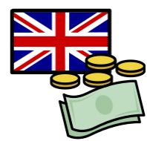  Currency | The money used in a particular country is referred to as its currency.

