Key Diagrams Scientists/Interesting Facts

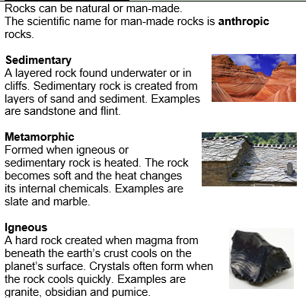
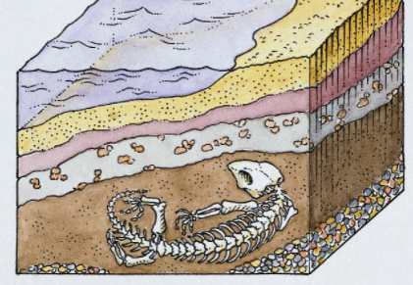
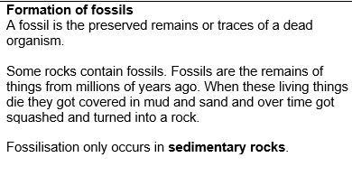

Sedimentary rock forms under the sea.
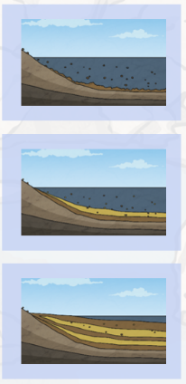

Useful links:

How are fossils made?
https://www.bbc.co.uk/bitesize/topics/z9bbkqt/articles/z2ym2p3
Rocks, soils and fossils
https://www.bbc.co.uk/bitesize/topics/z9bbkqt

Key Information
1. | Rocks can be natural or man-made.
2. | Igneous rocks are formed from magma or lava.
3. | Sedimentary rocks are rocks that are formed under the sea.
4. | Metamorphic rock starts as either a sedimentary or an igneous rock. It changes into metamorphic rock when it is near magma and therefore heats up.
5. | The scientific name for man-made rocks is anthropic rocks.
6. | A fossil is the preserved remains or traces of a dead organism.
7. | Fossilisation only occurs in sedimentary rocks.
8. | Palaeontology is the study of fossils.
9. | Mary Anning is a famous palaeontologist
10 | Soil is made from four things – worn down rock, organic matter, water and air.. It covers most of the world’s land.
11. | We need soil to grow plants for food
 | The 4 main processes in soils formation are additions, losses, translocations and transformations.

