Key Diagrams

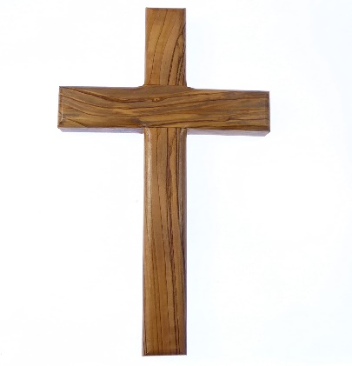
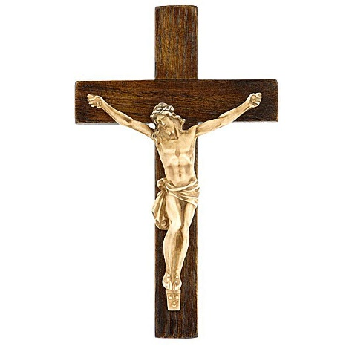
Key Facts
1 | Easter is a Christian festival and is the most important Christian celebration – not Christmas!
 | Christians celebrate because Jesus was resurrected three days after his death.
2 | Christians go to church on Good Friday to reflect on the meaning of the crucifixion and the messages of Christianity.
3 | A crown of thorns was put on Jesus’ head. He had to carry his own large wooden cross up a hill. At the top hill, Jesus was nailed to the cross, with nails through his hands and feet. Jesus was left on the cross to die.
4 | The central message of Christianity is that through his death, Jesus atoned for the sin of mankind which came in the world when Adam and Eve ate the apple in the Garden of Eden.
5 | Christians go to church between 12:00 and 3:00 on Good Friday to prayer and remember Jesus’ sacrifice.
6 | Roman Catholics start their service at 3pm, the time they believe Jesus died.
Vocabulary
Christian | A believer in Jesus and his teachings.
Good Friday | The day that Jesus died on the cross.
sacrifice | Jesus giving himself up to be crucified to save humankind.
crucifixion  The Crucifixion | Nailing someone to a cross to die.  The crucifixion of Christ.
apostles/disciples | Followers of Jesus Christ who went from place to place telling people about him and persuading them to become Christians.
cross | The most important Christian symbol
crucifix | A crucifix is a cross with a figure of Jesus Christ on it.
atoned | To make amends. If you do something as an atonement for doing something wrong, you do it to show you are sorry.
resurrected | To rise or raise from the dead/bring back to life.
stations of the cross | A series of pictures in 14 steps showing Jesus’ journey to the cross before his crucifixion.

