Key Diagrams
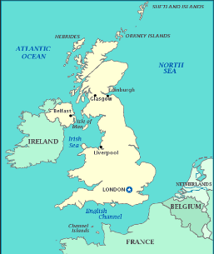
Seas around the United Kingdom

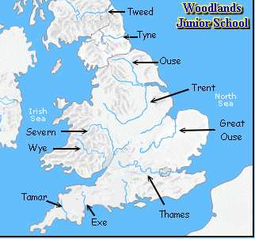
Significant rivers in the United Kingdom

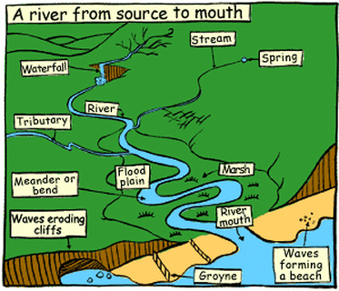

The journey of a river

Key Facts
1 | A river is made up of 3 courses – Upper, Middle and Lower.
2 | Rivers begin at their source in higher ground such as mountains or hills, where rain water or melting snow collects and forms tiny streams.
3 | Rivers are formed when one stream meets another and they merge together, the smaller stream is known as a tributary. It takes many tributary streams to form a river.
4 | Rivers flow in channels. The bottom of the channel is called the bed and the sides of the channel are called the banks.
5 | As a river flows, the force of its moving water washes away loose soil and pieces of rock. In this way the river cuts its own channel in the ground. The process of wearing away rocks is called erosion.
6 | A fast flowing river will carry soil and dirt from its banks and bed downstream and drop them when it gets wider and slows down.
7 | The water cycle is the continuous journey water takes from the sea, to the sky, to the land and back to the sea. The movement of water around our planet is vital to life as it supports plants and animals.
Vocabulary
River | A river is a large amount of fresh water flowing continuously in a long line across the land.
Sea | The sea is the salty water that covers about three-quarters of the Earth's surface.
Source | The source of a river or stream is the place where it begins.
Mouth | The end of the river where it meets the sea.
Meander | A curve in a river. Meanders form a snake-like pattern as the river flows across a fairly flat valley floor.
Confluence | The confluence of two rivers is the place where they join and become one larger river.
Valley | A valley is a low stretch of land between hills, especially one that has a river flowing through it.
Floodplain | The flat area bordering a river, composed of sediment deposited during flooding
Erosion | The gradual destruction and removal of rock or soil in a particular area by rivers, the sea, or the weather.
Deposition | A process in which layers of a substance are formed on its surface over a period of time.

