Key Diagrams
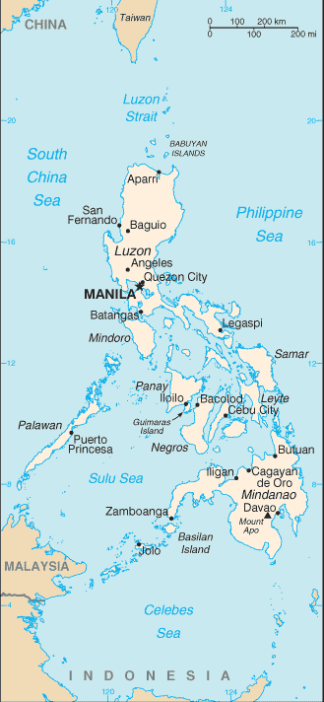

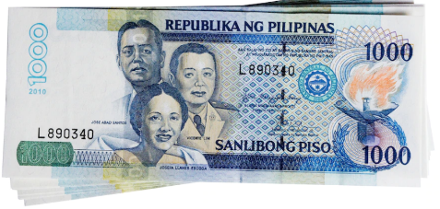

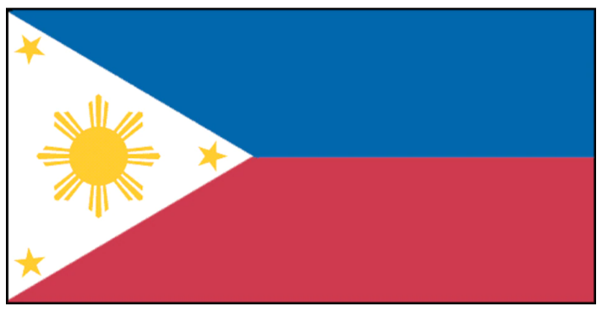
Key Facts
1 | The Philippines is an archipelago, or string of over 7,100 islands, in south eastern Asia between the South China Sea and the Pacific Ocean.
2 | The two largest islands, Luzon and Mindanao, make up for two-thirds of the total land area.
3 | Its official name is Republic of the Philippines and Manila is the capital city.  MONEY: Philippine peso
4 | The Philippines has a population of round 110 million people! The official language is Filipino and English.
5 | The Philippines lies entirely within the humid tropics. Warm temperatures occur throughout the year. Temperatures are usually highest during the dry season, from March through June.
6 | The Philippines is one of the only countries in Asia in which Christianity is the national religion. 92 % of the population are Christians with around 80% following the Roman Catholic faith.
7 | Ferdinand Magellan (an explorer) discovered the Philippines on March 7th 152. King Phillip of Spain sent him to discover new places. The Philippines was named after King Phillip.
8 | Rice is the primary staple food. About one-quarter of the total farmland is used for rice growing.
9 | The Philippines is one of the world’s leading producers of coconuts and coconut products, which are valuable exports.
Vocabulary
continent | A continent is a very large area of land that consists of several countries
equator | The equator is an imaginary line around the middle of the Earth at an equal distance from the North Pole and the South Pole.
archipelago | An archipelago is a group of islands, especially small islands.
currency | The money used in a particular country is referred to as its currency.
agriculture | Agriculture is farming and the methods that are used to raise and look after crops and animals.
fair-trade | Fair trade is the practice of buying goods directly from producers in developing countries at a fair price
culture | Culture consists of activities such as arts and philosophy, which are considered to be important for the development of civilisation.
Christianity | Christianity is a religion that is based on the teachings of Jesus Christ and the belief that he was the Son of God.
ecosystem | An ecosystem is all the plants and animals that live in a particular area together with the complex relationship that exists between them and their environment.

