Key Diagrams
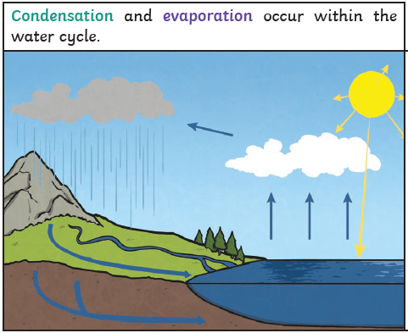
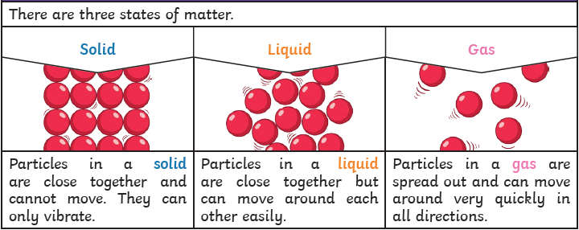
- Water from lakes, puddles, rivers and seas is evaporated by the suns heat, turning it into water vapour.
- This water vapour rises, then cools down to form water droplets in clouds (condensation).
- When the droplets get too heavy, they fall down to earth as rain, sleet, hail or snow (precipitation).

Vocabulary
Solid | A solid substance or object stays the same shape whether it is in a container or not.
Liquid | A liquid is a substance which is not solid but which flows and can be poured, for example water.
Gas | Gas is a substance like air that is neither liquid nor solid and burns easily. It is used as a fuel for cooking and heating.
Particles | In physics, a particle is a piece of matter smaller than an atom, for example an electron or a proton.
Melt | When a solid substance melts or when you melt it, it changes to a liquid, usually because it has been heated.
Condensation | Condensation consists of small drops of water which form when warm water vapour or steam touches a cold surface such as a window.
Evaporation | Evaporation is when a liquid changes to a vapour, caused by an increase in temperature and/or a decrease in pressure.
Water Vapour | Water in the form of gas, after it has been heated

Facts
1 | Matter usually exists in one of three states or phases: solid, liquid, or gas.
2 | The chair you are sitting on is a solid, the water you drink is liquid, and the air you breathe is a gas.
3 | Materials can change between states when you heat or cool them.
4 | If a solid is heated to its melting point, it melts and changes to a liquid. This is because the particles start to move faster and faster until they are able to move over and around each other.
5 | When freezing occurs, the particles in the liquid begin to slow down as they get colder. They can then only move gently on the spot, giving them a solid structure.
6 | Evaporation occurs when water turns into water vapour. This happens very quickly when the water is hot, like in a kettle, but it can also happen slowly, like a puddle evaporating in the warm air.
7 | Condensation is when water vapour is cooled down and turned into water. You can see this when droplets of water form on a window. The water vapour in the air cools when it touches the cool surface.
8 | Water boils at 100 degrees and turns into a gas. Water freezes at 0 degrees and turns to a solid. Water is the olny a liquid that boils at 100 degrees and freezes at 0 degrees. Water is the only material on earth which exists natually in all 3 states.

