Week beginning Monday 25th January
Begin with:
Count forwards and backwards from 0-20 and 20-0.
One more and one less than numbers up to 10. “What is one more than…? What is one less than…?”
Practise the 3D shape names and the 2D shapes you can see within them.
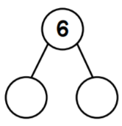
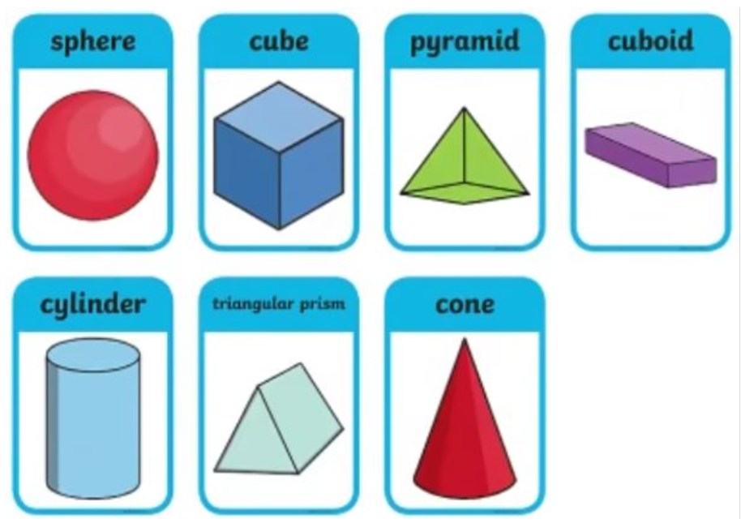

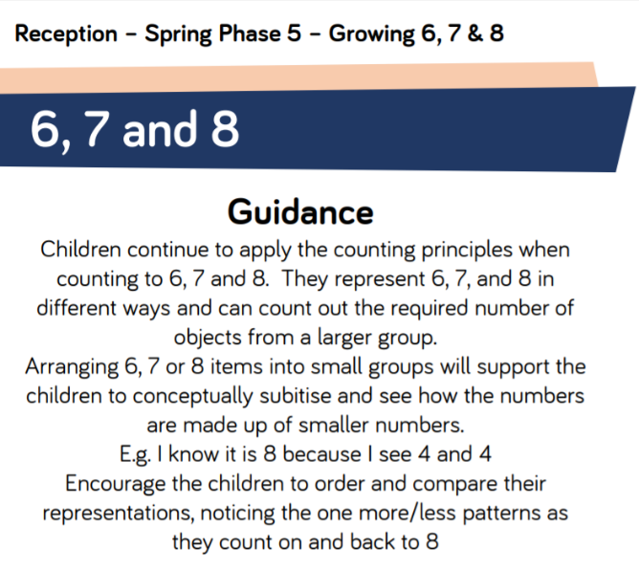
Main activity:
This week we will be looking at the composition of the numbers 6, 7, 8 and their addition facts.
Log onto
https://whiterosemaths.com/homelearning/early-years/growing-6-7-8/
Watch the videos for each day.
Follow up activity:
We will be using the part, part whole model to work out the number addition facts of each number.

