Maths On A Page
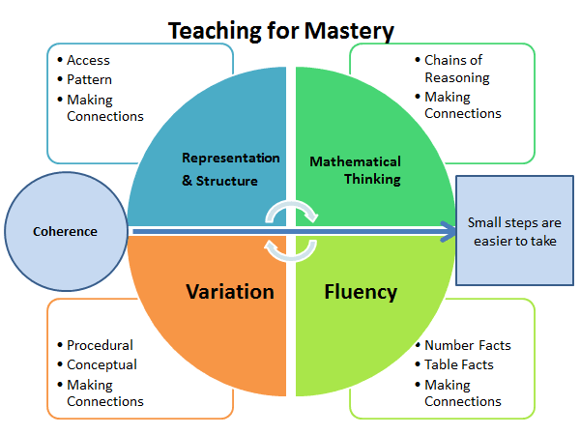
INTENT:
At Harrow Gate we recognise that Mathematics is essential to everyday life, critical to science, technology and engineering, and necessary for financial literacy and most forms of employment.
We aim to provide a high-quality mathematics education with a mastery approach so that all children can apply their fluency in a variety of different problem solving and reasoning contexts.
We intend on delivering a curriculum which:
- Allows ALL children to be a part of creative and engaging lessons that will give them a range of opportunities to explore mathematics following a Teaching for Mastery approach.
- The lesson design links to prior learning to ensure all can access the new learning and teachers carefully sequence the small steps in order to build a secure understanding.
- Gives each pupil a chance to believe in themselves as mathematicians and develop the power of resilience and perseverance when faced with mathematical challenges linked to our school A.R.T. focus.
- Engages all children and entitles them to the same quality of teaching and learning opportunities, striving to achieve their potential.
- Make connections across mathematical ideas to develop fluency, mathematical reasoning and competence in solving increasingly sophisticated problems.
- Provides equal opportunities for children to apply their mathematical knowledge to other subjects (cross-curricular links).
- Enable children to develop a passion for mathematics and celebrate maths in all areas of life.
IMPLEMENTAION:
White Rose (WR) sequences the learning through a small steps approach. However, these small steps do not represent one lesson and teachers must not use these as a ‘conveyor belt’ approach. Alongside WR, the ‘Ready to Progress’ statements produced by NCETM are used to inform our own assessments of the children.
Medium term planning:
While long term planning identifies the order of the teaching adapted by the teacher, the medium-term plan is completed prior to the delivery of the unit, using the White Rose Primary Maths resources. Using this document teachers will identify:
- Small steps suggested by White Rose
- Potential misconceptions
- New vocabulary to be taught.
- Support for the less able children
- Objectives for those children attaining below ARE.
- The representations used throughout the unit.
- Initial teaching ideas
- Links to resources, I see reasoning, testbase etc.
- Interleaving ideas for tasks and DNA
- Challenge for GDS tasks
- Stem sentences to aid reasoning
- The key objectives outlined in the Ready to Progress statements.
- Rapid Recall focused objectives.
Lesson planning:
The teaching team will meet up daily to discuss assessments from the previous lesson and identify how best to progress. Using planning boards, teachers will plan, task design and refer to ‘Rosenshine’s Principles of Instruction’.

Lesson structure/Weekly expectations
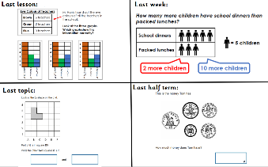
- Do Now Activity
Every lesson begins with a review of previous learning. Alongside the usual DNA format, the teacher may use different methods to enable effective recall practise. NO NEW LEARNING!
- Fluency
Lessons will contain aspects of fluency through intelligent practice. This may be through procedural/conceptual variation activities in addition to using multiple representations.
- Problem solving and reasoning.
These are at the heart of gaining a deeper understanding of Maths and the teacher will develop Mathematical thinking by adapting these tasks where necessary.
I See Reasoning, has been written to provide rich, visual maths prompts to help build children’s conceptual understanding. In LK2/UK2 they provide rich, open contexts for mathematical discussion and enquiry. Testbase is used to create the KS1/KS2 reasoning SATs papers and have an assortment of problems linked to all curriculum objectives.
- Greater Depth
Integral to mastery of the curriculum is the development of deep rather than superficial conceptual understanding (NCETM). GDS mathematicians should have the opportunity to solve problems of greater complexity (i.e., where the approach is not immediately obvious),
• independently explore and investigate mathematical contexts and structures, communicate results clearly and systematically explain and generalise the mathematics.
Rapid Recall/ Basic skills practise (15 minutes daily)

Opportunities for practising Rapid Recall are given to all children from nursery to Year 6. This is NOT part of the maths lesson.

Children are to be tracked by teachers using the new rapid recall progression document.

Times tables are a key focus for the school and every opportunity should be given to children to practise. For those children who struggle to maintain these facts should be explicitly taught strategies to aid them in rapid recall of facts such as skip counting, using known facts, chanting and singing, and to develop a bank of different strategies to rely on so they increase in confidence and resilience.

Times Table Rock Stars can be used to encourage practise, but this should be used alongside other methods.

Mastering Number
In reception and KS1 maths mastery will be taught four times a week for 10 – 15 minutes. This is a non-negotiable and will be monitored by the maths lead.
Reception overview
They will explore the composition of numbers within 5. They will begin to compare sets of objects and use the language of comparison. They will begin to identify when two sets are equal or unequal and connect two equal groups to doubles. They will begin to connect quantities to numerals.
Year 1 overview
Pupils will have an opportunity to consolidate the Early Learning Goals and continue to explore the composition of numbers within 10, and the position of these numbers in the linear number system. Pupils will continue to explore the composition of numbers within 10 and explore addition and subtraction structures and the related language (without the use of symbols). Pupils will explore the composition of numbers within 20 and their position in the linear number system. They will connect addition and subtraction expressions and equations to ‘number stories’)
Year 2 overview
Pupils will have an opportunity to consolidate their understanding and recall of number bonds within 10; they will re-cap the composition of the numbers 11 to 20 and reason about their position within the linear number system. Pupils will have an opportunity to use their knowledge of the composition of numbers within 10 to calculate within 20; they will explore the links between the numbers in the linear number system within 10 to numbers within 100, focusing on multiples of 10 and the midpoint of 50.

Calculation Day

A separate calculation day, possibly unrelated to the regular teaching of Maths, is delivered once a week.

An arithmetic test is completed bi-weekly timetable alternating with the explicit teaching of skills. This allows the children targeted practise of specific calculation objectives.

Week 1 will be the teaching and practise of the skill using a variety of methods including variation questioning and practical resources.

Week 2 has a focus on test technique and gives the children the opportunity to practise the new skills taught in addition to timed arithmetic questions. Test technique should be taught alongside this.

Working Walls:

Vocabulary should be displayed for the maths currently being learned and not pristine ‘wallpaper’.

STEM sentences should be used to scaffold the learning. These can be found on the WR small steps.

Posters created with the children during maths inputs should be displayed and referred to.

The wall should be directly relevant to that week’s learning.

Prompts from previous units should also be kept on display to encourage children to keep using their new knowledge.

Other displays in the classroom, e.g., science and foundation subject displays, should showcase excellent mathematics work from across the curriculum.

Feedback:

All marking and feedback are given at the point of learning in real time, where necessary, written feedback should be in red pen this ensures misconceptions are being addressed immediately. All adults in a maths lesson will actively be moving around ALL children.

Children are encouraged to mark their own work and correct errors using a different colour during a focused feedback session where the teacher is secure in the knowledge of the children’s ability. Teaching point is the question that all children have found tricky. Do not waste time reviewing the questions that the children have answered correctly.

Regular review sessions should be in place in order to support memory recall.

All work should be acknowledged to thoroughly check the children’s marking and to assess for next steps in learning, even where it is self-marked by the child.

Verbal feedback is given where and when necessary, to individuals, small groups and whole class and encourages the children to be persistent, resilient, and focused.

For a large number of pupils, the lesson is paused, and the misconception addressed immediately, or the errors are addressed in the next lesson.

