Maths On A Page

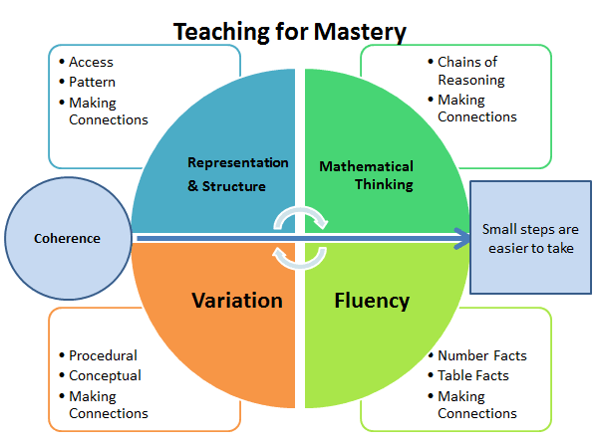

**INTENT:**

At Harrow Gate we recognise that Mathematics is essential to everyday life, critical to science, technology and engineering, and necessary for financial literacy and most forms of employment.

We aim to provide a high-quality mathematics education with a mastery approach so that all children can apply their fluency in a variety of different problem solving and reasoning contexts.

We intend on delivering a curriculum which:

* Allows ALL children to be a part of creative and engaging lessons that will give them a range of opportunities to explore mathematics following a Teaching for Mastery approach.
* The lesson design links to prior learning to ensure all can access the new learning and teachers carefully sequence the small steps in order to build a secure understanding.
* Gives each pupil a chance to believe in themselves as mathematicians and develop the power of resilience and perseverance when faced with mathematical challenges linked to our school A.R.T. focus.
* Engages all children and entitles them to the same quality of teaching and learning opportunities, striving to achieve their potential.
* Make connections across mathematical ideas to develop fluency, mathematical reasoning and competence in solving increasingly sophisticated problems.
* Provides equal opportunities for children to apply their mathematical knowledge to other subjects (cross-curricular links).
* Enable children to develop a passion for mathematics and celebrate maths in all areas of life.

We deliver this curriculum using the **Maths – No Problem!** approach, a highly-effective (award-winning) programme of teaching methods and resources based on recommendations from world-renowned experts.

**Lesson structure/Weekly expectations**

* **Explore -** During this part of the lesson, learners will be working in groups exploring the task themselves, however they see fit, whether this is with concrete resources, modelling or different strategies etc.
* **Master -**  The Master section can provide some anticipated methods for solving the problem and teachers use this to guide the discussion.
* **Guided Practice -** where learners can work through the questions in pairs
* **Journalling -** Journalling provides pupils with a chance to develop their communication skills by learning to articulate their ideas and explicate their mathematical thinking that surfaced during exploration.
* **Independent Practice -** Independent Practice can be found in the workbook and as the name suggests pupils work through these by themselves. Both sets of questions have been designed with variation in mind, so learners can develop a deeper understanding of the topic as they work through the exercises.

.

**Rapid Recall/ Basic skills practise (15 minutes daily)**

* Opportunities for practising Rapid Recall are given to all children from nursery to Year 6. This is NOT part of the maths lesson.
* Children are to be tracked by teachers using the new rapid recall progression document.
* Times tables are a key focus for the school and every opportunity should be given to children to practise. For those children who struggle to maintain these facts should be explicitly taught strategies to aid them in rapid recall of facts such as skip counting, using known facts, chanting and singing, and to develop a bank of different strategies to rely on so they increase in confidence and resilience.
* Times Table Rock Stars can be used to encourage practise, but this should be used alongside other methods.

**Mastering Number**

In reception and KS1 maths mastery will be taught **four times a week for 10 – 15 minutes**. This is a **non-negotiable** and will be monitored by the maths lead.

**Reception overview**

They will explore the composition of numbers within 5. They will begin to compare sets of objects and use the language of comparison. They will begin to identify when two sets are equal or unequal and connect two equal groups to doubles. They will begin to connect quantities to numerals.

**Year 1 overview**

Pupils will have an opportunity to consolidate the Early Learning Goals and continue to explore the composition of numbers within 10, and the position of these numbers in the linear number system. Pupils will continue to explore the composition of numbers within 10 and explore addition and subtraction structures and the related language (without the use of symbols). Pupils will explore the composition of numbers within 20 and their position in the linear number system. They will connect addition and subtraction expressions and equations to ‘number stories’)

**Year 2 overview**

Pupils will have an opportunity to consolidate their understanding and recall of number bonds within 10; they will re-cap the composition of the numbers 11 to 20 and reason about their position within the linear number system. Pupils will have an opportunity to use their knowledge of the composition of numbers within 10 to calculate within 20; they will explore the links between the numbers in the linear number system within 10 to numbers within 100, focusing on multiples of 10 and the midpoint of 50.

**Working Walls:**

* **Vocabulary** should be displayed for the maths currently being learned and not pristine ‘wallpaper’.
* **STEM sentences** should be used to scaffold the learning. These can be found on the WR small steps.
* Posters created with the children during maths inputs should be displayed and referred to.
* The wall should be directly relevant to that week’s learning.
* Prompts from previous units should also be kept on display to encourage children to keep using their new knowledge.
* Other displays in the classroom, e.g., science and foundation subject displays, should showcase excellent mathematics work from across the curriculum.

**Feedback:**

* All marking and feedback are given at the point of learning in **real time**, where necessary, written feedback should be in red pen this ensures misconceptions are being addressed immediately. All adults in a maths lesson will actively be moving around **ALL** children.
* Children are encouraged to mark their own work and correct errors using a different colour during a focused feedback session where the teacher is secure in the knowledge of the children’s ability. Teaching point is the question that all children have found tricky. Do not waste time reviewing the questions that the children have answered correctly.
* Regular review sessions should be in place in order to support memory recall.
* All work should be acknowledged to thoroughly check the children’s marking and to assess for next steps in learning, even where it is self-marked by the child.
* Verbal feedback is given where and when necessary, to individuals, small groups and whole class and encourages the children to be persistent, resilient, and focused.
* For a large number of pupils, the lesson is paused, and the misconception addressed immediately, or the errors are addressed in the next lesson.