Nursery English Curriculum Map: Power of Reading
Nursery  Using a Power of Reading Teaching Sequence to enhance the English Curriculum. | 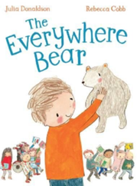  Autumn 1 | 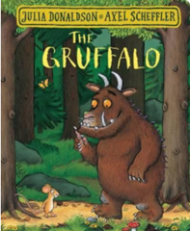  Autumn 2 | 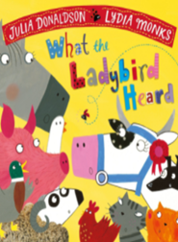  Spring 1 | Spring 2  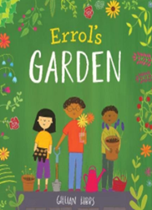 | 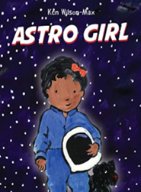  Summer 1 | 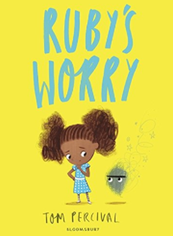  Summer 2
Literary Form | Contemporary Fiction  (with rhyming pattern) | Classic Texts and Modern Classics  Traditional Tale and Twists  (with repeated refrain) | Contemporary Fiction  (with rhyming pattern) | Picture Book | Contemporary Fiction | Picture Book
Links to Main EYFSP Area of Learning | Understanding the World:  People and Communities | Understanding the World:  The World | Understanding the World:  The World | Understanding the World:  People and Communities  The World | Understanding the World:  People and Communities | PSED:  Managing Self
PSED + Human Themes | Belonging | Resilience and Problem Solving | Working Together | Protecting Nature | Aspirations and Dreams | Trust/Identifying Worries
Phonics and Early Reading Experience (Building Visual and Aural Skills) | Link to Phase 1/Launchpad for Literacy  - Nursery rhymes: jobs and occupations  - Rhythm and rhyme  - Family songs  - Instrumental sounds  - Matching aural patterns like rhyming pairs to visual patterns by onset and rime | Link to Phase 1/Launchpad for Literacy  - Rhythm and rhyme  - Hearing and seeing the Basic Code in context  - Lifting meaning through performance reading  - Developing inference  - Reading illustration  - Reading own writing  - Rhythm and rhyme  - Body percussion and voice sounds | Link to Phase 1/Launchpad for Literacy  - Rhythm and rhyme  - Vocalising animal sounds Singing farm songs  - Words as tags - maps  - Reading own mapmaking and role-play writing outcomes | Link to Phase 1/Launchpad for Literacy  - Environmental sound discrimination  - Hearing and seeing the Basic Code in context  - Developing fluency  - Developing inference Reading illustration | Link to Phase 1/Launchpad for Literacy  - Environmental sound discrimination  - Hearing and seeing the Basic Code in context  - Developing fluency  - Developing inference Reading illustration  - Word and language play | Link to Phase 1/Launchpad for Literacy  - Voice sounds – emotional expression  - Teaching the Basic Code in context  - Opportunity for Complex Code: ‘y’ at end of words like Ruby, worry  - Developing fluency through high frequency words Developing inference  - Reading illustration  - Reading own writing
Early Years Foundation Stage Statutory Framework Covered by this sequence | Birth to Three
 | Prime Areas  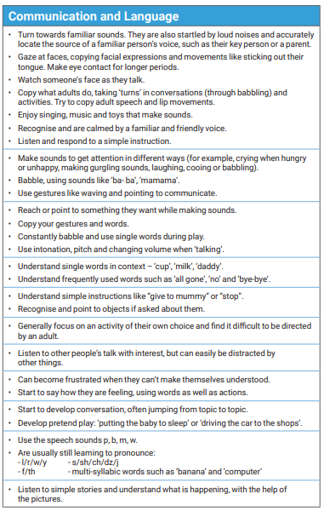  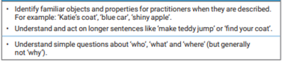 |  |  | Specific Areas  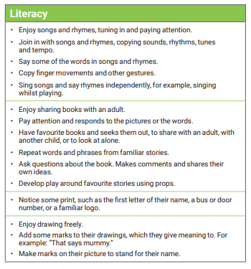
 | Three and Four-Year-Olds
 | Prime Areas  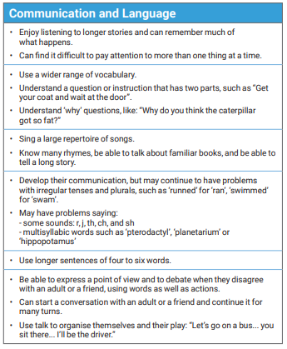 |  |  | Specific Areas  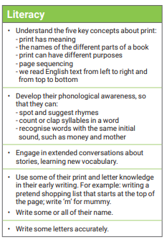
Linguistic Experiences - generated by high quality text | Past tense narrative  Precise language using  prepositions and adverbials  Book Talk | Past tense narrative  Precise language using  prepositions and adverbials  Dialogue  Exclamations and questions  Book Talk | Past tense narrative  Precise language using prepositions and adverbials  Positional language  Lists and ordinal Language  Book talk | Soundscaping with untuned instruments and voice sounds Teaching the Basic Code and Consonant clusters in context  Lifting meaning through performance reading Developing inference Reading illustration  Precise language using prepositions and adverbial  Positional language | First person narrative  Soundscaping with untuned instruments and voice sounds Teaching the Basic Code and Consonant clusters in context  Lifting meaning through performance reading Developing inference Reading illustration  Past tense narrative  Precise language using prepositions and adverbials | Simple narrative voice  Past tense consistency and conjunctions in telling personal stories  Word collections: exploring colloquial language of families, synonyms  Language related to size and comparison  Apostrophe for possession
Physical Development Opportunities | Dancing  Re-enacting the storm with scarves and fabric.  Digging movements Action and finger rhymes  Printmaking | Animal actions  Re-enacting and hatching plans  Provide the children with paper plates, feathers, collage pieces and googly eyes. Encourage them to make representations of animals from the story by selecting their materials and sticking them, using their fingers or tools like tweezers.  Provide large blocks, logs and small word figures in the construction area to allow the children to create scenes from the story.  Allow the children to weave with sticks to make an owls nest.  Warm up for a physical development lesson basing the movement on that of owls, snakes, foxes and mice.  Use large and small equipment to explore the ways in which they move and where they hide.  Look at prepositions like, over, under, across, above, below, around and work out ways of travelling through, under or on equipment or around a space. | Animal actions  Re-enacting and hatching plans around a large scale farmyard Doing a farmer’s work: using tools that develop gross motor skills and those that strengthen hand and finger muscles and co-ordination | Re-enacting the story  Provide the children with paper collage pieces to create garden scenes using their fingers or tweezers as tools.  Provide large blocks, logs and small word figures in the construction area to allow the children to create scenes from the story.  Make use of the outdoor area for sorting logs/sticks/rocks/stones for decoration - GMS.  Sorting and planting seeds – FMS  Use different size watering cans and spray guns to water areas. | Re-enact story  Make telescopes and decorate using their fingers or tweezers as tools.  Making various sized round and round movements.  Imagining zero gravity and making space movements.  Rolling dough and cutting biscuits like Astrid.  Rocket blasting movements. | Gross motor: active play and moving bodies in different ways.  Fine motor: make pom-pom worries.
Teaching Approaches | - Reading aloud and re-reading  - Reponses to illustration  - Role Play and Drama  - Visualising  - Book Talk | - Book Talk ‘Tell Me’  - Responding to illustration  - Role on the Wall  - Shared reading  - Reading aloud  - Freeze Frame and Hot seating  - Shared writing  - Role-play and drama.  - Story mapping | - Reading aloud and rereading  - Role Play and Drama  - Visualising  - Role play and Drama  - Illustration and Artwork | - Response to illustration  - Reading aloud and re-reading  - Role on the Wall  - Drawing and annotating  - Observational drawing  - Shared and modelled writing  - Sharing personal narratives  - Storytelling  - Creative Writing  - Bookmaking  - Role Play  - Freeze Frame and Thought Tracking  - Writing in role  - Shared reading  - Book Talk  - Real World Experiences | - Response to illustration  - Role on the Wall  - Telling of personal narratives  - Reading aloud and re-reading Role-Play  - Shared writing  - Hot seating | - Response to illustration  - Freeze framing  - Telling of personal narratives  - Visualisation  - Book talk  - Reading aloud and re-reading  - Role on the Wall  - Looking at language  - Writing in role  - Shared writing  - Illustration  - Storymapping  - Book making
Possible Extended Writing Outcomes | - Writing Outcomes  - Shared journal  - Advice notes  - Posters  - Poetry  - Speech and thought bubbles  - Story mapping | - Class journal  - Thought bubbles  - Animal and woodland poems  - Letters and notes to the animals  - Shopping list  - Character description  - Gruffalo crumble recipe | - Writing Outcomes  - Shared Journal  - Speech/Thought Bubbles  - Map making  - Caption Writing  - Bookmaking | - Responses to illustrations shared  - Personal Narratives  - Responsive sentences  - Writing in role  - Plant care instructions  - Notes and letters  - Fieldwork journal  - Labels and Captions  - Descriptive annotations  - Enquiry chart with statements and questions#  - Maps and plans  - Lists  - Leaflet or poster | - Responses to illustrations shared  - Personal Narratives  - Responsive sentences  - Lists  - Informational sentences  - Informational texts  - Letters  - Thoughts about a story | - Responses to illustrations shared  - Personal Narratives  - Letters  - Cards  - Thoughts about a story  - Illustrations sharing emotions  - Writing in role  - Storymaps  - Own fictional narratives
Other books with similar themes | This is the Bear by Sarah Hayes, illustrated by Helen Craig (Walker)  Dogger by Shirley Hughes (Red Fox)  Katie Morag and the Tiresome Ted by Mairi Hedderwick (Red Fox)  Knuffle Bunny by Mo Willems (Walker)  That Rabbit Belongs to Emily Brown by Cressida Cowell and Neal Layton (Hodder)  I Love You, Blue Kangaroo by Emma Chichester Clark (HarperCollins)  Red Ted and the Lost Things by Michael Rosen and by Joel Stewart (Walker)  Traction Man Meets TurboDog by Mini Grey (Red Fox)  Lost and Found by Oliver Jeffers (Harper Collins)  The Way Back Home by Oliver Jeffers (Harper Collins)  A Bit Lost by Chris Haughton (Walker) | Stories dealing with fears and overcoming them:  Little Mouse’s Big Book of Fears’ by Emily Gravett.  ‘The Dark’ by Lemony Snickett and Jon Klassen  ‘Orion and the Dark’ by Emma Yarlett  ‘George and the Dragon’ by Wormell  Stories involving trickery:  ‘No Dinner. The Story of the Old Woman and the Pumpkin’ by Jessica Souhami  The Sweetest Song in ‘The Story Tree’ by Hugh Lupton  ‘Use Your Imagination’ by Nicola O'Byrne  ‘What the Ladybird Heard’ by Julia Donaldson and Axel Sheffler  ‘The Highway Rat’ by Julia Donaldson and Axel Sheffler  Other books by Julia Donaldson and Axel Sheffler:  The Gruffalo’s Child  The Snail and the Whale  Room on the Broom  Monkey Puzzle  Tiddler  Zog |  | Other books by Gillian Hibbs (all published by Child’s Play): Tilly’s at Home Holiday  Tilly’s Staycation Covered in Adventures  Books that help children to recognise and explore emotions:  Sweep, Louise Greig and Júlia Sardà (Egmont)  Silly Billy, Anthony Browne (Walker)  Owl Babies, Martin Waddell and Patrick Benson (Walker) Dogger, Shirley Hughes (Red Fox)  A Book of Feelings, Amanda McCardie and Salvatore Rubbino (Walker)  Happy, Mies Van Hout (Leminscaat)  Feelings: Inside my heart and in my head, Libby Walden and Richard Jones (Caterpillar Books)  Lost and Found, Oliver Jeffers (HarperCollins)  The Girl With a Parrot on her Head, Daisy Hirst (Walker)  Little Mouse’s Big Book of Fears, Emily Gravett (Macmillan)  Grumpy Frog, Ed Vere (Puffin) Glad Monster, Sad Monster, Ed Emberley (Little, Brown)  Pom Pom Gets the Grumps, Sophy Henn (Puffin)  The New Small Person, Lauren Child (Puffin)  A Great Big Cuddle, Michael Rosen and Chris Riddell (Walker) | Books with a Space theme:  Goodnight Spaceman, Michelle Robinson and Nick East (Puffin)  The Way Back Home, Oliver Jeffers (HarperCollins)  Moon, Patricia Hegarty and Britta Teckentrup (Little Tiger)  Whatever Next, Jill Murphy (Macmillan)  Starry Skies, Samantha Chagollan and Nila Aye (Walter Foster Jnr)  Once Upon a Star, A Poetic Journey Through Space, James Carter and Mar Hernandez  (Caterpillar Books)  Man on the Moon (a day in the life of Bob), Simon Bartram (Templar)  Toys in Space, Mini Grey (Red Fox)  By the Light of the Moon, Tom Percival (Bloomsbury)  How to Be on the Moon by Viviane Schwarz (Walker)  Non-Fiction books about Space:  Busy People: Astronaut, Ando Twin and Lucy M. George (QED) What is the Moon? Katie Daynes and Marta Alvarez Miguens (Usborne)  A Cat’s Guide to the Night Sky, Stuart Atkinson, illustrated by Brendan Kearney (Laurence King)  Gravity, Jason Chin (Andersen Press)  Usborne Beginners: Living in Space, Lucy Bowman  TechTots STEM: Where Does the Sun Go? Harriet Blackford, illustrated by Mike Henson (Boxer Books)  Professor Astro Cat's Solar System, Dominic Walliman, illustrated by Ben Newman (Flying Eye)  Other books by Ken Wilson-Max:  Where is Lenny? Ken Wilson-Max (Alanna Max)  The Drum (Children, Music Life), Ken Wilson-Max and Catell Ronca (Tiny Owl)  The Flute (Children, Music Life), Ken Wilson Max and Catell Ronca (Tiny Owl) | Books that explore emotions:  Sweep, Louise Greig and Júlia Sardà (Egmont)  Silly Billy, Anthony Browne (Walker)  Owl Babies, Martin Waddell and Patrick Benson (Walker)  Dogger, Shirley Hughes (Red Fox)  A Book of Feelings, Amanda McCardie and Salvatore Rubbino (Walker)  Happy, Mies Van Hout (Leminscaat)  Feelings: Inside my heart and in my head, Libby Walden and Richard Jones (Caterpillar Books)  Lost and Found, Oliver Jeffers (HarperCollins)  The Girl With a Parrot on her Head, Daisy Hirst (Walker) Little Mouse’s Big Book of Fears, Emily Gravett (Macmillan) Grumpy Frog, Ed Vere (Puffin) Glad Monster, Sad Monster, Ed Emberley (Little, Brown)  Pom Pom Gets the Grumps, Sophy Henn (Puffin)  The New Small Person, Lauren Child (Puffin)  A Great Big Cuddle, Michael Rosen and Chris Riddell (Walker)  Picture Books:  Tobias and the Super Spooky Ghost Book (HarperCollins, 2010)  Jack’s Amazing Shadow (Pavilion, 2013)  Herman’s Letter (Bloomsbury, 2013)  Bubble Trouble (Bloomsbury, 2014)  Herman’s Holiday Bloomsbury 2015)  Perfectly Norman (Bloomsbury, 2017)  Goat’s Coat illustrated by Christine Pym (Bloomsbury, 2018)

