Parents Information Pack – **Please keep this at home.**

Contents

* Welcome letter from the Principal
* Ethos, mission statement and curriculum
* Meet the staff & school organisation
* Enquire Learning Trust
* Opening times
* Uniform
* School meals
* Parents as partners
* Home School Agreement
* Behaviour expectations
* School Rules poster
* Promoting positive attendance
* Attendance and Expectations
* The Attendance flow Chart
* Safeguarding
* The Education Welfare Officer / Parent support– Karen Gibbon
* Parent pay
* Curriculum
* Parent code of conduct
* Educational visits and enhanced curriculum
* E-safety
* Internet, Video & Photography Consent
* GDPR Privacy Notice

|  |  |  |  |  |
| --- | --- | --- | --- | --- |
| **Contacts**   |  |  |  | | --- | --- | --- | | Harrow Gate Academy School  Piper Knowle Road  Stockton on Tees  TS19 8DE  Main office 01642 673984  E-Mail: [Enquiries@harrowgateacademy.org](mailto:Enquiries@harrowgateacademy.org) | |  | | --- | | Enquire Learning Trust    Unit 5 Navigation Court Wakefield WF2 7BJ  Email: [info@enquirelearningtrust.org](mailto:info@enquirelearningtrust.org) | | | |
|  |  |

**Welcome from the Principal**

**Thank you for choosing Harrow Gate Primary Academy**

Dear Parents, Carers and Friends of Harrow Gate Primary Academy,

I would like to extend a warm welcome to all the children, their parents and carers, families, friends and members of the local community who are central to the life of Harrow Gate Primary Academy. Our whole school community values the contribution every child brings to our school, which makes our school a happy and harmonious place to learn and work. Our mission statement is that, ‘All children will be proud, spirited, successful learners with the aspiration and desire to succeed.’

Learning is our core purpose and we champion challenge and learning within a safe school environment where everyone is helpful, considerate and respectful of each other. We have been concentrating on making the learning links explicit with a level of challenge that encourages our pupils to develop resilience, independence and persistence. We want our children to be encouraged to explore ideas, reason, explain and justify their thinking. This will enable them to make informed decisions and facilitate lifelong learning. I believe it will also contribute towards keeping them safe.

Relationships and attitudes are very positive and an ethos exists in which learning together becomes an enjoyable and fulfilling experience for all. I feel privileged to be the Principal of a school that is truly unique.

Our school embraces and celebrates every kind of achievement. This is reflected in our commitment to inclusion and unity. At all times, we strive for the highest standards in all areas of the curriculum for all children. With our core values of **Achievement**, **Resilience** and **Trust**, all of our children strive to be the best they can be.

At Harrow Gate Primary Academy, we welcome parents as partners so that, together, we can promote high standards of learning and behaviour. We welcome your involvement in all aspects of school life. Thank-you for choosing our school and I hope that our ‘welcome pack’ provides you with a flavour of what our school has to offer you and your child. If you have not already done so, I encourage you to come and visit us to find out more by having a tour and talking to our staff and children. Appointments can be made through the school office.

I look forward to a continued happy and successful relationship with you over the coming years.

With kind regards



Mrs Vicky Galt

Principal

**Ethos and Mission Statement**

**Mission Statement**

**The academy will endeavour to raise the achievement and aspirations of every child.**

**What is the ART of Harrow Gate?**

**Achievement:** Children meet the *challenge* and *high* *expectations* in learning through *dynamic engagement*.

**Resilience:** Children are *courageous* and *passionate* in their approach to learning, which fosters *self-believe* and *pride*.

**Trust:** The Harrow Gate *family* work as a *team* of *honesty,* *respect, loyalty* and *effective communication* to ensure success for all.

**Curriculum at Harrow Gate Primary Academy**

The curriculum outlines the key knowledge that students need to learn in order to be successful learners and well-rounded people. A challenging curriculum will require students to think deeply about subject and lesson content.

At Harrow Gate, our values are Achievement, Resilience and Trust. These are at the core of our curriculum. Our curriculum also outlines the key knowledge that students need to learn in order to be successful learners

We pride ourselves on delivering a curriculum that promotes deep thinking, empathy and success.

****At Harrow Gate, we want families to be involved with the curriculum. We will invite you to a half termly curriculum celebration / workshops where the children exhibit their learning and use their skills to teach others.

**Meet the Staff**

|  |  |  |
| --- | --- | --- |
| **Leadership Team** | | |
|  |  | **T:\Photographs\Staff Pictures 2020\Mr Majeed.jpg** |
| Mrs Vicky Galt  Principal | Mrs Gemma Holloway Vice Principal / SEND co | Mr Murtza Majeed  EYFS leader |

|  |  |  |  |  |
| --- | --- | --- | --- | --- |
| **Teachers** | | | | |
|  |  |  |  |  |
| Mr Jack Adams | Mr Adam Amos | Mrs Sam Best | Miss Lindsey Clough | Mr Vinny Dawson |
|  |  |  |  |  |
| Miss Emily Duncan | Mr John Galt | Mrs Olivia Henderson | Mrs Nichola Pavey | Mrs Kristina Pybus |
|  |  |  |  | **T:\Photographs\Staff Pictures 2020\Sian Ward.jpg** |
| Mrs Rebecca Tash | Mrs Angela Vernon | Mrs Rachel Wilson | Miss Emma Yeadon | Miss Sian Ward |
|  |  |  | |  |
| Mr Aiden Bell | Mr Christopher Smith | Miss Jade Ruston  Nursery Manager | |  |

|  |  |  |  |  |
| --- | --- | --- | --- | --- |
| **Teaching Assistants** | | | | |
|  |  |  |  |  |
| Miss Sam Chilver | Mrs Rebecca Carter | Mrs Toni Dickinson | Mrs Tracey Edwards | Miss Michelle Hughes |
|  |  |  |  |  |
| Mrs Janice Leonard | Miss Keiley Owens | Ms Alison Oates | Miss Vikki O’Hara | Ms Steph Patterson |
|  |  |  |  |  |
| Mrs Sam Wilson | Mrs Vicky Williams | Miss Kelly Shaw | Mrs Sarah Bailey | Mrs Charlotte Hyman |
| T:\Photographs\Staff Pictures 2020\HARROW GATE SCHOOL EDITED HEADSHOTS _ (121 of 152).jpgMiss Jenny Shotten |  |  |  |  |
|  |  |  |  |  |

|  |  |  |  |
| --- | --- | --- | --- |
| **SEND Teaching support** | | | |
|  |  |  |  |
| Mrs Tracey Wilson | Mrs Caroline Green | Mrs Sam Hellson | Miss Kelly Lansell |

|  |  |  |  |
| --- | --- | --- | --- |
| **Parent and child wellbeing** | | **Finance and Administration** | |
|  |  |  |  |
| Mrs Ema Jackson Positive mental health officer | Mrs Karen Gibbon Education  Welfare officer | Ms Shirley Paterson Office Manager | Miss Sam Scott Finance Assistant |

|  |  |  |  |  |
| --- | --- | --- | --- | --- |
| **Supervisors (Breakfast club and Lunchtime)** | | | | |
|  |  |  |  |  |
| Miss Claire Appleby | Mrs Tracey Kidd | Mrs Joyce Lee | Mrs Sue Mitchell | Miss Rachel Sturdy |

|  |  |  |  |
| --- | --- | --- | --- |
| **Catering Staff** | | | |
|  |  |  |  |
| Mrs Allison Brown Head Cook | Mrs Linda Donaldson | Mrs Sonya McGreal | Miss Lisa Hall |

**Site Manager**

**Mr Peter Turner**

Mr Pet



****

**We are part of the Enquire Learning Trust Academy**

We are a multi-academy trust currently responsible for 30 academies in four clusters across the North of England, North East Lincolnshire, Hull, Manchester and Stockton-On-Tees.

We work in complete collaboration with each of our academies and place a strong emphasis on school-to-school support and learning. Our academies work in collaboration with one another, sharing both their talent and ideas with others, giving employees the opportunity to learn from individuals within our other academies.

We recognise that the most important assets we have are our employees, and for our academies to succeed we need to ensure we employ the very best people to every single role. Our core values and beliefs are consistent throughout all of our academies, and our keys to success are at the heart of everything we do.

Every role across the Trust is valued, appreciated and purposeful. We believe that the outcome of every role across the Trust should improve the education each of our learners receive. Whether teaching, support or leadership, every single role is vital to the success of our academies.

We also recognise that all of our academies are different, and we encourage individuality. Whilst we believe our academies should work together to support best practice and to share ideas, we do not believe that implementing blanket priorities and objectives is pertinent to a successful academy, and encourages autonomy to academy leaders wherever possible.

**Values**

* We believe that all learners can be powerful learners, given access to good learning experiences. We want children and the academies they attend to be confident, successful and ambitious.
* We envisage a Trust where well-led, highly skilled and committed professionals collaborate, learn and innovate together to ensure that all academies are successful, and where all learners have access to effective and innovative provision that meets their needs and aspirations.
* We want to add value to achievement and raise standards. We also want to change lives. We know that this requires our provision and our practice to be world class – because of the distance we have to travel, we understand that good will not be good enough and that we need to develop a shared appreciation of excellence and then strive to enact this every day.
* We need to show that we take learning seriously and work together to create a vibrant culture in which this can happen. We know that it is what we do that counts and that our thinking must be visible in classrooms if it is to have leverage. Children are at the forefront of all that we do and aspire to do. We need to take serious steps to engage them, to hear their voice in authentic ways and then to use their insight and expertise to develop radical pedagogies that taps into their passions and interests and use the potential of emergent technologies.

[**https://enquirelearningtrust.org/**](https://enquirelearningtrust.org/)

**Nursery Times**

Open weekdays Monday to Friday during the school term.

**MORNINGS**

7.45am -breakfast club only gates open. Breakfast club gates close at 8.15am.

8.30am- all other entrance gates open.

|  |  |
| --- | --- |
| **Morning Nursery Session** | |
| Door opens 8:30am and close at 8:40am | Door open for collection at 11:30am  Children must be collected by 11:40am |
| If the door is closed you must go to the main reception | |
| **Afternoon Session** | |
| Door opens 12:00pm and closes 12:10pm | Door opens for collection at 3:00pm  Children must be collected by 3:10pm |

If you have a child in the Reception class, you are welcome to collect your nursery child at the same time. We do not expect you to wait around.

Door times may vary depending on the weather. If it is raining, we might open early but will never close the doors early.

**30Hours Nursery entitlement**

We do provide places for 30 hours entitlement. Children would begin the day at 8:30am and leave at 3:00pm in line with the morning and afternoon session.

Please go to <https://www.gov.uk/apply-30-hours-free-tax-free-childcare> for assessment of 30 hours entitlement- most working people are entitled but some measures of minimum and maximum earnings are in place.

**Nursery Uniform**

**White or red polo shirt**



**Long hair tied back**

No jewellery, excessive accessories, or nail varnish

**Black jogging bottoms**

**Black Shorts**

**Black or grey skirt**

**Black leggings**

**Black or grey pinafore**

**Red gingham dress**

**Black, red or grey tights**

No brand names, logos, stripes, trousers with clip fasteners, patterns/colours

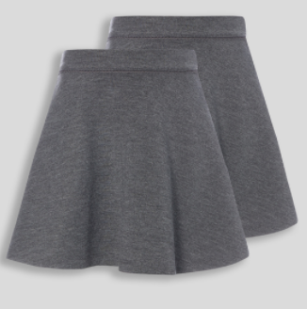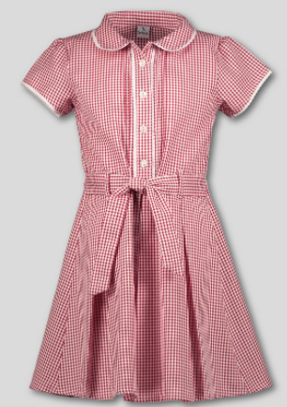

**Red cardigan or jumper**

*We cannot be held responsible for any lost clothing that is not labelled.*



**Black shoes**

To promote independence the children must be able to put on their own shoes. Therefore, we ask that all children come to school in Velcro shoes (black boots can be worn in the winter).

Shoes cannot have other colours, coloured soles, logos or coloured tags. Only completely black is acceptable.

****

**PE kit**

Children can come to school already dressed in their PE kit on their designated PE day. This can be black or red shorts and white t-shirt and jumper or cardigan (summer). Black or grey jogging bottoms, white t-shirt and jumper or cardigan (winter).

All items have to be plain, no logos, coloured stripes or brand names.

Uniform can be embroidered with the school logo. This is a personal choice and by no means expected. The following companies offer embroidery- all links are available on our website <https://www.harrowgateacademy.org/parents/uniform>











****

**School Meals**

**(30 hours children only, children attending for 15 hours will go home at lunchtime or begin nursery after lunchtime).**

**Cost**

Currently school meals cost £2.25p per day, £11.25 per week.

**Organisation of School meals**

We operate a wristband service, which means each morning children get to choose their lunch from a list of choices. There will always be two hot choices, a cold choice and a vegetarian choice. Our menu is available on the school website or you can obtain a copy from the main office.

We encourage that you discuss the meals on offer with your child.

**Packed lunch**

If you prefer to give your child a packed lunch we also encourage healthy eating in school. Chocolate, sweets or chocolate bars, fizzy drinks and energy drinks are not permitted.

**NUT FREE SCHOOL:**

We have children with severe nut allergies. Do not send your child with any food product that is nut based.

There is always milk and water available to drink.

**Parents as partners**

We encourage parents to become part of the Harrow Gate family. We communicate primarily through Class Dojo. This is a free app which can be downloaded via the app store. We make all our children an account then provide parents with a log in code. On class Dojo you can:

* Send and receive messages to all staff including the principal
* Be kept up to date with class message and celebrations on the class story and school story
* Be informed of any behaviour points your child has earned or lost
* Your child’s portfolio section of class Dojo: children share work they have achieved at school and you can share success at home also.

**Reports**

Parents receive an academic report termly. You will receive this via an email so please ensure that your email addresses are current at all times.

Parent meetings with the class teacher are held each term to discuss progress, celebrations and next steps for your child.

**Home – School Agreement**

A Home-School Agreement is a statement explaining:

\*the school’s aims

\*the school’s responsibilities towards its pupils who are of compulsory school age

\*the responsibility of parents

\*what the school expects of its pupils.

This is a simple agreement between the school, pupil and parent which outlines effective ways in which we can agree to work together to foster and maintain respectful and pro-active relationships as your child moves through school.

|  |  |  |
| --- | --- | --- |
| **As a school we will:** | **As a parent / carer I will:** | **As a pupil I will:** |
| * provide a safe and happy environment where all children are valued, respected and listened to * provide excellent teaching and an engaging curriculum to meet the needs of all children * provide as much support as we can to help your child meet their full potential * provide opportunities for your child to practise what they have learnt in school at home * regularly share the progress of your child, through books being sent home, online reporting, regular parent consultation meetings * support your child to develop a moral and ethical compass for life enabling them to grow up to be the best person they can be through a Values-based education philosophy * achieve high standards of behaviour by providing opportunities for children to develop positive social relationships, self-esteem and a sense of responsibility * teach your child to develop a positive attitude to others regardless of: * age * disability * gender * race * religion or belief * marriage or civil partnership * respect the confidentiality of information regarding each child. * provide information to you about our school, including relevant policies, meetings, workshops, and events by: * sharing information via ‘Class Dojo’ * keeping our website up-to-date, * providing a monthly news letter   updating an annual calendar of events at regular intervals. | * make sure my child attends school regularly and arrive at school by 8:55am * wears the correct school uniform (or PE kit on the appropriate day) * let the school know of any concerns or worries that may be affecting my child’s learning, behaviour or ability to do home learning, so that school can support and hopefully be resolved quickly * support Harrow Gate’s values- Achievement, Resilience and Trust – and education philosophy by encouraging my child to develop a positive attitude our every member of our community and beyond * attend meetings with my child’s teacher and other staff, aiming to be positive and productive, working towards moving my child on in their learning * support and work with the school to   ensure that the behaviour policies of the school are maintained   * respect the confidentiality of each child * Follow the schools ‘Code of conduct’ policy at all times. * regularly read information on the schools:   Dojo pages  Twitter Account  Website  Newsletters  So that I am kept-up to-date with important details of relevant policies, meetings, events and information about my child.   * update school immediately of any changes in:   contact phone numbers  address  family situation  health issues | * come to school regularly and on time, * wear school uniform (or PE kit on   appropriate days)   * be tidy in appearance and hygienic * follow Harrow Gate’s values of:   Achievement Resilience and Trust  by respecting and empathising with others   * follow our golden rules:   \*we will follow instructions  \*we talk politely and use good manners  \*we will care and show respect to others (never hurting anyone)  \*we will look after our school and the belongings of all  \*we will be honest and take responsibility for our actions  \*we will have a positive attitude towards our learning and others   * be responsible for my school and home learning * take good care of the building, equipment and school grounds * reflect on my behaviour and learning and learn from all experiences * Tell a member of staff if I am worried or unhappy. |

**Behaviour Expectations**

**At Harrow Gate Primary Academy we:**

* Aim to motivate children and raise self-esteem
* Value achievement and show appreciation of good work and behaviour
* Have high expectations with regard to behaviour and encourage pupils to take responsibility for their own actions
* Aim to provide children, irrespective of age, social class, gender, race, religion, academic or physical ability, with a learning environment that all pupils respect and which is safe and secure. In this environment, we hope that pupils will feel happy, comfortable and confident.
* Encourage the child to develop self-discipline, awareness and respect for their own needs and rights and those of others, a caring attitude for people, property and environment.
* Aim to ensure that all adults present a positive role model for children to follow and ensure a positive atmosphere for learning where everyone can maximise their potential.
* Feel strongly that it is important for children to receive their education in a stable and ordered environment. Children are expected to be polite, helpful and hard working.
* Whilst our ultimate aim is to promote self-discipline and to offer pupils incentives to work hard and conduct themselves appropriately, we recognise that in certain circumstances, sanctions are considered necessary.

**Staff Expectations**

Members of the staff at Harrow Gate have a very important role to play and adhere to the following code of practice:

* The whole staff, both teaching and non-teaching must take responsibility in the maintenance of the ethos and discipline in school to provide consistency.
* Praise where appropriate
* Draw attention to good behaviour. Attention should be focused upon positive attributes.
* Rules should be expressed positively and their rationale explained. Pupils should also play a part in forming school and classroom rules.
* A balanced system of rewards and sanctions should be in place.
* Minimise unnecessary confrontation, undue criticism, embarrassment.
* All responses should be seen to be fair.

**Pupil Expectations**

We expect the children at Harrow Gate to:

* Address/refer to all members of staff and other pupils politely and by using their name.
* Be honest and accept responsibility for own actions and belongings.
* To arrive at school on time, appropriately dressed and with a positive attitude to work.
* To walk around the school and enter and leave school in an orderly manner. This also applies to cloakrooms.
* To show kindness and tolerance towards others without bullying mentally, physically or emotionally.
* To remember good manners saying please, thank you, excuse me.
* Not to swear or use bad language.
* Not to interrupt when someone is already talking.
* To eat sensibly with good manners at the lunch tables.
* To care for the environment and use the litterbins provided.
* To care and use school property and equipment correctly and sensibly.
* To use the toilets properly and always wash hands afterwards.
* To remain the playground before school and at break and lunchtimes unless it is wet weather or pupils have specifically been given permission to stay in.
* To never leave the school grounds during school hours unless supervised by a member of staff or collected by an authorised person.
* To refrain from bringing chewing gum, bubble gum, sweets, crisps and chocolates into school.
* To wear only the minimum jewellery – watches, small sleeper earrings or studs.

The children are constantly reminded in a positive way of these guidelines and expectations and are informed of the school rules in assembly on a termly basis. The school rules and code of conduct are also displayed around the school.

**\*see school rules poster**

**In our classrooms:**

At Harrow Gate we believe that positive teaching strategies help prevent disruptive behaviour. Children are given work appropriate to their needs so that self-esteem and confidence will develop, the children then feel an integral part of the school and will not cause disruption. They will want to come to school and will be able to achieve success.

* Routines are clearly established. The children are involved in this process.
* Children are expected to participate in all activities with a positive attitude.
* Consistent expectations for learning are set.
* Pupils are made clear about what is expected of them.
* Tasks are matched to ability to ensure a sense of success for all children. Learning Intentions are communicated to the children in every lesson to ensure that children know what, how and why they are learning and why.
* Children are listened to and taken seriously.

At Harrow Gate, we get to know the children educationally and emotionally. We believe that children are only able to learn when they are able to focus and concentrate. All staff ensure that children have the emotional and wellbeing support to enable them to focus on their learning.

**Rewards**

All staff recognise the importance of praise and celebration of achievement.

Therefore as well as verbal praise, stickers and quick notes home, we also use the following rewards:

**Class Dojo:**

* The children will be rewarded with Dojos to reflect their positive behaviour for learning / exceptional achievement
* Weekly: 100% club have access to activities at an appropriate time in the week
* Percentages are calculated weekly and children who score above the school bench mark of 95% will select a prize from the class dojo prize draw
* The child with the highest total for the week will select a prize from the SUPER DOJO draw

Parents can keep a check on their child’s achievements through their own personal log in.

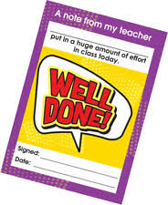

**Praise Pads/post cards:** Daily rewards from all staff:

Children receive a praise pad note from staff in acknowledgment of any achievements or celebrations.

****

**A R T Awards**

Whole School Award from the Principal linked to **the A.R.T of Harrow Gate**.

Children are given recognition of achievements that are linked to Achievement, Resilience and Trust.

Children receive a certificate, sticker and wristband in a celebration assembly, where parents are invited to join their child in revelling in their glory

**Intervention Planning and Sanctions**

**Focus on learning -** It is also vital that the learning is well planned and differentiated so that all children are able to stay on task.

There are a number of strategies throughout the school to address poor behaviour and teachers are encouraged to develop their own methods which are appropriate to the age group and maturity of their classes. However, all staff at Harrow Gate follow the same protocol for intervention where this is necessary. This is the ‘stages’ and are as follows:

**Stage 1:**

**Non-verbal interventions:**

Often looks or a small head movement from the teacher is enough to deter children from further disruption.

**If the behaviour continues:**

**Verbal intervention – Calm and focused**

Although this is meant to be a warning, it is important that it is still linked (as far as possible) to learning or questioning. The children are clearly told the behaviour that is not appropriate in order for them to recognise it and stop.

**If the behaviour continues:**

**Consequence – Children receive a ‘Stage 1’ and this is recorded in Class Dojo.**

**Stage 2:**

If the children continue to struggle with their behaviour choices, they will receive TIME OUT

Time out from workplace and other pupils within the classroom:

EYFS- 3 mins / KS1- 5 mins / KS2- 10 mins

**Consequence – Children receive a ‘Stage 2’ and this is recorded in Class Dojo.**

**Stage 3:**

TIME OUT in another class within the same team

EYFS – 5 mins

KS1 – 10 mins

KS2 – 15 mins

**Consequence – Children receive a ‘Stage 3’ and this is recorded in Class Dojo.**

**At every stage when the child returns to their learning positively their behaviour stage resets to the beginning.**

**Stage 4 REMOVAL**

(If a child has an Individual Behaviour Plan then this must be followed by all staff to ensure positive behaviour returns.)

At this stage, the child will be removed from the class by the adult support available in the year group. This adult will walk the child to an area of school that is calm, quiet and focused so that they can support the child in identifying their behaviour needs, managing their emotions etc.

Once the child is calm, this can be as short or long as it needs to be, the adult supports the child back into the lesson and their learning.

If a child becomes / is extremely volatile then a stage 5 is appropriate**. Parents will be informed by a member of staff when a Stage 4 reached**

**Stage 5**:

**Internal or External Exclusion**

Decision as to behaviour consequence. Internal exclusion or fixed term exclusion.

Parents to be informed by Principal / Vice principal

**RED letter** to be sent.

½ day spent in Internal Exclusion

A child may go straight to a Stage 5 and the Principal or Vice Principal for the following:

* Abusive, threatening language and or behaviour towards another person.
* Malicious damage
* Serious fighting
* Proven theft

**A severe incident may include one or more of the following:**

* Endangering themselves or others
* Swearing at a member of staff
* Observed hurting another deliberately
* Refusal to comply with the ‘consequence’ instructions in the above stages.

Behaviour including any of the above may result in:

* Pupil being sent to the Principal / Vice Principal
* Parents immediately called to school
* Internal exclusion of the pupil
* Governors informed

 If behaviour is extreme and poses a threat to staff or pupils and parents are not available to remove their child from the premises, the police will be called.

Returning pupil after fixed term or internal exclusion – the pupil’s behaviour will be closely monitored for a fixed period. Repeated poor behaviour may result in a **Permanent Exclusion**

**Exclusions**

These are at the discretion of the Principal. Each serious misdemeanour will be considered and exclusion will depend on the severity and frequency. Harrow Gate Primary Academy undertakes internal / fixed term exclusions should the need arise.

**Internal exclusions**

Internal exclusion means that a child is excluded and removed from the school part of the building and school support staff will supervise. Work will be set for the child. Parents will be informed about the incident, the internal exclusion and the amended school times*.*

**Excluded for a fixed period of time.**

This is where a child is removed from school for a limited time period. The period can last from 2 – 5 days. Parents will be informed in writing of the reasons for exclusion. A date for the pupils return to school must be specified at the time of exclusion. The letter must inform the parents they have the right to appeal to the Governing body and LEA within 7 days.

The Principal / Vice Principal will take this course of action. The chair of the Governing body will be informed at the time of exclusion.

It is important to remember that exclusion only occurs when all other avenues have been explored and the pupil continues to demonstrate extremely aggressive behaviour or is not prepared to co-operate in any way. The child’s parents will have to be informed of the possibility of exclusion during consultation periods.

**Permanent Exclusions**

The same procedure must be adopted as for the fixed term exclusion.

The letter to the parent should:

· Explain that the exclusion is permanent

· Give the reasons for the exclusion

· Mention any previous warnings, fixed term exclusions or relevant information

· Inform the parents of their rights to make written and oral

representations to the Governing body.

***Any exclusions, whether fixed or permanent, are recorded on and cannot be removed from a child’s records.***

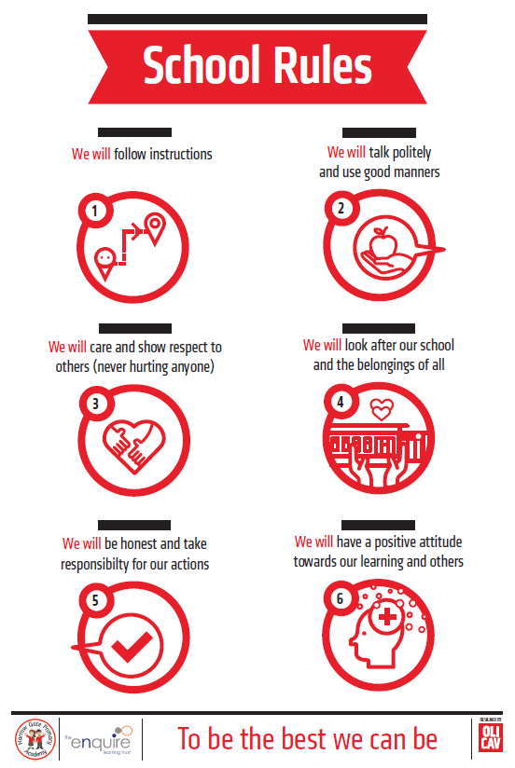

Promoting Positive Attendance

**Half-termly rewards**

If a child has 96% percent attendance across a half term they are included in an attendance treat- these can include bouncy castle time, arts, crafts, cooking sessions and travelling theatres and zoo groups.

**Termly awards assembly**

Children who have 100% over a full term will receive their bronze badge, and then over 2 terms they get their silver.

**Yearly**

If a child has 100% attendance, over a full year they receive their gold attendance badge and a special individual treat.

**Attendance and Expectations**

**What you can expect from Harrow Gate Primary Academy:**

* We will promote good attendance and punctuality and will investigate any unexplained and/or unjustified absence.
* We will work closely with parents/carers where child’s absence is cause for concern.
* We will support children to achieve good attendance and punctuality.
* We will support children returning to school after prolonged absence.

**What Harrow Gate Primary Academy expects from Children:**

* To attend regularly and on time
* To be punctual to all lessons
* To ensure that they register for all timetabled lessons and inform the Office where appropriate if they cannot be registered.
* To ensure all messages and notes from parents/carers are taken to the appropriate place.

**What Harrow Gate Primary Academy expects from Parents/Carers:**

* To ensure their child attends the academy on those days it is open, dressed in full uniform and equipped to learn.
* To ensure their child attends every day the Academy is open unless they are too ill to do so.
* To avoid keeping their child away from the Academy for any reason other than illness or other authorised explanation (see overleaf).
* To avoid arranging holidays during term time
* To immediately inform the Academy Office if their child is unable to attend (by **9:30** **am** where possible), including the reason for absence and expected date of return.
* If no indication of a return date has been given, parents/carers should contact the Academy on each day of absence.

If your child is ill then please let Miss Sam Scott in the office know either by the School Gateway app or by phoning the school office on 01642 673984.

Teachers like being kept in the loop of absence via the Class Dojo app. However, you MUST let the school office know about the absence first.

**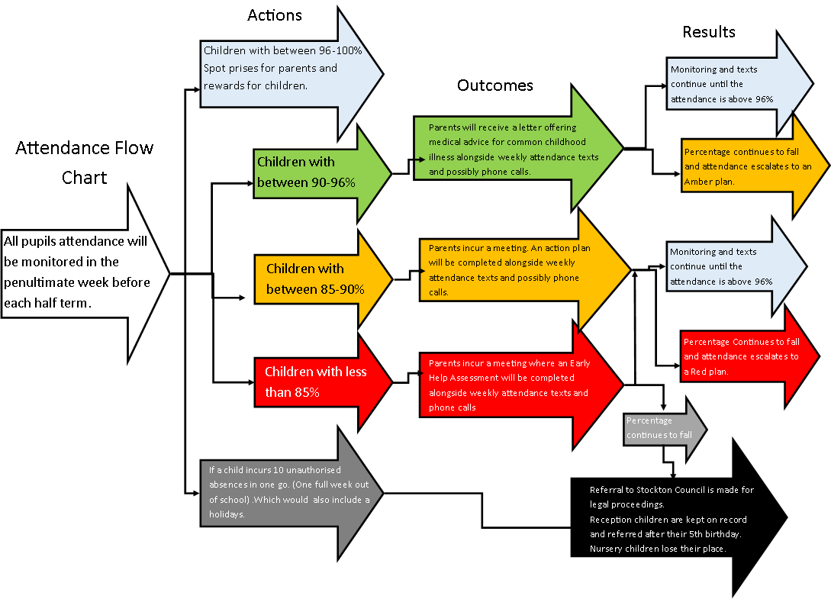The Attendance Flowchart**

**Safeguarding**

**Keeping Children Healthy and Safe from Harm**

We are committed to safeguarding and meeting the needs of all our children. Keeping them safe is a Key priority!

**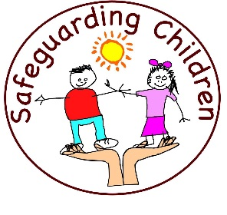**Harrow Gate Primary Academy is responsible for keeping your child safe in school. We put into place a variety of **Safeguarding** policies to ensure their health, learning and development is at the centre of all we do.

**What safeguarding means?**

* Protecting children from harm
* Protecting their health and development
* Protecting their physical and emotional needs.

**What we will do if we have a concern about one of our children?**

If we are concerned that a child may be, **in any way**, at risk of abuse or neglect, we will follow the procedures in our Child Protection Policy. The procedures have been written to protect all children and support families, children and staff.

**Firstly**, we will take advice from Social Care if we have a serious concern about your child. They will advise us on the appropriate steps to take and whether we can discuss our concerns with you. In almost all circumstances, you will be kept informed as to what you can expect to happen.

If you are concerned about the safety or welfare of any child, including your own, you should act immediately and ring Social Care,

The Children’s Hub  
Tel: 01642 130080

You will be able to speak with someone who will take any concerns seriously. They will ask for your name and address but you can ring anonymously.

**Please** tell us ifthere is anything in your child’s life that we need to know. Things that happen outside of school can affect their time with us both in and out of class.   
In school, the members of the Safeguarding team are; **Mrs. V. Galt** (overarching school safeguarding officer) alongside Mrs Kelly, Mrs Scotter and Mrs Holloway. As well as the Education Welfare Officer Mrs Karen Gibbon. You can of course speak to any member of staff and you are assured of prompt action to any problem you tell us about.

**Education Welfare Officer**

**Karen Gibbon**

Hello, I am Karen Gibbon,

I am here to help you with any worries or concerns you have about your child. It can be about home, school, or anything that can affect family life, so let us work together and make it a positive and happy school experience for everyone. We need good home-school communication to work in partnership.   
For my part, I can offer a listening ear, supporting the move to secondary school, welcome you as a new parent, and help with routines at home and information about other agencies.

I can also offer support with things like;

* Behaviour
* New to school
* Transition
* Attendance
* Housing and Debt
* Relationship breakdown
* Financial advice and food bank vouchers

I know parenting is not an easy job and at times things can get tough. It can be great and rewarding one day and challenging and helpless the next but I am here to help you! Do not feel alone or isolated, come and have a chat.    
   
There are many opportunities for you to come into school. I am available during school hours but I am happy to make other arrangements or home visits if that helps.

Call into school or phone **01642 673984** – And just ask Sam on main office to speak to me Karen Gibbon.

.

**Parents Code of Conduct**

At Harrow Gate Primary, we are very fortunate to have a supportive and friendly parent body. Our parents recognise that educating children is a process that involves partnership between parents, class teachers and the school community. As a partnership, our parents will understand the importance of a good working relationship to equip children with the necessary skills for adulthood.

For these reasons, we continue to welcome and encourage parents/carers to participate fully in the life of our school.

The purpose of this policy is to provide a reminder to all parents, carers and visitors to our school about the expected conduct. This is so we can continue to flourish progress and achieve in an atmosphere of mutual understanding.

**Guidance**

We expect parents, carers and visitors to:

* Respect the caring ethos and core values of our school
* Understand that both teachers and parents need to work together for the benefit of their children.
* Demonstrate that all members of the school community should be treated with respect and therefore set a good example in their own speech and behaviour.
* Seek to clarify a child’s version of events with the school’s view in order to bring about a peaceful solution to any issue.
* Correct own child’s behaviour especially in public where it could otherwise lead to conflict, aggressive behaviour or unsafe behaviour.
* Approach the school to help resolve any issues of concern.
* Avoid using staff as a threat to stop children’s behaviour at home.

Any concerns you may have about the school must be made through the appropriate channels:

* speaking to the class teacher
* a member of the Leadership team
* the Executive Principal
* the Chair of Governors

This is so they can be dealt with fairly, appropriately and effectively for all concerned.

**In order to support a peaceful and safe school environment the school cannot tolerate parents, carers and visitors exhibiting the following:**

* Disruptive behaviour that interferes or threatens to interfere with the operation of a classroom, an employee’s office, office area or any other area of the school grounds.
* Using loud/or offensive language, swearing, cursing, using racist or homophobic language or displaying temper.
* Threatening to do actual bodily harm to a member of school staff, Governor, visitor, fellow parent/carer or pupil regardless of whether or not the behaviour constitutes a criminal offence.
* Damaging or destroying school property.
* Abusive or threatening e-mails or text/voicemail/phone messages or other written communication
* Racist or discriminatory comments or speech.
* Defamatory, offensive or derogatory comments regarding the school or any of the pupils/parent/staff, at the school on Facebook or other social media sites.
* The use of physical aggression towards another adult or child. This includes physical punishment against your own child on school premises.
* Approaching someone else’s child in order to discuss or chastise them because of the actions of this child towards your own child. (Such an approach to a child may be seen to be an assault on that child and may have legal consequences).
* Smoking and consumption of alcohol or other drugs whilst on school property.
* Dogs being brought on to school premises.

Should any of the above behaviour occur on school premises the school may feel it is necessary to contact the appropriate authorities and, if necessary, ban the offending adult from entering the school grounds.

We trust that parents and carers will assist our school with the implementation of this policy and we thank you for your continuing support of the school.

**Inappropriate use of Social Network Site**

Social media websites are being used increasingly to fuel campaigns and complaints against schools, Head teachers, school staff, and in some cases other parents/pupils.

The Governors of Harrow Gate considers the use of social media websites being used in this way as unacceptable and not in the best interests of the children or the whole school community.

Any concerns you may have must be made through the appropriate channels by speaking to the class teacher, the Principal or the Chair of Governors, so they can be dealt with fairly, appropriately and effectively for all concerned.

In the event that any pupil or parent/carer of a child/ren being educated in the Harrow Gate Primary is found to be posting libellous or defamatory comments on Facebook or other social network sites, they will be reported to the appropriate 'report abuse' section of the network site.

All social network sites have clear rules about the content that can be posted on the site and they provide robust mechanisms to report contact or activity that breaches this. The school will also expect that any parent/carer or pupil remove such comments immediately.

In serious cases, the school will also consider its legal options to deal with any such misuse of social networking and other sites. Additionally, and perhaps more importantly is the issue of cyber bullying and the use by one child or a parent to publicly humiliate another by inappropriate social network entry. We will take and deal with this as a serious incident of school bullying.

Thankfully, such incidents are extremely rare.

**Educational visits and enhanced curriculum**

We believe that educational visits are an integral part of the entitlement of every pupil to an effective and balanced curriculum. Appropriately, planned visits are known to enhance learning and improve attainment, and so form a key part of what makesthe Enquire Learning Trust a supportive and effective learning environment. The benefits to pupils of taking part in visits and learning outside the classroom include, but are not limited to:

* Improvements in their ability to cope with change.
* Increased critical curiosity and resilience.
* Opportunities for meaning making, creativity, developing learning relationships and practicing strategic awareness.
* Increased levels of trust and opportunities to examine the concept of trust (us in them, them in us, them in themselves, them in each other).
* Improved achievement and attainment across a range of curricular subjects. Pupils are active participant’s not passive consumers, and a wide range of learning styles can flourish.
* Enhanced opportunities for ‘real world’ ‘learning in context’ and the development of the social and emotional aspects of intelligence.
* Increased risk management skills through opportunities for involvement in practical risk-benefit decisions in a range of contexts. i.e. encouraging pupils to become more risk aware as opposed to risk averse.
* Greater sense of personal responsibility.
* Possibilities for genuine team working including enhanced communication skills.
* Improved environmental appreciation, knowledge, awareness and understanding of a variety of environments.
* Improved awareness and knowledge of the importance and practices of sustainability.
* Physical skill acquisition and the development of a fit and healthy lifestyle.

Payment

When organising activities, school trips or visits, which enrich the curriculum and educational experiences of the children the school expects parents will pay part of the cost of the activity. School always heavily subsidises the cost of any activities so that requests of payment are kept as low as possible. Parents have a right to know how each activity is funded and the school provides this information on request. Parents always have the right to withdraw their children form these educational visits/ activates however, the child is still expected to attend school. If we do not receive sufficient contributions, we may have to cancel an activity.

Residential Visits

The school organises residential visits out of school time, which is to provide education indirectly related to the National Curriculum. However, we do make a charge to cover the costs of board, lodging and travel. All parents are requested to make payment for these visits.

Swimming

The school organises swimming lessons for all children from Year 2 up. These take place in school time and are part of the National Curriculum. We make no charge for the actual swimming activity. We inform parents when these lessons are to take place. There is no charge to parents for this activity.

After school sports clubs

The school offers additional sports coaching after school. Sports coaches, who are not members of staff, run and organise these sessions. We make no charge for this activity.

**E-Safety**

Children are more increasingly using technological device and using the internet in all areas of their lives, here at Harrow Gate, we value the contribution of technology and the internet for educational and self-research purposes. We believe in teaching children about online safety and how to use the devices accurately and safely.

**Children in school are taught and expected to;**

* Are responsible for using the academy digital technology systems in accordance with the Acceptable Use Agreement.
* Have a good understanding of research skills and the need to avoid plagiarism and uphold copyright regulations
* Need to understand the importance of reporting abuse, misuse or access to inappropriate materials and know how to do so.
* Will be expected to know and understand policies on the use of mobile devices and digital cameras. They should also know and understand policies on the taking / use of images and on cyber-bullying.
* Should understand the importance of adopting good online safety practice when using digital technologies out of academy and realise that the Academy’s Online Safety Policy covers their actions out of academy, if related to their membership of the Academy.

**Parents and carers are expected to;**

Play a crucial role in ensuring that their children understand the need to use the internet / mobile devices in an appropriate way. The academy will take every opportunity to help parents understand these issues. Parents and carers will be encouraged to support the academy in promoting good online safety practice and to follow guidelines on the appropriate use of:

* Digital and video images taken at academy events.
* Use of social media.
* Their children’s personal devices in the academy (where this is allowed).

**GDPR Privacy Notice**

**Who processes your information?**

Harrow Gate Primary School is the data controller of the personal information you provide to us. This means the school determines the purposes for which, and the manner in which, any personal data relating to pupils and their families is to be processed.

In some cases, your data will be outsourced to a third party processor; however, this will only be done with your consent, unless the law requires the school to share your data. Where the school outsources data to a third party processor, the same data protection standards that Harrow Gate Primary School upholds are imposed on the processor.

Liz Thompson is the data protection officer. Their role is to oversee and monitor the school’s data protection procedures, and to ensure they are compliant with the GDPR. The data protection officer can be contacted [liz.thompson@enquirelearningtrust.org](mailto:liz.thompson@enquirelearningtrust.org)

**Why do we collect and use your information?**

Harrow Gate Primary School holds the legal right to collect and use personal data relating to pupils and their families, and we may receive information regarding them from their previous school, LA and/or the DfE. We collect and use personal data in order to meet legal requirements and legitimate interests set out in the GDPR and UK law, including those in relation to the following:

* Article 6 and Article 9 of the GDPR
* Education Act 1996
* Regulation 5 of The Education (Information About Individual Pupils) (England) Regulations 2013

In accordance with the above, the personal data of pupils and their families is collected and used for the following reasons:

* To support pupil learning
* To monitor and report on pupil progress
* To provide appropriate pastoral care
* To assess the quality of our service
* To comply with the law regarding data sharing
* To safeguard pupils

**Which data is collected?**

The categories of pupil information that the school collects, holds and shares include the following:

* Personal information – e.g. names, pupil numbers and addresses
* Characteristics – e.g. ethnicity, language, nationality, country of birth and free school meal eligibility
* Attendance information – e.g. number of absences and absence reasons
* Assessment information – e.g. national curriculum assessment results
* Relevant medical information
* Information relating to SEND
* Behavioural information – e.g. number of temporary exclusions

Whilst the majority of the personal data you provide to the school is mandatory, some is provided on a voluntary basis. When collecting data, the school will inform you whether you are required to provide this data or if your consent is needed. Where consent is required, the school will provide you with specific and explicit information concerning the reasons the data is being collected and how the data will be used.

**How long is your data stored for?**

Personal data relating to pupils at Harrow Gate Primary School and their families is stored in line with the school’s GDPR Data Protection Policy.

In accordance with the GDPR, the school does not store personal data indefinitely; data is only stored for as long as is necessary to complete the task for which it was originally collected.

**Will my information be shared?**

The school is required to share pupils’ data with the DfE on a statutory basis.

The National Pupil Database (NPD) is managed by the DfE and contains information about pupils in schools in England. Harrow Gate Primary School is required by law to provide information about our pupils to the DfE as part of statutory data collections, such as the school census; some of this information is then stored in the NPD. The DfE may share information about our pupils from the NDP with third parties who promote the education or wellbeing of children in England by:

* Conducting research or analysis
* Producing Statics
* Providing information, advice or guidance

The DfE has robust processes in place to ensure the confidentiality of any data shared from the NDP is maintained.

Harrow Gate Primary School will not share your personal information with any third parties without your consent, unless the law allows us to do so. The school routinely shares pupils’ information with:

* Pupils’ destinations upon leaving the school
* The LA
* The NHS
* The DfE
* Enquire Learning Trust

**What are your rights?**

Parents and pupils have the following rights in relation to the processing of their personal data.

You have the right to:

Be informed about how Harrow Gate Primary School uses your personal data.

* Request access to the personal data that Harrow Gate Primary School holds.
* Request that your personal data be amended if it is inaccurate or incomplete.
* Request that your personal data is erased where there is no compelling reason for its continued processing.
* Request that the processing of your data is restricted.
* Object to your personal data being processed.

Where the processing of your data is based on your consent, you have the right to withdraw this consent at any time.

If you have a concern about the way Harrow Gate Primary School and/or the DfE is collecting or using your personal data, you can raise a concern with the Information Commissioner’s Office (ICO). The ICO can be contacted on 0303 123 1113, Monday-Friday 9am-5pm.

**Where can you find out more information?**

If you would like to find out more information about how we and/or the DfE collect, use and store your personal data, please visit our website [www.harrowgateacademy.org](http://www.harrowgateacademy.org) and download our GDPR Data Protection Policy