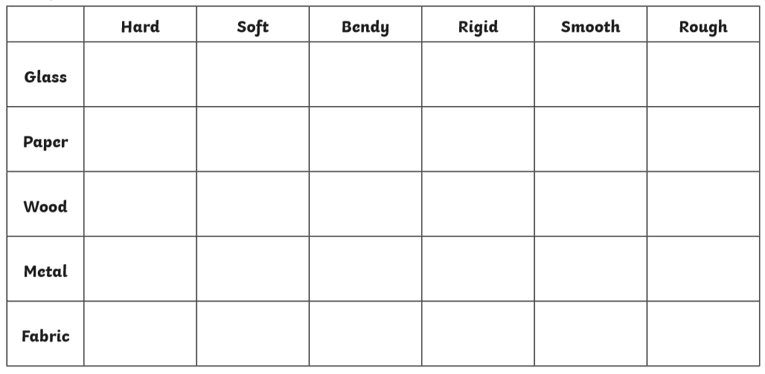
Properties of Material
Explore you home and garden for different materials. What do they feel like?
Tick the correct words, which describe the material.

