How are Christmas and Diwali similar and different?
R.E Vocabulary Organiser
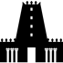  Mandir  Shrine | A Hindu temple, the place of worship  A place where people worship NOT a building
Diva lamp | A small lamp
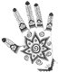  Mehndi | Henna temporary tattoo drawn on hands feet and body
Diwali | Festival celebrated by Hindus
Puja | The daily Hindu worship
Rangoli | Bright coloured patterns drawn on the ground outside
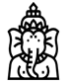  Ganesh  Lakshmi | The god of wisdom and good luck  The goddess of wealth and good fortunate
Bible | Christian holy book.
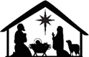  Nativity | Tells the story of the birth of Jesus Christ.
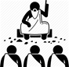  Disciples | A person who followed a teacher.
Tradition | A long established custom. Custom means a way of doing something at a particular time – A birthday cake  Presents at Christmas
Worship | Showing love for God through prayer.
The Vedas | The most important of Hindu texts
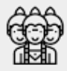  Deity | A god or goddess

