**Reception Home Learning**

**Easter Activities**

**Have a Happy Easter!**

**Spring Observations**

Have a look outside. What signs of spring can you see?

Draw a picture and label it or write a caption to let us know what you have observed, for example, I can see….

Use your listening ears to hear the phonemes as you segment the words for writing.

Send a photo of your work and any spring observations you can make from your window.

**Make an Easter Card for Your Class**

Draw a picture and write a message to your class. Send it through Dojo and we will share your picture or video on Class Story for all of your friends to see!

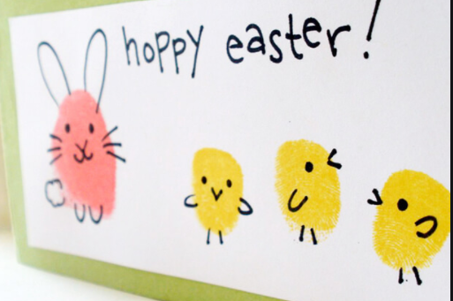

**Keeping Fit**

Easter Cosmic Yoga <https://www.youtube.com/watch?v=kxk7> 8inN-3Y

**Traditional Egg Decorating**

Maybe you have some eggs that are out of date? Why not decorate them and have a competition with your family?

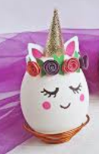 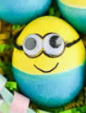  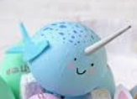

**Shape Easter Eggs**

Draw large oval Easter eggs and decorate them by drawing and colouring different shapes and patterns. What shapes can you name?

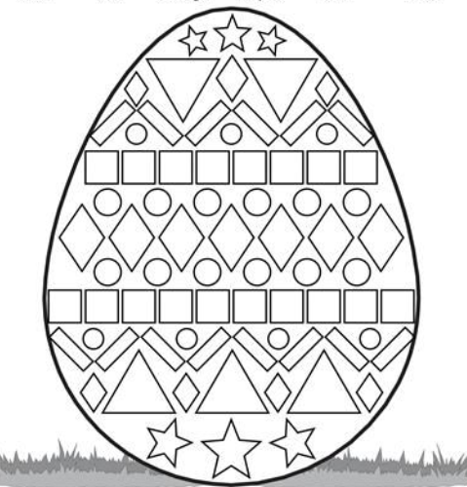

Watch the Easter Story – <https://www.youtube.com/watch?v=Wnbo2AmS3OI>

<https://www.youtube.com/watch?v=0PSgoPdKQFQ>

BBC Easter Recipes for kids- <https://www.bbcgoodfood.com/recipes/collection/easter-kids>

A fun song to learn for Spring –

<https://www.youtube.com/watch?v=IEey4LZLeGw>

**Daily Practise!**

Please keep in touch. We would love to see what you are doing!

* Practise writing your name
* Practise saying the letter names and sounds using the sound mat, ‘the name is…the sound is…’
* Practise saying the non decodable words on the sound mat.
* Count from 0-20 then from 20-0.
* 10 minutes of reading.
* Listen to a story.

**Egg Carton Flowers**

<https://www.iheartartsncrafts.com/egg-carton-flowers-kids-craft/>

Or, you can use your coloured pencils to create spring flowers.

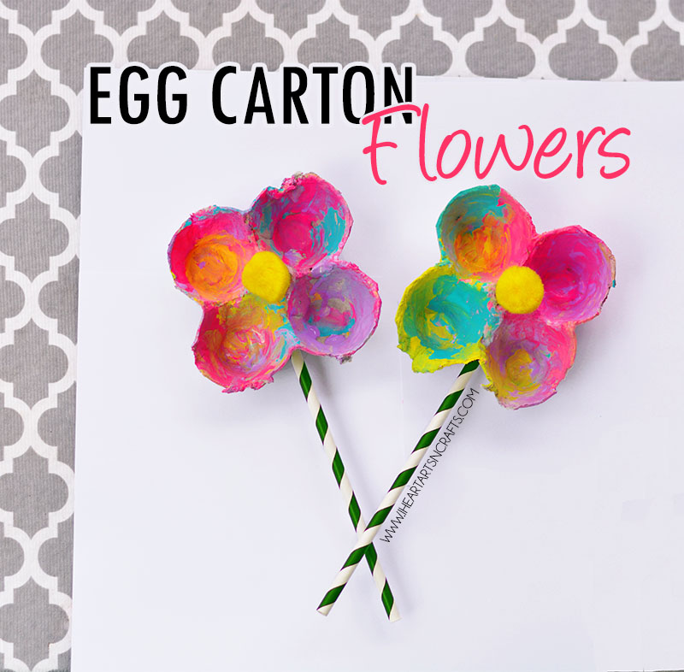

4

6

10

**Phonics Activity**

Watch one of the Easter stories.

* Draw a picture of one of the scenes from the story.
* Label your picture or write a caption to describe what is happening. E.g.

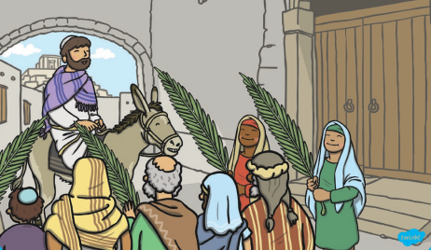

Jesus is on a donkey.

**Maths Activity**

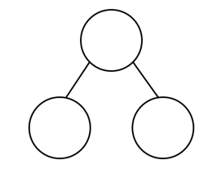

Use your part part model to practise number bonds.

Then use what you have learnt to write the matching addition and subtraction sentences in your maths book.

E.g.

6 + 4 = 10

4 + 6 = 10

10 – 6 = 4

10 – 4 = 6