

Every day I should:

* Write my name
* Practise saying the letter names and sounds using the sound mat
* Practise saying non-decodable words using the sound mat
* Count from 0-20 then from 20-0
* Practise handwriting one letter in your book
* Practise writing one number from 0-9 sheets
* 10 minutes of reading
* 20 minutes of topic work
* Listen to a story
* Exercise e.g. by taking part in P.E with Joe or Cosmic Yoga on YouTube.

It is up to you what time your child completes their home learning during the day.

**My Logins / Websites**

<https://www.mathletics.com/uk/>

<https://www.phonicsplay.co.uk/> **Phase 2, 3 and 4 games only**.

<https://www.storylineonline.net/> To listen to stories.

<https://twitter.com/audibleuk/status/1240680479470366721?s=12> To listen to stories.

[https://www.worldofdavidwalliams.com](https://www.worldofdavidwalliams.com/) To listen to stories.

<https://www.twinkl.co.uk/go> For assigned phonics, maths and topic activities. Use the code **LC8704**

<https://www.youtube.com/watch?v=Rz0go1pTda8> P.E with Joe.

PE with Joe YouTube

Maths

We will be practising maths we have already learned in class.

* Can you practise your doubles song using

[**https://www.youtube.com/watch?v=8jOzhiACB68**](https://www.youtube.com/watch?v=8jOzhiACB68)

Using this song can you practise writing doubles in your maths book using the addition symbol. If you get stuck remember to use your fingers and maybe you could find some things around the house to add together. For an extra challenge could you make up your own addition sentences. Don’t forget when you write it in your maths book ‘1 number, 1 square.’ e.g 5+0=5

* Can you write the numbers 0-10 across the top of your maths book? Under each number can you a coloured circle to match each number correctly? For an extra challenge you could write the number 0-20 with a coloured circle to match each number.

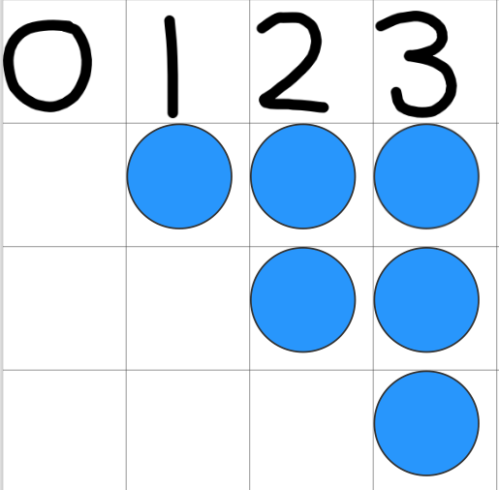

* Complete the assigned tasks on Mathletics. Each child’s username and password is on the front cover of their blue maths book.

Phonics over the week

We are going to be learning the digraphs ch, sh, th, ng and oa this week. This will include words that contain these, how to use them and the formation.

**Digraph ch**

<https://www.youtube.com/watch?v=mGSFG37LewA>

**Digraph sh**

[**https://www.youtube.com/watch?v=7gBsGxhdt2E**](https://www.youtube.com/watch?v=7gBsGxhdt2E)

**Digraph th**

<https://www.youtube.com/watch?v=7f74GArsWis>

**Digraph ng**

[**https://www.youtube.com/watch?v=Nrjb0rIer5M**](https://www.youtube.com/watch?v=Nrjb0rIer5M)

**Digraph oa**

<https://www.youtube.com/watch?v=M8nGaspuWAQ>

Can you practise writing some of the words using each sound in your writing book?

Look out every day on class story for a new picture to write a sentence about. Extra Dojo’s if you can put an ‘and’ in your sentence.

Reception Home Learning

Week beg 30.3.2020

23.3.2020