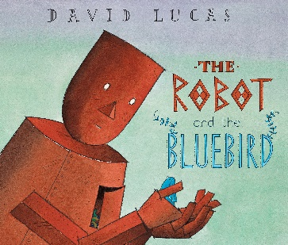

Robot and the Bluebird

English Vocabulary Organiser
hollow | Having an empty space inside.
shelter | A place that protects you from bad weather or danger.
storms | Strong winds and usually rain, thunder, lightning, or snow.
outstretched | To extend or stretch out.
scrap | To get rid of something.
rusting | Rust is a brown substance that forms on iron or steel, for example when it comes into contact with water.
Autumn | The season between summer and winter when the weather becomes cooler and the leaves fall off the trees.
weakly | Not having strong muscles.
farther | A long way from somewhere.
shivered | To shake because you are cold or frightened.
astonished | To be surprised or shocked.
fluttered | To make a lot of quick movements.
creaking | A short, high pitched sound when something is moving.
clanking | When large metal objects clank, they make a noise because they are hitting together or hitting against something hard.
strength | How physically strong you are.
faintest | Barely visible.
whisper | To say something very quietly.

Synonyms
Using synonyms will help to expand your child’s vocabulary and allow them to experience new language! While reading ‘’Robot and the Bluebird’ I will expose the children to new words.
Home challenge, see if you can use synonyms while talking to your child.
Book language | Synonym
Hollow | Empty
Shivered | Trembled
Astonished | Surprised
Creaking | Squeaking

