Key vocabulary
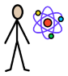  Scientist | Someone whose job it is to teach or do research in science.
  Comparative test | A test that compares the effect of different things.
  Observing changes over time | To notice something and record it as being important.
  Grouping and classifying | A number of people or things that are put together and considered the same.
  scientific question | A question that may lead to a hypothesis and help us in answering (or figuring out) the reason for some observations.
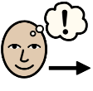  Prediction | A statement about what you think will happen in the future
  Findings | To learn the facts about something.
  Data | Information in the form of facts or numbers.
  Test | A test is a deliberate action or experiment to find out how well something works.
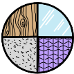  Material | A solid substance, for example a cloth.
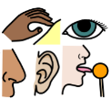  Senses | The physical abilities of sight, smell, hearing, touch, and taste.
  Absorb | To take in a substance.
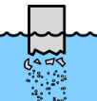  Dissolve | To become completely mixed with a liquid.
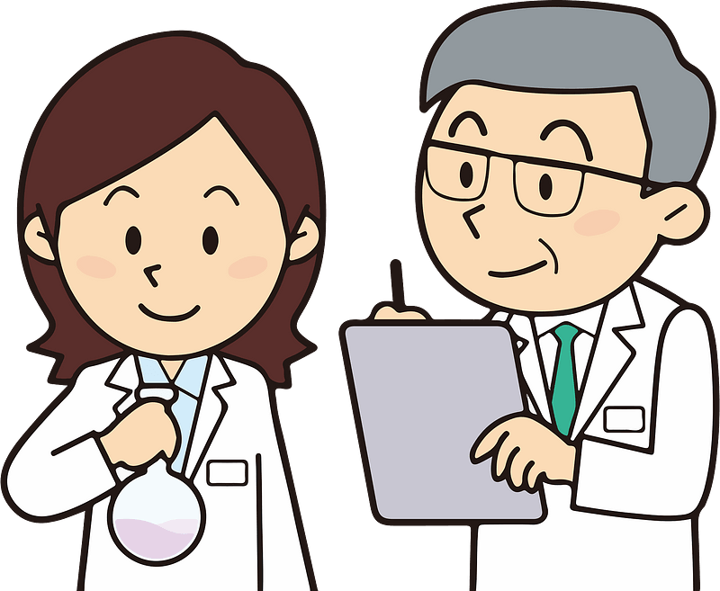
What is a scientist?

