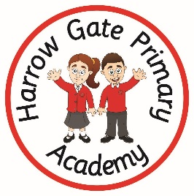
Harrow Gate Primary re-opening instructions
Harrow Gate Primary will reopen On Monday 8th June 2020 as long as the Government 5 measures have been met. These are:
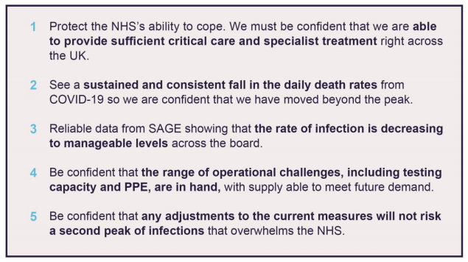

Children of Keyworkers
Children must attend school in uniform
Please read the information below carefully so that you can ensure that we all reduce the risk of spreading COVID 19.
One adult is to bring and collect children from school.
Entrance and Start time: Bring your child to the Main Entrance at whatever time meets your working needs from 8:00am. Please do not wait around outside of school, as this will increase the risk of contamination. You will NOT be able to enter the school building.
You must not be late, as this will cause a problem with other classes who are entering after your child.
Collection and End time: Collect your child from the Main Entrance at whatever time meets your working needs up to 4:00pm.
Our safety measures to limit spread of COVID 19
How we will socially distance the children

Small groups of approximately 15 children working together with one/two members of staff as an isolated group. Each group will be in a separate room.
Older children will be kept apart as much as possible through room design.

It will be very difficult to socially distance younger children within each group however, they will not mix with other groups. Open spaces and increased hygiene will be used to protect them.

Hygiene will be enforced at all times.

Class supervision
Staff rotas have been created so that staff’s time in the building is minimised.
This means that your child will not always have their class teacher. All groups will be supervised by a qualified, familiar member of the Harrow Gate staff.
Break time and Lunchtime play

Each group will remain together. We have divided the school site into separate areas so that the children do not mix groups.
They will get regular short breaks outside throughout the day. Older children will be encouraged to play games that allow some level of distancing.
Younger children will have lots of space to run around using their outdoor areas.

Play equipment will be shared as little as possible and if it is shared, it will be cleaned between uses.

Hygiene will be enforced at all times.

What other measures are in place in the classroom?

All children must bring their learning packs to school!
Using their own pencil case and equipment will reduce the risk of spreading COVID.

Single iPads will be available to each child on their desk and not shared. These will be wiped regularly through the day and at the end of the day.

There is access to soap and sanitiser, which will be regularly used.

There will be regular cleaning of surfaces.

Nursery and Reception children will stay with their small groups. Equipment will be restricted to items that can be washed easily.

Hygiene will be enforced at all times.

The dinner hall

Children will eat lunch in the hall at a safe social distance.

They will only do so with their group.

Hygiene will be enforced at all times.

Start and end of the day
Each group/bubble will be allocated a specific drop off and pick up time. Please refer to above for your child’s time and location for drop-off and collection.

Only one parent can accompany the child to school.

You must social distance and keep a gap between yourself and other parents.

Staff will remind you if you are getting too close.

What happens if a member of staff or a pupil gets Covid 19?
If a child / adult becomes ill at school, we will isolate them immediately from the rest of the building.
Parents will be called if a child needs to be taken home
A temporary withdrawal of the whole group will then be applied so that deep cleaning can happen and then all children in that group can return.

If the child / adult tests positive then all members of this group MUST self-isolate for 14 days.

