|  |
| --- |
| Key Diagrams |

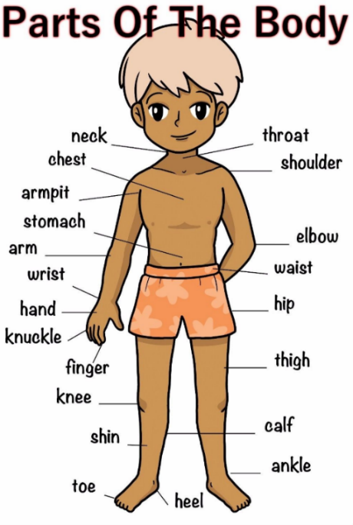

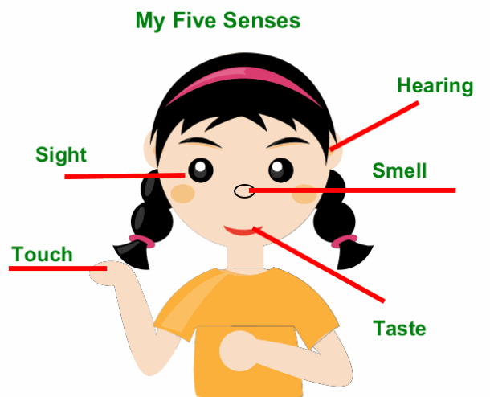

|  |  |
| --- | --- |
| Key Information | |
| 1 | A mammal is a warm-blooded vertebrate animal that is distinguished by the possession of hair or fur, females make milk for their young, and (typically) the birth of live young. |
| 2 | A fish a limbless cold-blooded vertebrate animal with gills and fins living always in water. |
| 3 | A bird is a warm-blooded egg-laying vertebrate animal distinguished by the possession of feathers, wings, a beak, and typically by being able to fly. |
| 4 | A reptile a vertebrate animal. They are distinguished by having a dry scaly skin and typically laying soft-shelled eggs on land. |
| 5 | Senses are the things that happen inside our body to tell us about the world around us. |

|  |  |
| --- | --- |
| Vocabulary | |
| Human | A person |
| Biology | **Biology** is the branch of science that studies life and living organisms. |
|  |  |
| Vertebrate | Animals with a back bone. |
| invertebrate | Animals without a back bone. |
| amphibian | A cold-blooded vertebrate animal. They are born in water and then live on the land as an adult. |
| carnivore | An eater of meat e.g. lion |
| herbivore | An eater of plants. |
| hearing | The sense that makes you aware of sounds. |
| sight | The act of seeing something with your eyes. |
| smell | To notice something when you breathe in through your nose. |
| taste | Your ability to recognise the flavour of things with your tongue. |
| touch | The ability to tell what something is like when you feel it with your hands. |