Key Diagrams

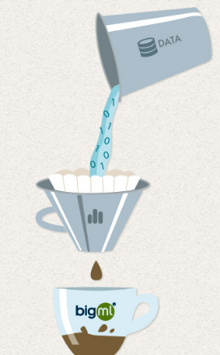
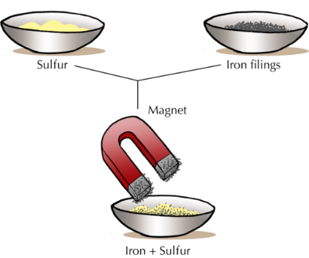
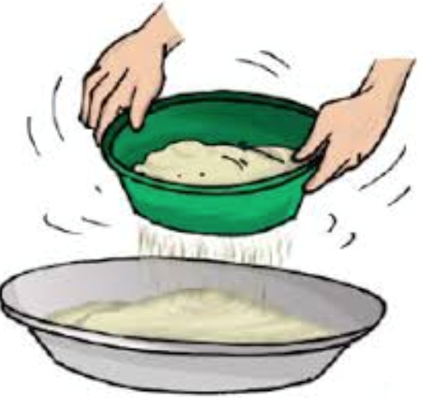

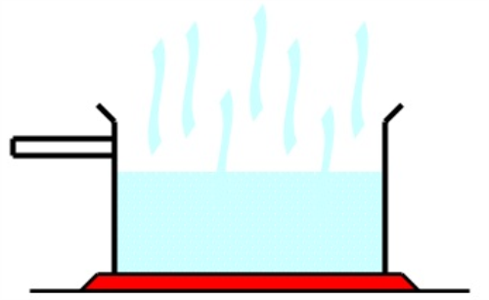

John Dunlop (1840-1921)

Key Information
Different materials have different properties and can be sorted or separated according to these properties
Dissolving a solid in water gives a solution where you can’t see the solid anymore
Solids mixed together is called a mixture
A mixture can be separated in different ways depending on what materials have been mixed
Some mixtures are not separable and these are called irreversible changes and they last forever
Some material turns into something that looks and feels different but it isn’t a permanent change.
John Dunlop invented the pneumatic tyre – changing the design of transport and vehicles.
Vocabulary
Insulator | A material or an object that does not easily allow heat, electricity, light, or sound to pass through it.
Conductor | A material or an object that does easily allow heat, electricity, light, or sound to pass through it.
Dissolve | To become incorporated into a solution.
Soluble | A material that is able to dissolve in water.
Insoluble | A material that cannot dissolve in water.
Sieving | A way to separate materials from on another due to their size.
Filtration | A mixture of solids and liquids are separated using paper with tiny holes trapping the solid particles.
Evaporation | Liquid elements can be heated and turned into a gas, leaving solid particles behind.
Magnetism | The metallic particles attract to the magnet leaving other particles behind.
Independent Variable | The variable that can change in an experiment.
Dependant Variable | Variables that must stay the same to ensure a fair test
Transparent | Completely see through
Solution | A mixture of a solid and liquid or two liquids
Reversible | A change to a material but it is not permanent
Irreversible | A change that will last forever
