**School will,**

* Send a home learning grid and a grab bag of resources for each child’s home learning needs
* Organise phonics and maths activities on Education City.
* Send phonics, maths, topic and English related tasks on class dojo portfolio daily.

**Keeping Fit:**

Cosmic Yoga

<https://www.youtube.com/watch?v=KAT5NiWHFIU>

Boom Chicka Boom

<https://www.youtube.com/watch?v=69f9sCwhwYk>

**Number bonds to 10**

<https://www.youtube.com/watch?v=lD9tjBUiXs0&t=108s>

**Topic video**

Brown bear facts

<https://www.youtube.com/watch?v=DAO0e9_L_ss>

We are going on a bear hunt

<https://www.youtube.com/watch?v=-d1_Z068z74>

Parents will,

* Let school know if your child is too unwell to complete any work via a Dojo message.
* Supervise children when using the resources specifically for home learning.
* When your child is writing their name, ensure they are holding the whiteboard pen/pencil correctly.
* Upload a photo of your child’s work onto Dojo.

Parents will ensure their children:

* Write their name, using their name card and independently.
* Count from 0-20 then from 20-0.
* 10 minutes of reading.
* Listen to a story at least once a day.
* Log onto Education City and complete your allocated activities over the 2 weeks.
* Practise writing the numbers 0-9.
* Sing the days of the week song <https://www.youtube.com/watch?v=3tx0rvuXIRg>

**Home Learning Expectations for Reception – Spring 1**

We expect your child to complete a little work every day whilst they are off school to isolate unless they are showing symptoms of Covid-19 and are too unwell to do so.

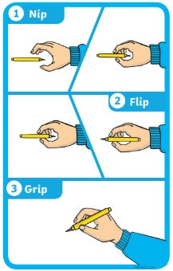

**Discuss the Weather and Season**

Discuss the weather daily. What do you observe happening outside? Do we have to take any measures against the weather? (Wellies and umbrella).

Discuss the month and season. What changes can you see happening outside?



**Creative Activity**

Use your playdough or pencils to create a picture of a bear and it’s habitat (where it lives).