

**Web sites / interactive learning**

Log in to Duolingo and practise your French learning so far (using the passwords/usernames given in school) <https://www.duolingo.com/>

BBC Bitesize French KS2 <https://www.bbc.co.uk/bitesize/subjects/zr8jmp3>

Count to 10 by singing along to the song <https://www.youtube.com/watch?v=lsc3qLMaCu8>

[**Monde de Petits**](http://www.mondedespetits.fr/comptine.php) is a French web site for kids filled with songs and activities. <https://www.mondedestitounis.fr/comptine.php>

**Subject specific activities**

Create a word search using French words. This could be colours, numbers, greetings or a mix of everything!

Make a double page spread about France’s famous landmarks (Eiffel tower, Palace of Versailles, Arc de Triomphe)

Spend 20 minutes practising your learning on duolingo

Listen to these French nursery rhymes – can you learn to sing one by heart? <https://www.youtube.com/watch?v=INXFEZpV8iU>

Write a shopping list in French – can you challenge someone to translate it?

**Maths Based ideas**

Can you count to 10 in French? Play this game to test your skills <https://primarygamesarena.com/Play/in-French-2117>

Can you count to 20 in French? Play this game to test your skills <https://primarygamesarena.com/Play/in-French-2116>

Write 5 addition or subtraction questions and test the family! Don’t go past 20 – for example: Deux + huit = ____

**English based ideas**

Listen to a children’s story in French by a native French speaker <https://www.thefrenchexperiment.com/stories>

Can you research Gustave Eiffel and create a facts page/Power Point about his life?

**French**

**Art based ideas**

Can you make a model of the Eiffel Tower?

Draw or paint a landscape! Can you paint/draw Mont Blanc?

Create a colour wheel and label each colour in French 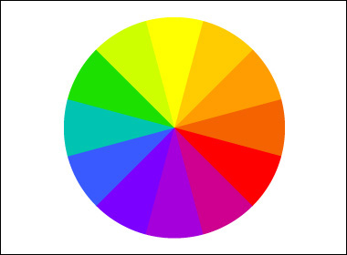

**TV shows**

***Petit Potam,*** French cartoons of a sweet little hippopotamus who drives the river ferry and tells lovely stories

**Sam sam**, is a 6-year-old good superhero “in training” living with his family and playing with his friends.

**Movement based ideas**

Count as you move! Complete the following warm up routine but you must count in French as you do it!

* 15 Star jumps
* 20 lunges (10 on each leg)
* 20 arm circles (10 on each arm)
* 10 sit ups