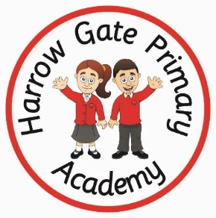de

**Art based ideas**

**Make a poster about why it is important to stay safe online** – watch this video for some great tips! <https://www.youtube.com/watch?v=aMSHtE42mmI>

**Why not design a new computer game character?** – What game will you character be for? Do they have any super powers? What about specific equipment?

**Web sites / interactive learning**

<https://beinternetlegends.withgoogle.com/en_uk/interland>

<https://secure.dbprimary.com/service/util/login?path=stockton%2Fprimary%2Fharrowgate>

<https://games.sense-lang.org/typingAlien.php>

**English based ideas**

Why not write a letter on Microsoft word to thank the NHS. Really, put your typing skills to the test!

**Movement based ideas**

**If/The Coding Game**: This activity introduces children to the **conditional statements** (If/Then Statements). A conditional statement tells the computer to execute a set of  action depending on a specific event.  The objective of the game is to follow the programmer’s instructions and perform a particular task.

**How to Play:**

For every round, one person is the Programmer and everyone else are the Computers. The Programmer stands in front of the Computers and gives them commands: "**If** I ____, **Then** you _____ " For example, the Programmer gave the command "**If** I turn in a circle, **Then** you turn in a circle." Or he can give challenging instructions like "**If**I touch my nose, **Then**you touch your legs."

**TV shows**

**Nursery and Reception:** How do computers work?

<https://www.bbc.co.uk/cbeebies/watch/nina-and-the-neurons-how-does-song>

**Key Stage 1 and 2: Two young coders visit BBC TV Centre to find out how code is used in making Dr Who.** <https://www.bbc.co.uk/teach/class-clips-video/computing-ks1--ks2-creating-computer-generated-visual-effects/zv2mhbk>

Programming a robot to play football.

<https://www.bbc.co.uk/teach/class-clips-video/computing-ks1--ks2-programming-robots-to-play-football/zjyvrj6>

**Subject specific activities**

**Be Internet Legends!** To make the most of the internet, children need to make smart decisions. Be Internet Legends empowers younger children to use the web safely and wisely, so they can be confident explorers of the online world. <https://beinternetlegends.withgoogle.com/en_uk/interland>

**DB primary:** Your class teachers will be setting regular coding challenges each week on DB Primary. Remember with coding you might need to explore and fail first before you can then debug!:

<https://secure.dbprimary.com/service/util/login?path=stockton%2Fprimary%2Fharrowgate>

**Typing Skills**: Saving the world is your mission! By typing fast on a keyboard, you will be able to defeat the aliens!

<https://games.sense-lang.org/typingAlien.php>