**Maths Based ideas**

**Litter Survey – create a tally chart of how many types of litter you see on your daily walk e.g. crisp packets, bottles etc. Can you make a graph from your data?**

**Natural calculations – can you make calculations using leaves, twigs and stones?**

**Create a map of your street or your local area. You could use a scale or grid references if you know how.**

**Web sites to explore**

**Edinburgh zoo cams -**[**https://www.edinburghzoo.org.uk/webcams/panda-cam/**](https://www.edinburghzoo.org.uk/webcams/panda-cam/)

**Scouts – The Great Indoors**[**https://www.scouts.org.uk/the-great-indoors/**](https://www.scouts.org.uk/the-great-indoors/)

**Girlguding – Adventures at home** [**https://www.girlguiding.org.uk/what-we-do/adventures-at-home/**](https://www.girlguiding.org.uk/what-we-do/adventures-at-home/)

**Map Zone -** [**https://www.ordnancesurvey.co.uk/mapzone/**](https://www.ordnancesurvey.co.uk/mapzone/)

**National Geographic -** [**https://www.natgeokids.com/uk/**](https://www.natgeokids.com/uk/)

**Reach Out Reporter -** [**https://www.reachoutreporter.com/**](https://www.reachoutreporter.com/)

**Check out 3D Geography – it is awesome!** [**https://www.3dgeography.co.uk/geography-topic**](https://www.3dgeography.co.uk/geography-topic)

**Virtual tours**

**Take a virtual tour to some of the most amazing places on the planet.**

**Travel to the Arctic and watch the lights over Lapland:** [**https://www.youtube.com/watch?v=3CFpeEpMGUA&feature=youtu.be**](https://www.youtube.com/watch?v=3CFpeEpMGUA&feature=youtu.be)

**Dive in to explore a coral reef:** [**https://www.youtube.com/watch?v=9N-2XqICOwU&list=PLbrqgwqqy3X7fSBM-S28cKaArgfYidlhY&index=2**](https://www.youtube.com/watch?v=9N-2XqICOwU&list=PLbrqgwqqy3X7fSBM-S28cKaArgfYidlhY&index=2)

**Visit London Zoo and its stunning wildlife:** [**https://www.youtube.com/watch?v=uypihSxskk8**](https://www.youtube.com/watch?v=uypihSxskk8)

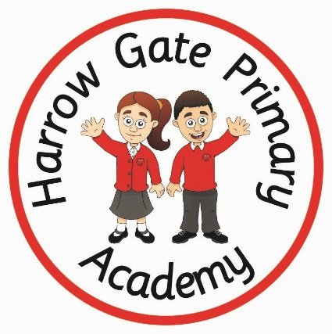

**Movement based ideas**

**Walk with your family - what habitats can you find? How many different types of flowers and trees can you find?**

**Geography**

**Subject specific activities**

**Watch BBC Geography Learning clips – they are amazing!** [**https://www.bbc.co.uk/programmes/b006vj4c/clips**](https://www.bbc.co.uk/programmes/b006vj4c/clips)

**Pick from a range of Geographical topics and become an expert. Show off what you know by creating a poster, Powerpoint, Kahoot Quiz, non-fiction page or a video. Choose from Volcanoes, Earthquakes, Rivers, seas and oceans, Land use, Biomes or Rainforests.**

**Can you make seed bombs and then scatter them everywhere when you go for your daily exercise with your family? Here is how to make them:** [**https://outdoorclassroomday.org.uk/resource/seed-bombs/**](https://outdoorclassroomday.org.uk/resource/seed-bombs/)

**You could keep a weather diary during this time. You could draw a picture, write a sentence, take photos, create a video weather report each day or record the temperature.**

**Do you know where your food comes from? Read the labels from all of the food in your cupboards. Where has it come from? Can you find these places on a map? Are you shocked or surprised by any? You could explore what food is produced in the UK.**

**Can you make a Rough Guide for your local area? What is important about your community? Where do people shop / live / socialise. Who are the important people in your local area? Who are your neighbours? Do some investigating and report your findings.**

**Follow and Tweet the Woodland Trust on Twitter @WoodlandTrust. They share amazing resources daily and will respond to any questions you ask them.**

**Follwo**

**Art based ideas**

**Art from Around the World with questions -** [**https://artclasscurator.com/art-around-the-world-in-30-days/**](https://artclasscurator.com/art-around-the-world-in-30-days/)

**Press flowers or create leaf rubbings using crayons and paper. Send photos of your creations to your teachers on Dojo.**

**Collect natural resources such as twigs and stones to create a natural piece of art. This can be made on the ground and then photographed.**

**English based ideas**

**Read tips about how you and your family can ‘Be more Green at home’.** [**https://www.yearofgreenaction.org/greener-choices-at-home**](https://www.yearofgreenaction.org/greener-choices-at-home)

**Next write a pledge / promise about how you will help the planet from home.**[**https://www.yearofgreenaction.org/make-a-pledge**](https://www.yearofgreenaction.org/make-a-pledge)

**Choose any country in the world. Create a non-fiction page / fact file about the culture, food, climate, people, jobs, animals, plants and transport.**

**Create ‘Top Ten Facts’ about the United Kingdom. Can you impress your teacher by finding out things that even they might not know?**