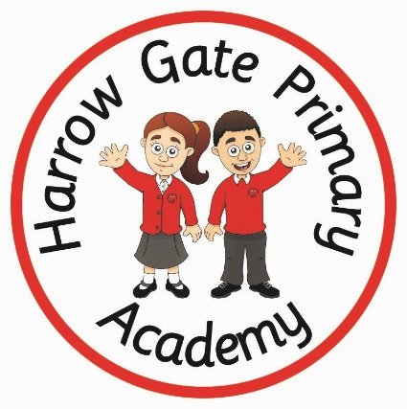

**TV shows**

**Watch Matilda and The Ramsey Bunch on BBC iPlayer and see if you can come up with something tasty to cook.**

**This episode of ‘Operation Outch’ is all about what makes you you. iPlayer series 7 episode 1**

**The odd squad will keep you up to date with lots of ways to keep healthy** [**https://www.bbc.co.uk/cbbc/watch/odd-squad-how-to-wash-your-hands**](https://www.bbc.co.uk/cbbc/watch/odd-squad-how-to-wash-your-hands)

**Web sites / interactive learning**

**Jigsaw families:** [**https://www.jigsawpshe.com/learning-at-home**](https://www.jigsawpshe.com/learning-at-home)

**Supermovers/;** [**www.bbc.co.uk/teach/supermovers**](http://www.bbc.co.uk/teach/supermovers)

**Childline Tool Box has a calm zone where you can access activities, breathing exercises, yoga, games and videos on ways to cope and expressing emotion** [**https://www.childline.org.uk/toolbox/calm-zone/?fbclid=IwAR2UDQqDr54URa1T6_pXFAJTxI3PpVt6dkR1dDHiyN4IrWpuocfTuRpUPQ8**](https://www.childline.org.uk/toolbox/calm-zone/?fbclid=IwAR2UDQqDr54URa1T6_pXFAJTxI3PpVt6dkR1dDHiyN4IrWpuocfTuRpUPQ8)

**English based ideas**

**Write a letter to one of your friends to let them know you are thinking of them while you’re not seeing them at school.**

**Think of the people that you are thankful for or who have helped you during the lockdown. You could record a video and tell them why you are grateful for them.**

**Maths Based ideas**

**Have a look at some different food packaging in your home. Compare the amounts of calories, fat and sugar.**

**Write a recipe for friendship. Have a look at** [**https://view.officeapps.live.com/op/view.aspx?src=http%3A%2F%2Fwww.primaryresources.co.uk%2Fpshe%2Fdocs%2Ffriendship_recipe.doc**](https://view.officeapps.live.com/op/view.aspx?src=http%3A%2F%2Fwww.primaryresources.co.uk%2Fpshe%2Fdocs%2Ffriendship_recipe.doc) **for some ideas**

**Art based ideas**

**Make a poster to remind everyone of the ways you can stay healthy. Think about food, exercise, sleep and hygiene.**

**Draw a family portrait of the people in your family.**

**Make a card for a friend or family member for an upcoming celebration.**

**PSHE**

**Subject specific activities**

**BBC bitesize has lots of links to PSHE and citizenship learning at** [**https://www.bbc.co.uk/bitesize/subjects/zqtnvcw**](https://www.bbc.co.uk/bitesize/subjects/zqtnvcw)

**Create your own personal or family shield or coat of arms. Remember to include lots of pictures that give clues about yourself or your family**

**Think about ways that you can help other during this time and make a list. You could include things like picking your toys and belongings up, being kind to your brothers or sisters or keeping your bedroom tidy.**

**Help your family to cook a healthy meal for you to share.**

**Keep a diary of what you are doing and how you are feeling each day. You could use emoji’s to express your feelings.**

**Make a list of all the things you are looking forward to doing when we are no longer in lockdown. Keep it somewhere safe and tick off your dreams and goals as you achieve them.**

**Colour a picture from one of your colouring books.**

**Every day the Smart School Council are asking a question linked to our current situation. Click on the daily link on Twitter** [**https://twitter.com/ssccty**](https://twitter.com/ssccty) **and you can get involved. You could even lead your own family meeting!**

**Movement based ideas**

**Take part in a cosmic kids yoga session each day. These are suitable for all the family.** [**https://www.youtube.com/user/CosmicKidsYoga**](https://www.youtube.com/user/CosmicKidsYoga)

**Make your own exercise schedule to keep you active for an hour each day. Think of all the things you love to do that keep you healthy e.g jumping, skipping, kicking a ball.**