The Battle of Hastings
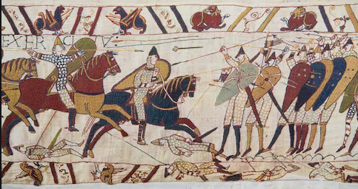
- Edward The Confessor was King of England and died in 1066 without leaving an heir to the throne.
- He gave his throne to Harold Godwinson who was crowned King at Westminster Abbey.
- William of Normandy wanted to be King of England and began to gather a huge army to fight for the kingdom.
- William of Normandy and 700 ships sailed across the English Channel to invade England and take the crown.
- Harold and his army quickly returned from Stamford Bridge, where they had been fighting the Vikings, to defend the country from William of Normandy.
- The Battle of Hastings took place on Senlac Hill in Hastings. King Harold’s men were at the top of the hill and William’s men were at the bottom.
- William’s men moved in and gained victory.
- Christmas day 1066 William of Normandy was crowned King of England at Westminster Abbey.

